1. ***Unscramble the words.*** *(Поставь буквы в правильном порядке)*

K s y-

l o u C d –

R i a n o w b -

1. ***Write the words*** *(Напиши слова под картинками).*
2. I can see the 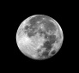 in the sky.

____________

1. The is shining.

________

1. A 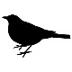 is flying.

___________

1. ***Spelling \****

1.

2.

3.

4.

5.

6.