[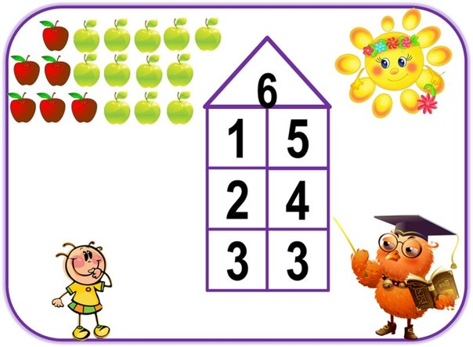](http://vk.com/photo-41855461_341134857)

[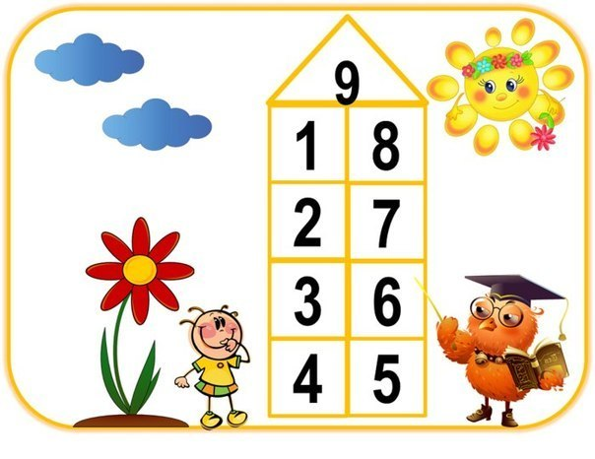](http://vk.com/photo-41855461_341134860)

[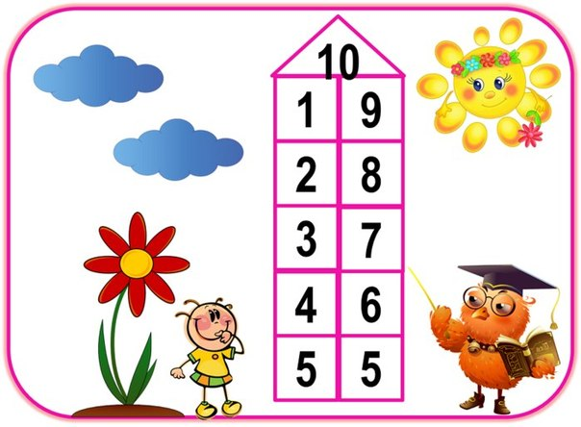](http://vk.com/photo-41855461_341134861)

[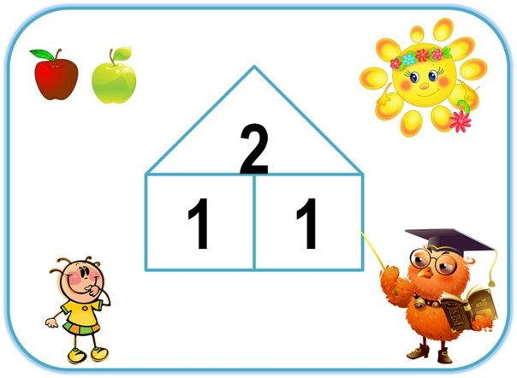](http://vk.com/photo-41855461_341134853)

[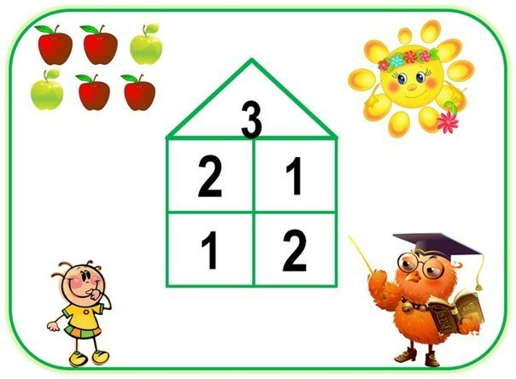](http://vk.com/photo-41855461_341134854)

[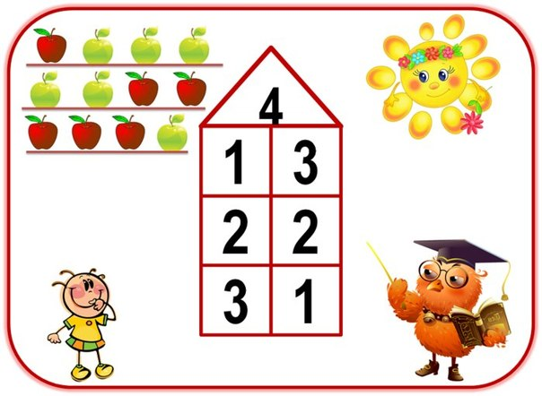](http://vk.com/photo-41855461_341134855)

[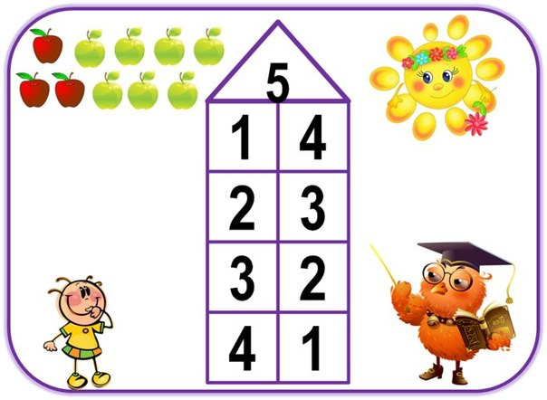](http://vk.com/photo-41855461_341134856)

[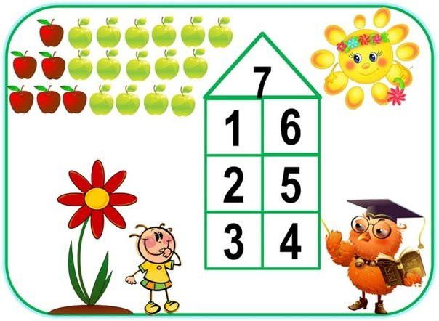](http://vk.com/photo-41855461_341134858)