Programming Languages | Definition of programming languages
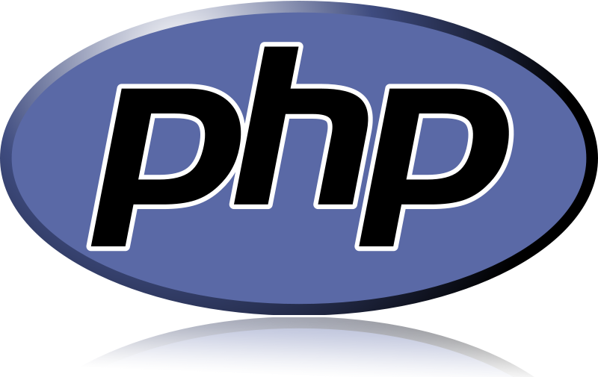 | PHP (recursive acronym for PHP: Hypertext Preprocessor) is a widely-used open source general-purpose scripting language that is especially suited for web development and can be embedded into HTML.
 | HyperТext Markup Language, commonly referred to as HTML, is the standard markup language used to create web pages. Used by most websites to create visually engaging web pages, user interfaces for web applications, and user interfaces for many mobile applications.
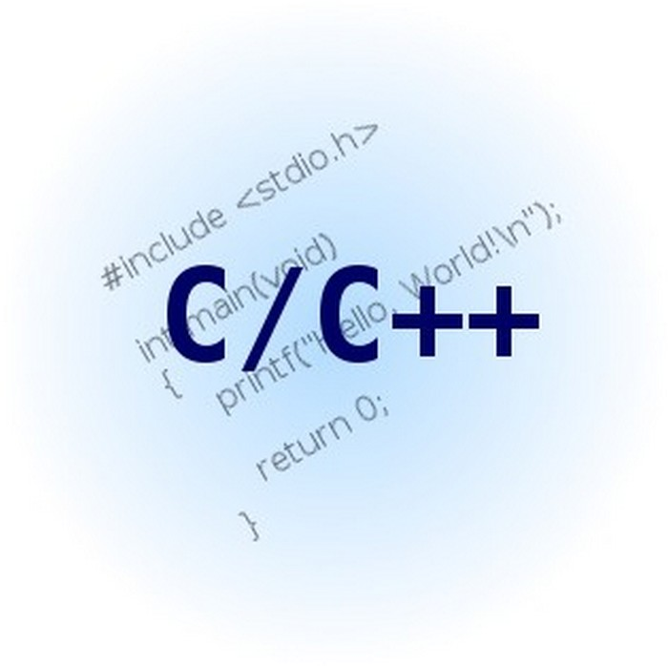 | C++ is a general-purpose programming language. It has imperative, object-oriented and generic programming features, while also providing facilities for low-level memory manipulation.
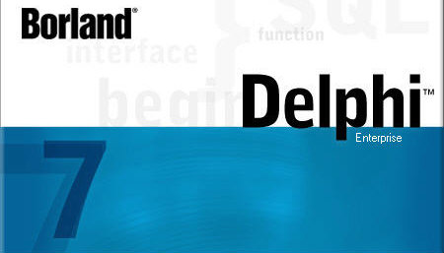 | Delphi is an integrated development environment (IDE) for console, desktop graphical, web, and mobile applications.
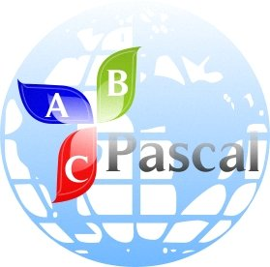 | Pascal is a historically influential imperative and procedural programming language, designed in 1968–69 and published in 1970 by Niklaus Wirth as a small and efficient language intended to encourage good programming practices using structured programming and data structuring.
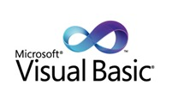 | Visual Basic is a third-generation event-driven programming language and integrated development environment (IDE) from Microsoft.Microsoft intended Visual Basic to be relatively easy to learn and use. Visual Basic was derived from BASIC and enables the rapid application development (RAD) of graphical user interface (GUI) applications, access to databases using Data Access Objects, Remote Data Objects, or ActiveX Data Objects, and creation of ActiveX controls and objects.

