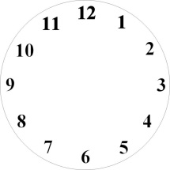 | It’s seven ten. (семь часов десять минут.) | It’s ten past seven. (десть минут восьмого)
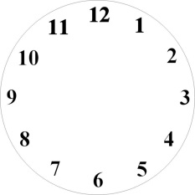 | It’s four twenty. | It’s twenty four.
 |  | It’s a quarter past eleven.
 | It’s three thirty.
 | It’s six fifty.

Напиши о себе, укажи время.
I get up at _______________________________________________________.
I wash my hands and face at ________________________________________.
I have breakfast at ________________________________________________.
I go to school at __________________________________________________.
I have lunch at ___________________________________________________.
I do my homework at ______________________________________________.
I go to bed at _____________________________________________________.

