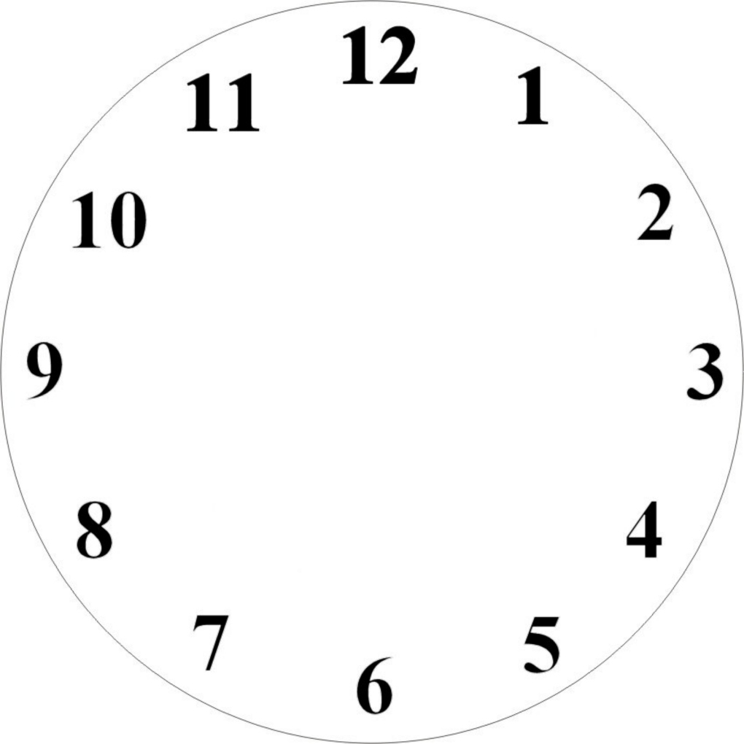
1 2 3 4 5 6 7

- It‘s twelve fifty.
- It’s half past three.
- It’s half past nine.
- It’s four twenty-five.
- It’s two thirty-five.
- It’s eleven fourty.
- It’s seven o’clock.

1 2 3 4 5 6 7

- It‘s twelve fifty.
- It’s half past three.
- It’s half past nine.
- It’s four twenty-five.
- It’s two thirty-five.
- It’s eleven fourty.
- It’s seven o’clock.

1 2 3 4 5 6 7

- It‘s twelve fifty.
- It’s half past three.
- It’s half past nine.
- It’s four twenty-five.
- It’s two thirty-five.
- It’s eleven fourty.
- It’s seven o’clock.

1 2 3 4 5 6 7

- It‘s twelve fifty.
- It’s half past three.
- It’s half past nine.
- It’s four twenty-five.
- It’s two thirty-five.
- It’s eleven fourty.
- It’s seven o’clock.

