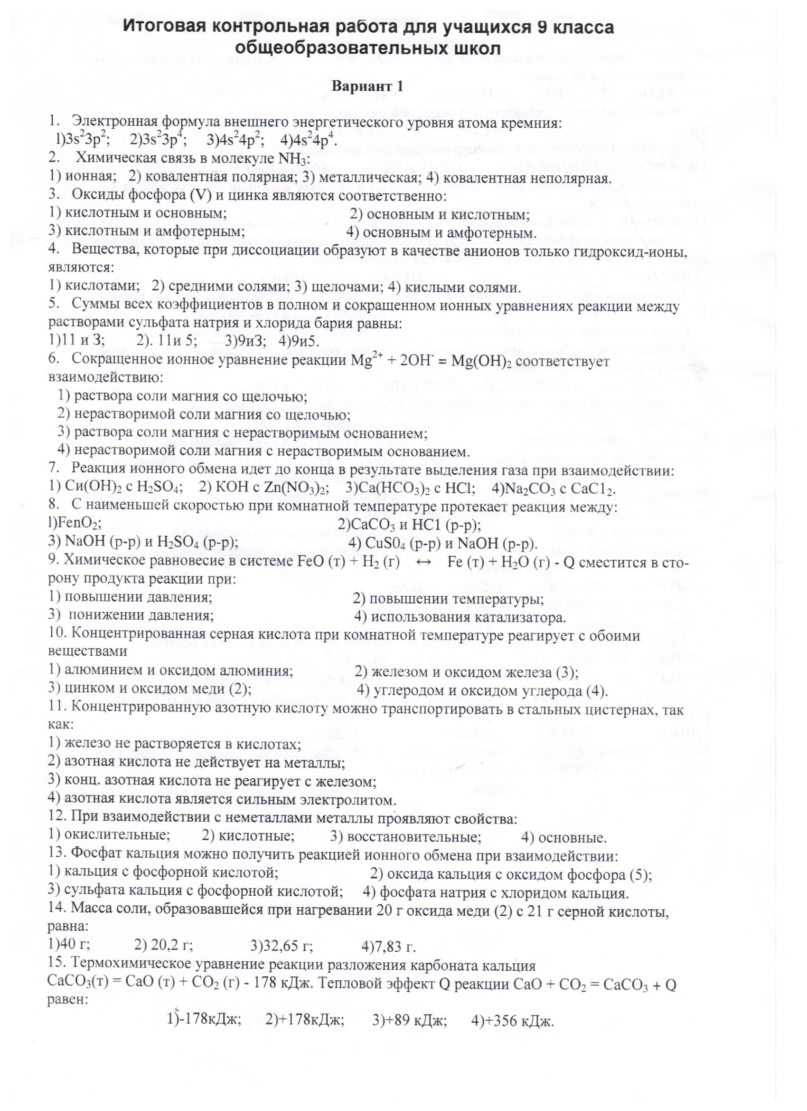

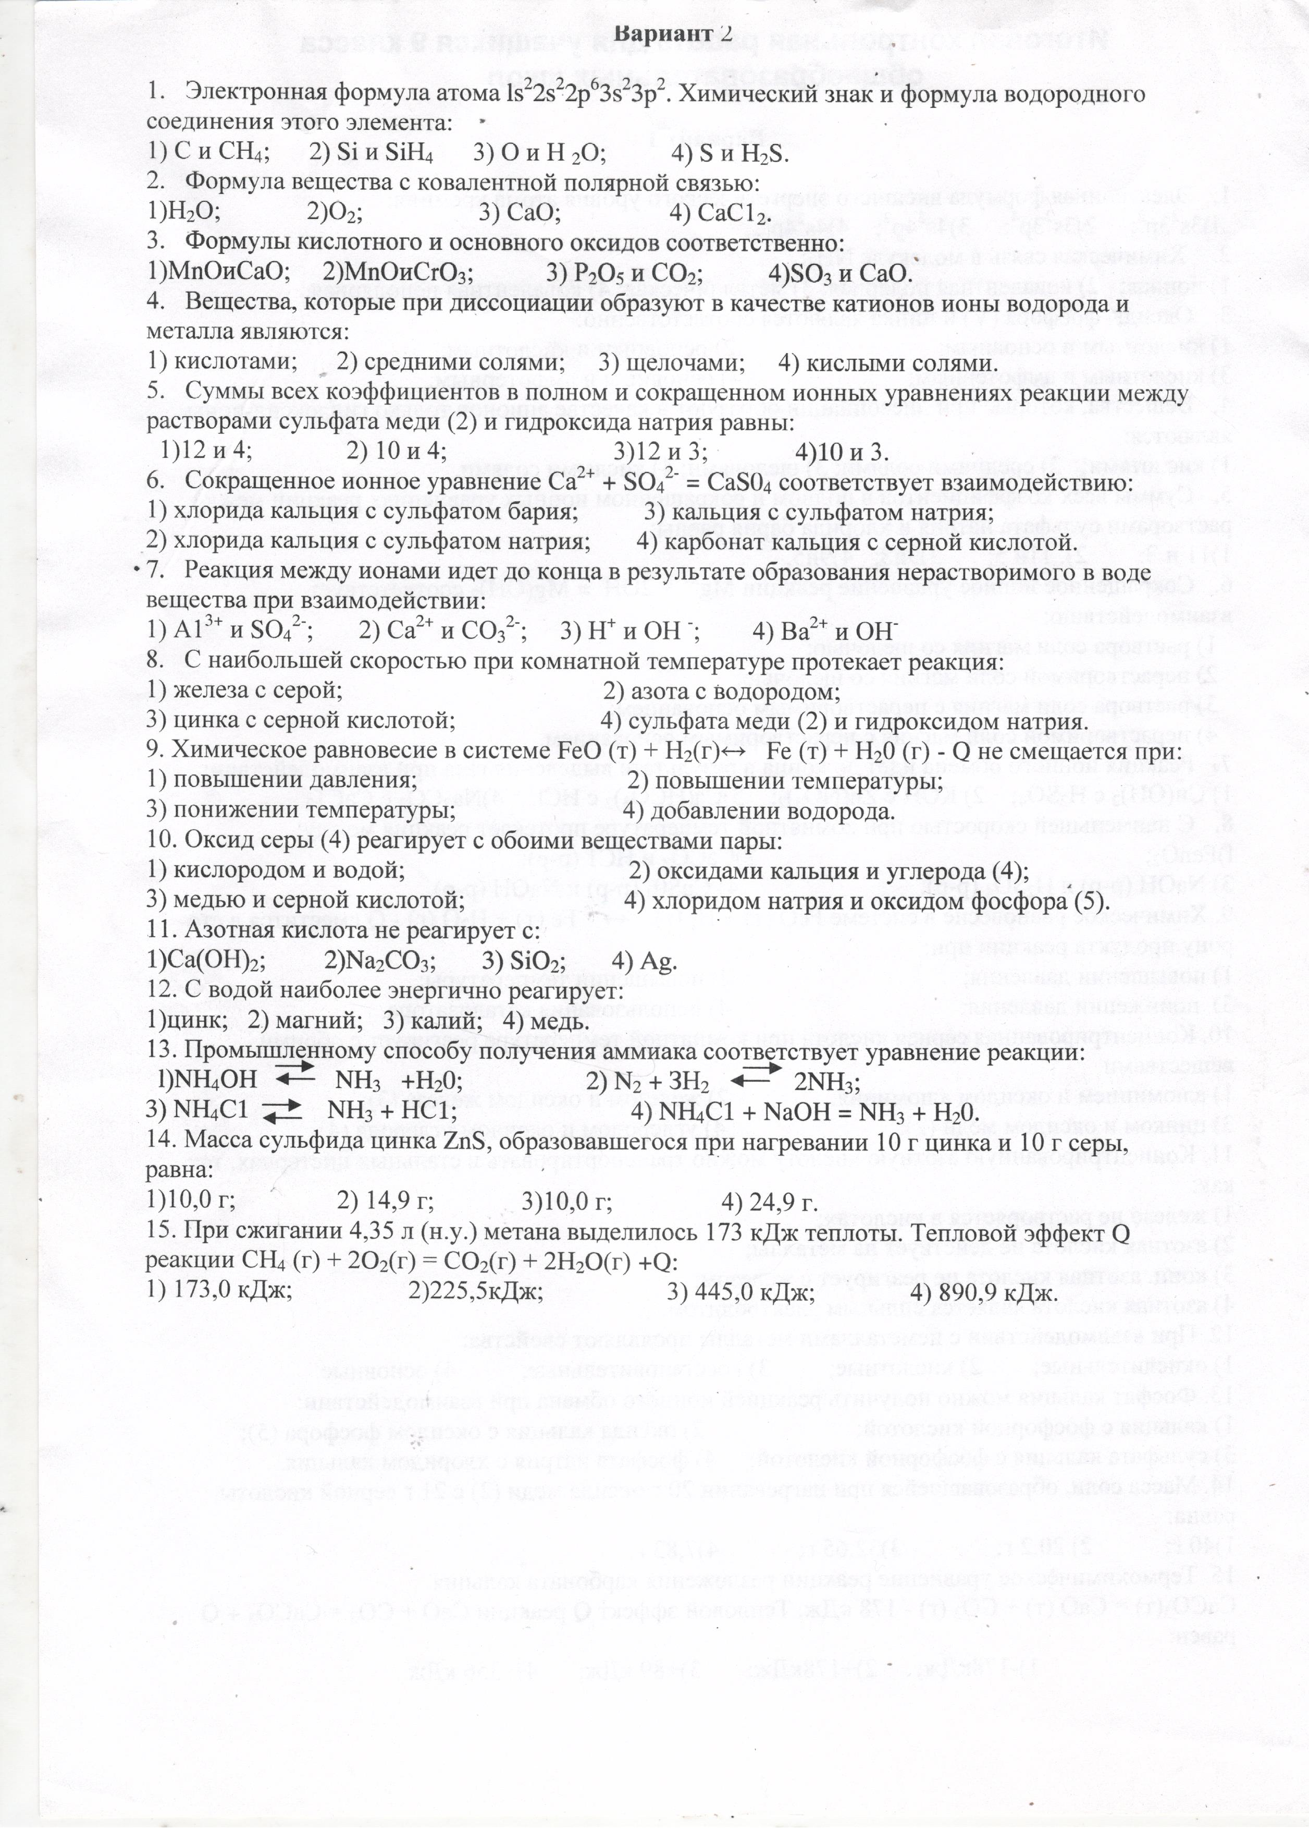

|  |  |  |  |
| --- | --- | --- | --- |
| Задания | Вариант 1 | Вариант 2 | Балл за задание |
| 1 | 1 | 2 | 1 |
| 2 | 2 | 1 | 1 |
| 3 | 3 | 4 | 2 |
| 4 | 3 | 4 | 2 |
| 5 | 1 | 2 | 3 |
| 6 | 1 | 2 | 4 |
| 7 | 3 | 2 | 4 |
| 8 | 1 | 4 | 2 |
| 9 | 2 | 1 | 2 |
| 10 | 3 | 1 | 2 |
| 11 | 3 | 3 | 2 |
| 12 | 3 | 3 | 1 |
| 13 | 4 | 2 | 2 |
| 14 | 3 | 2 | 4 |
| 15 | 2 | 4 | 3 |
| Итоговый балл | | | 35 |

|  |  |  |  |  |
| --- | --- | --- | --- | --- |
| Отметка | 2 | 3 | 4 | 5 |
| Баллы | 0-16 | 17-23 | 24-29 | 30-35 |

Ответы и критерии оценки