Introduction
England is a magnificent country in the United Kingdom of Great Britain and is the largest part of it.
Its territory consists mostly of low hills and plains, especially in the central part. Thanks to its geographical location, significant history and rich culture England has a great deal of unforgettable places to visit not only in big cities, but in the picturesque countryside as well.
England has always been and still stays one of the most favorite destinations for tourists from all over the world. Fantastic ancient castles, unique landscape, unsurpassed architecture plunge visitors into the fantastic world of legends and fairy tales.
It is almost impossible to rank 10 the best sights in England, but in our report we try to observe some of them and choose the most remarkable one.

London
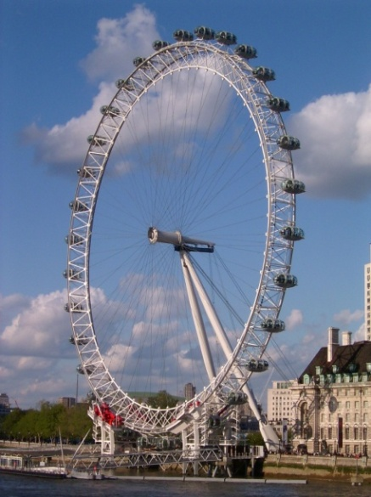
London definitely can be called as one of the most beautiful cities in the UK. It is the capital of Great Britain and situated in the South-Western part of it. London is the second most populated city in Europe and is the largest in the EU. [1]
London often gives an impression of being more popular with its past than its present. But many unkempt buildings were rediscovered and now put the city in a new light. The city offers visitors a journey through the ages of history.
To watch the city up to 25 miles in each direction from the London Eye is one of the first necessary things each tourist must do first of all. [4]
2 months during the summer is opened for tourists Buckingham Palace, the official residence of Queen’s family.
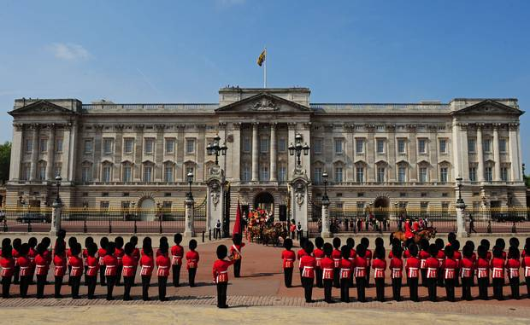
Another unforgettable experience will provide you the changing of the Queen’s guard.

The most recognizable bridge in the world is the London Bridge. It was built within 8 years and nearly 250 workers were involved. The construction is 265 m long and the framework weighs about 11 000 tons. [2]
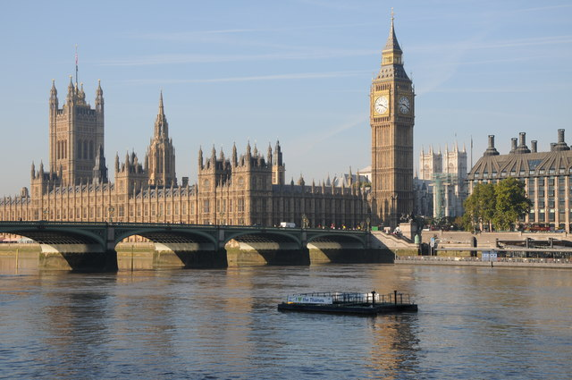
Walking along the river Thames one can hear the deep tone of the famous bell Big Ben, located in the Clock Tower.

On the North bank of the river Thames visitors can see the most rich in historic sights place – Westminster with world famous Westminster Abbey. This is a large gothic church, the traditional place of coronation and burial sites. [3]
What is more, London is a hometown for Sherlock Holmes. It is also a fascinating city laden with history, full of museums and art galleries with free entrance, beautiful green parks, fantastic shopping and dining, a vibrant theatre scene, and, of course, royalty. London is truly a city that has it all.
London however is not only a historic theme park. It is a lively and amazing cosmopolitan city with music, clubs, street fashion a modern art. It offers a variety of sophisticate restaurants and a mixture of unique boutiques. [4]
Much of London’s energy is centered now in Soho. With its pavement cafes and gurgling cappuccino machines it has become a meeting place for all kinds of people from all over the world. [1]
Yorkshire
Yorkshire is an earldom in Northern England. This is a wonderful place which attracts tourists from all over the world like any other.
It has earned its fame due to unspoiled stretches of countryside like Yorkshire Dale and North York Moor. [6]
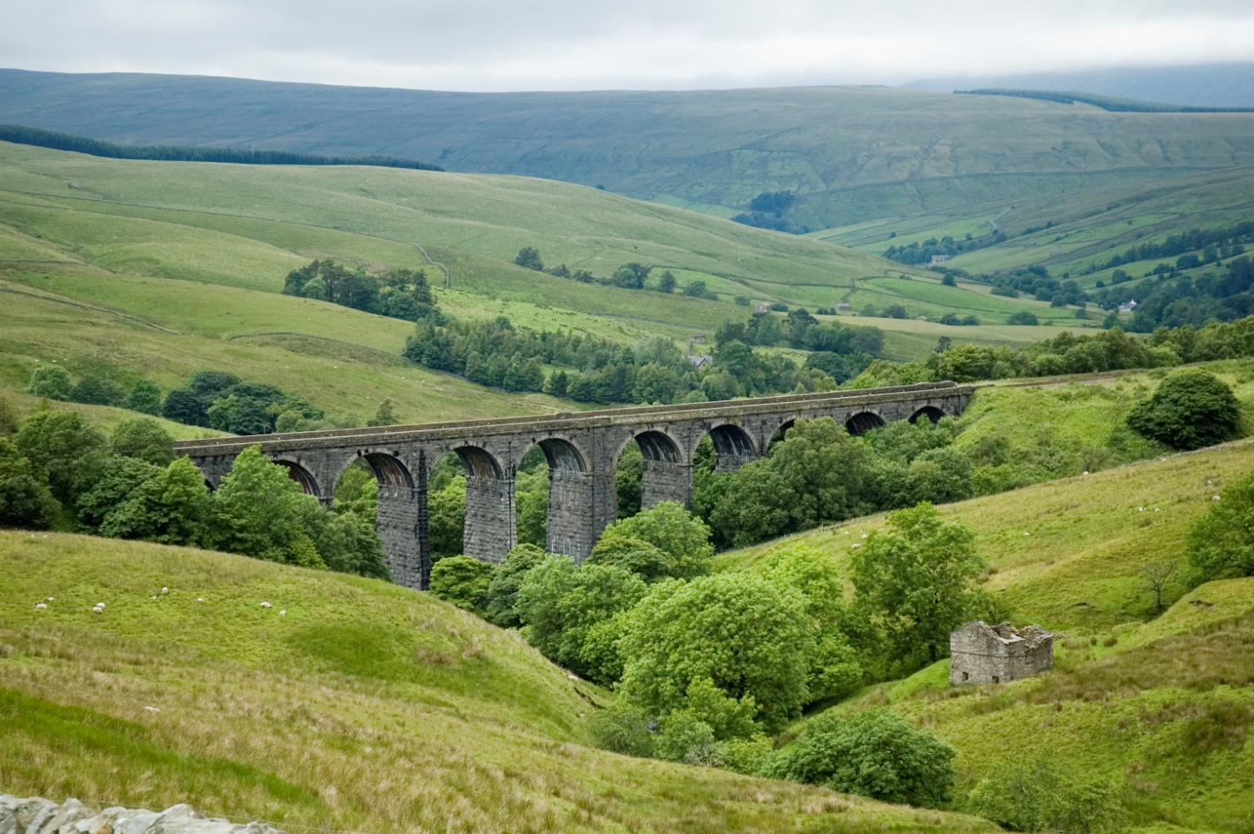
Enjoying natural waterfalls, cliffs, breathing fresh full of life and joy air, gathering some berries, walking across the vast tales, watching ancient castles – all this amusements can offer the Yorkshire to its visitors.
You also can sink in the fabulous atmosphere and feel yourself like a character of a famous fairy tale about hobbits.
Furthermore, Yorkshire claims to have the best ever cuisine. It boasts more Michelin-starred restaurants than anywhere else. [7]

Devon
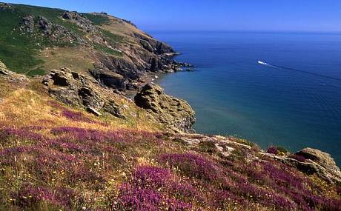
England is watered by Atlantic Ocean, North and Irish seas. But one of the most fascinating views is in Devon, an earldom in the South-Western England. From the one side it id watered by Bristol Bay and from the other side – by the English Channel. [5]

The inner part of Devon is mainly countryside. The main economic branch is tourism. The climate there is quite mild. National parks of Devon are especially attractive for tourists. Visitors are pulled by picturesque tales, rocks and sea resorts. All the resort cities of Devon have a common name – the English Riviera. These areas are little populated so visitors can fully enjoy the beauty of untouched nature. [8]
A visit here mixes two of life’s loveliest pleasures: good food and the great outdoors. Devon folk make the most of the rich larder of food on their doorstep. Lamb, venison, pheasant, pork and seafood are staples, and the county’s farmers’ markets are full of artisan producers selling delicious cider, apple juice, cheese and ice cream. [5]
Lake District
The Lake District opens the tourists the most thrilling and grandest view in Britain.
Its picturesque patchwork of lakes, valleys, woodlands and fells make it one of the best places in Britain to get out and experience the great outdoors, whether it’s on a leisurely bike ride down country lanes or a day-long hike across the hills. [6]
The Lake District also has numerous artistic and literary connections, most famously William Wordsworth, who was born in Cockermouth in 1770 and drew much of his poetic inspiration from the surrounding landscape. And while the weather is notoriously unpredictable (locals will tell you that it’s not unusual to experience all four seasons in a single day), showers and racing clouds only emphasise the grandeur of the magnificent scenery. [9]
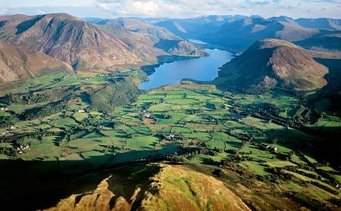

Windsor Castle
It is a well known fact, that England had a very difficult and cruel history. That’s why there are so many castles. Many of them have vanished many centuries ago. Those, which left, are ruined or damaged. But for this country its castles are not just an exciting monument, but an integral part of its past. [7]
Windsor Castle is a residence of Queen’s family in Windsor, Berkshire. It was founder by Wilhelm the Conqueror in 1066. For 900 years this castle has been an unforgettable symbol of British Monarchy, towering from the hill in the valley of Thames.
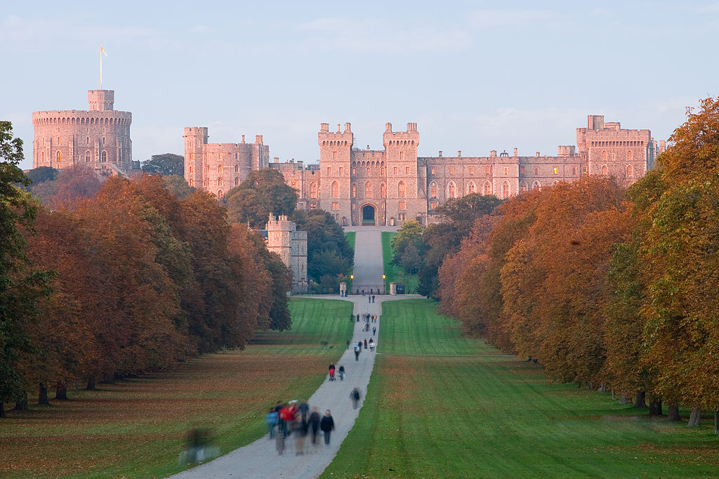

This is one of the biggest and liveliest castles in the UK. It remains the main place of living for the Queen’s family. Most of it is opened for tourists. Everyone can walk through the halls and admire the atmosphere of the royal life. [9]
According to the words of the famous writer Samuel Pips, this is the most romantic castle. [8]
Stonehenge
One of the world’s most vital prehistoric sites and surely one of Britain’s most popular tourist attractions, the ancient ring of Neolithic stones at Stonehenge has attracted hordes of pilgrims, philosophers and mystery seekers for centuries. [8]
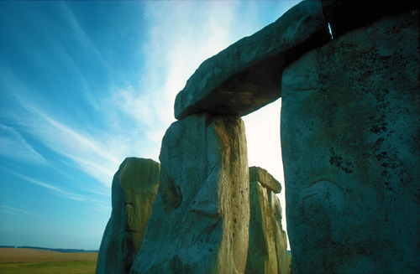
Its original purpose is unclear to us, but some have speculated that it was a temple made for the worship of ancient earth deities. It has been called an astronomical observatory for marking significant events on the prehistoric calendar. Others claim that it was a sacred site for the burial of high-ranking citizens from the societies of long ago. While we can't say with any degree of certainty what it was for, we can say that it wasn't constructed for any casual purpose. Only something very important to the ancients would have been worth the effort and investment that it took to construct Stonehenge.
The stones we see today represent Stonehenge in ruin. Many of the original stones have fallen or been removed by previous generations for home construction or road repair. But it definitely stays Britain's greatest national icon, symbolizing mystery, power and endurance. [10]
Dorset
Another UNESCO World Heritage site, the Jurassic Coast, is the popular name given to this 95-mile (155 km) long stretch of coastline in southern England, located along the east Devon and Dorset shores. [8]
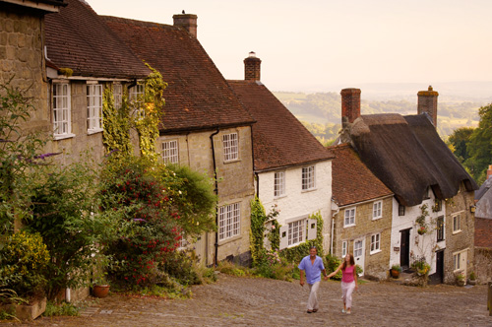
Although, you won’t be chased by a T-Rex, you might go home with some Jurassic treasures, as the area has fossils scattered along its beaches. If plowing through the sand and mud is not your definition of fun, then just enjoy a leisure walk down the wild beaches to witness the sheer white cliffs and stunning rock formations with the millions of earthly years frozen in them. [5]

Cornwall
Cornwall is defined by its magnificent coastline with 300 miles of dunes and cliffs, medieval harbours and oak-forested creeks – and every mile accessible on foot. Such an unspoilt coastline inspires Enid Blyton-style adventures: take a picnic and the dog through fields fringed in wildflowers to a remote beach; clamber down stepping-stone cliffs to rock pools that are works of marine art; swim with seals and harmless basking sharks. [9]
You can't get further west than the ancient Celtic kingdom of Cornwall (or Kernow, as it's known to Cornish-speakers). Blessed with the southwest's wildest coastline and most breathtakingly beautiful beaches, this proudly independent peninsula has always marched to its own tune.
While the staple industries of old – mining, fishing and farming – have all but disappeared, Cornwall has since reinvented itself as one of the nation's creative corners. Whether it's exploring the space-age domes of the Eden Project, sampling the culinary creations of a celebrity chef or basking on a deserted beach, you're guaranteed to feel the itch of inspiration. Time to let a little Kernow into your soul.
Since 2006, Cornwall's historic mining areas have formed part of the UK's newest Unesco World Heritage site, the Cornwall & West Devon Mining Landscape. [11]
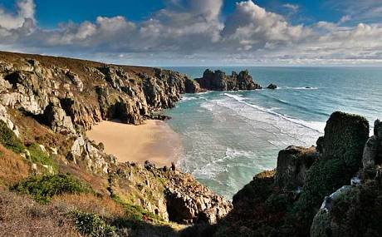
Manchester
Manchester is England’s second city, and the city with the most visitors outside of London. It is located in the south-central part North West England.


Without any doubt Manchester can be called the city of sport. It has two Premier League football clubs bearing the city’s name, Manchester City and Manchester United.
Manchester also offers vibrant culture, fashion, and shopping. Manchester’s Chinatown, located right next to the Gay Village, is one of the most bustling and colorful areas of the city. It is an eye-pleaser for architecture buffs, a never-ending story for the Orient lovers and a garden of Eden for the hungry. [9]

Liverpool
The city of music that is often synonymous with The Beatles, Liverpool is also a culture capital, and a destination for art lovers, fans of the theatre and museumgoers.
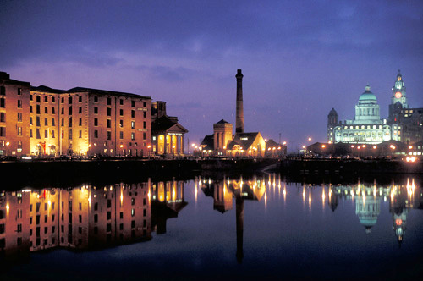
You cannot visit Liverpool and not experience a trip to The Beatles Storyat Albert Dock–a brilliant tour through the Beatles’ lives, with tons of memorabilia and insights from friends and family. Also, to fully comprehend the important influence Liverpool had throughout the centuries in the development of the British Empire, be certain to visit the Maritime Mercantile City. [9]

Conclusion
In our report we observed some of the most well-known and popular by tourists places to visit in England.
It would be unfair to determine, that they are the most famous in the country. In fact, England belongs to those kinds of countries, where you can’t list all the sights. Each statue, each monument, each narrow street or valley is unique, with its rich history and the invisible print of past.
Within one country there are combined quite rural landscapes, medieval castles and Gothic Cathedrals, daredevilry and awesomeness of noisy parties, shopping in exclusive and expensive boutiques and flea markets as well, sophisticated cuisine and best ever universities.
England is the country for the huge variety of tastes and abilities, but it definitely will nobody leave indifferent.
List of references
- London: https://ru.wikipedia.org/wiki/%D0%9B%D0%BE%D0%BD%D0%B4%D0%BE%D0%BD

London - Top Ten Sights: http://www.topsightseeing.com/england/london/topsights/

Westminster Abbey: http://en.wikipedia.org/wiki/Westminster_Abbey

London Attractions: http://www.aviewoncities.com/london/londonattractions.htm

Top 10: best places and cities in England: http://www.telegraph.co.uk/travel/destinations/europe/uk/11177512/Top-10-best-places-and-cities-to-visit-in-England.html

Best Places to Visit in Britain: http://www.touropia.com/best-places-to-visit-in-the-uk/

Йоркшир Дейл: http://www.km.ru/turizm/encyclopedia/iorkshir-deils

http://allcastle.info/europe/england/001

Top ten places to visit in England: http://www.neverstoptraveling.com/the-top-10-places-in-britain

Stonehenge: http://www.britannia.com/history/h7.html

Introducing Cornwall: https://www.lonelyplanet.com/england/southwest-england/cornwall

