1. 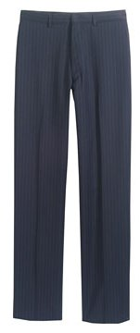

1. 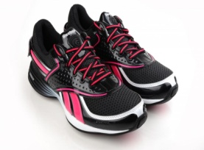

2. 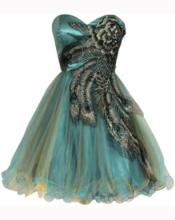

3. 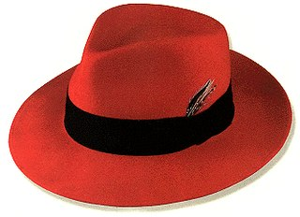

4. 

5. 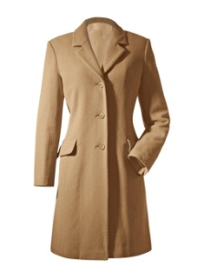

6. 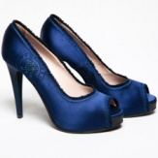

7. 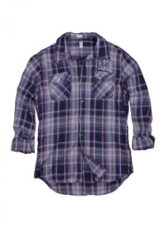

8.

|  |  |  |  |  |  |  |  |
| --- | --- | --- | --- | --- | --- | --- | --- |
| 1 |  |  |  |  |  |  |  |
|  |  |  |  |  |  |  |  |
|  |  |  | 2 |  |  |  | 3 |
| 4 |  |  |  |  |  |  |  |
|  |  |  |  |  |  |  |  |
|  |  |  |  |  | 5 |  |  |
|  |  |  | 6 |  |  |  | 7 |
|  |  |  |  |  |  |  |  |
|  |  | 8 |  |  |  |  |  |
|  |  |  |  |  |  |  |  |
| 9 |  |  |  |  |  |  |  |
|  |  |  |  |  |  |  |  |  |
| 10 |  |  |  |  |  | 11 |  |  |
|  |  |  |  |  |  | 12 |  |  |
|  |  | 13 |  |  |  |  |  |  |
| 14 |  |  |  |  |  |  |  |  |
|  |  |  |  |  |  |  |  |  |
|  |  |  |  | 15 |  |  |  |  |
|  |  | 16 |  |  |  |  |  |  |
|  |  |  |  |  |  |  |  |  |
|  |  |  |  |  |  |  |  |  |
|  |  |  |  |  |  |  |  |  |

8. 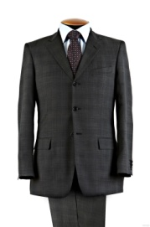 8. 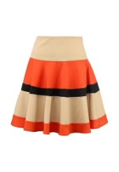

9. 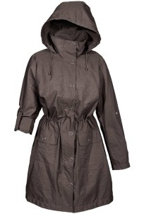

10. 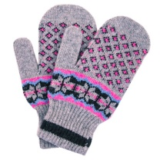

11. 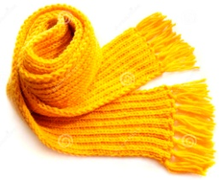

12. 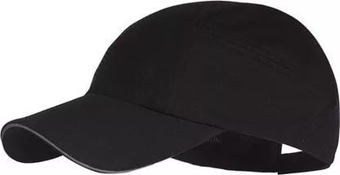

13. 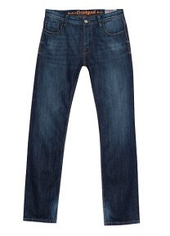

14. 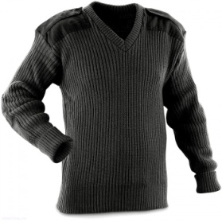

15. 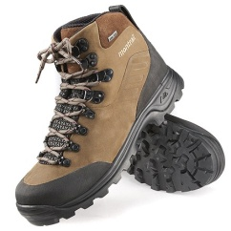

16. 