|  |  |  |  |  |  |  |  |  |  |  |  |  |  |  |  |  |  |  |  |  |  |
| --- | --- | --- | --- | --- | --- | --- | --- | --- | --- | --- | --- | --- | --- | --- | --- | --- | --- | --- | --- | --- | --- |
| 3 |  |  |  |  |  |  |  |  |  |  |  | 2 |  |  |  |  |  |  |  |  |  |
| ё |  |  |  |  |  |  |  |  |  |  |  |  |  |  |  |  |  |  |  |  |  |
| 4 |  | 4 |  |  |  |  |  |  |  |  |  |  |  |  |  |  |  |  |  |  |  |

|  |  |  |  |  |
| --- | --- | --- | --- | --- |
| 3 | + | 1 | = | 4 |
|  |  |  |  |  |
| . |  |  |  |  |
|  |  |  |  |  |
| . |  |  |  |  |
|  |  |  |  |  |

|  |  |  |  |  |
| --- | --- | --- | --- | --- |
| 3 | + | 1 | = | 4 |
|  |  |  |  |  |
| . |  |  |  |  |
|  |  |  |  |  |
| . |  |  |  |  |
|  |  |  |  |  |

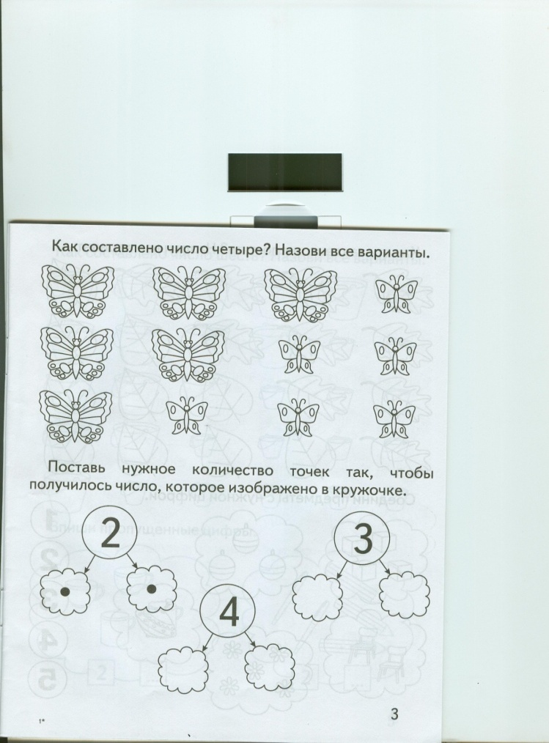

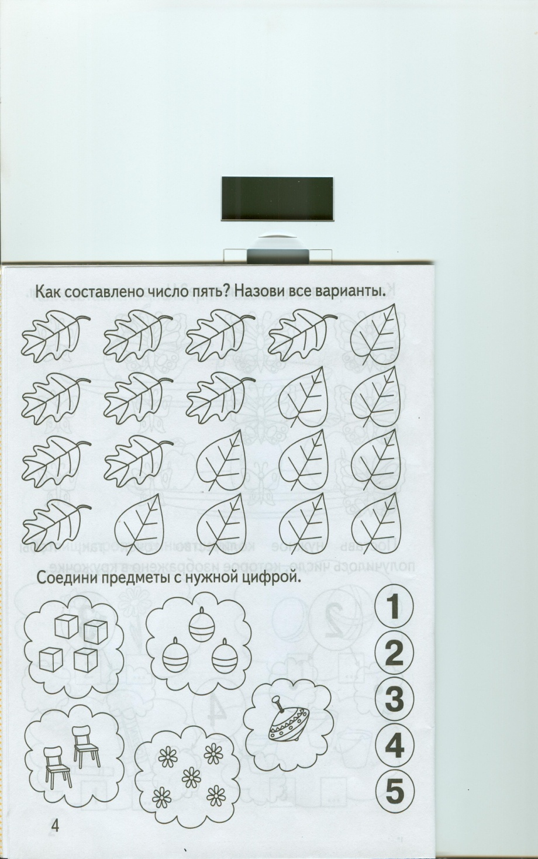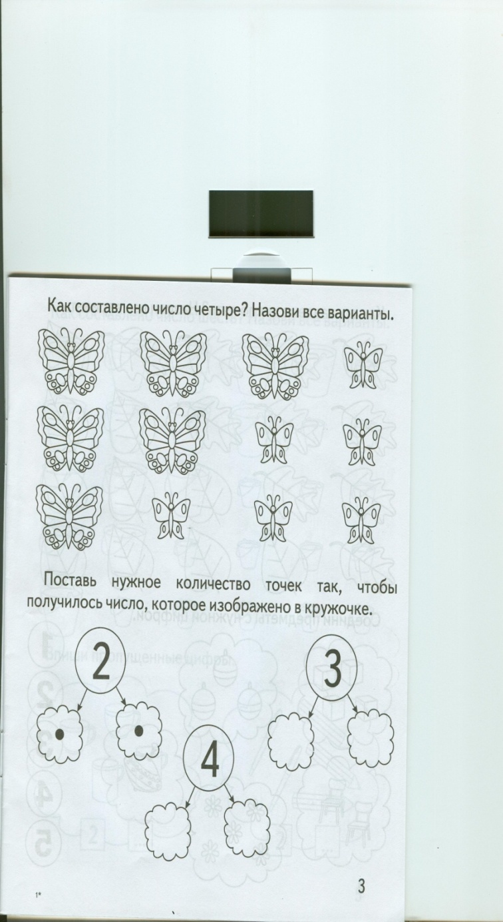



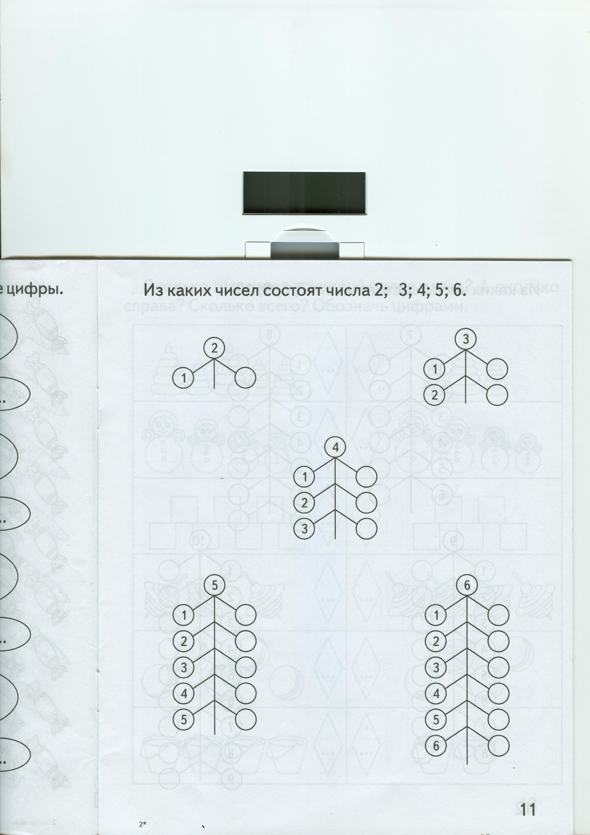

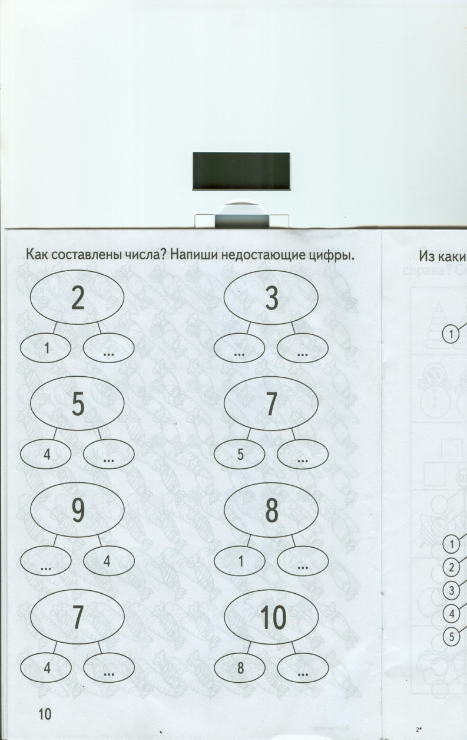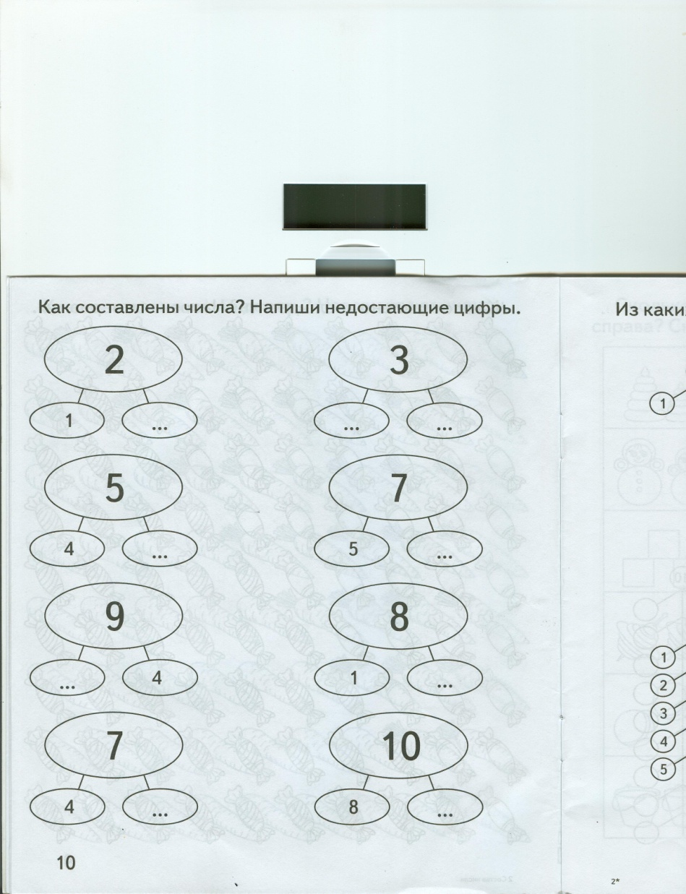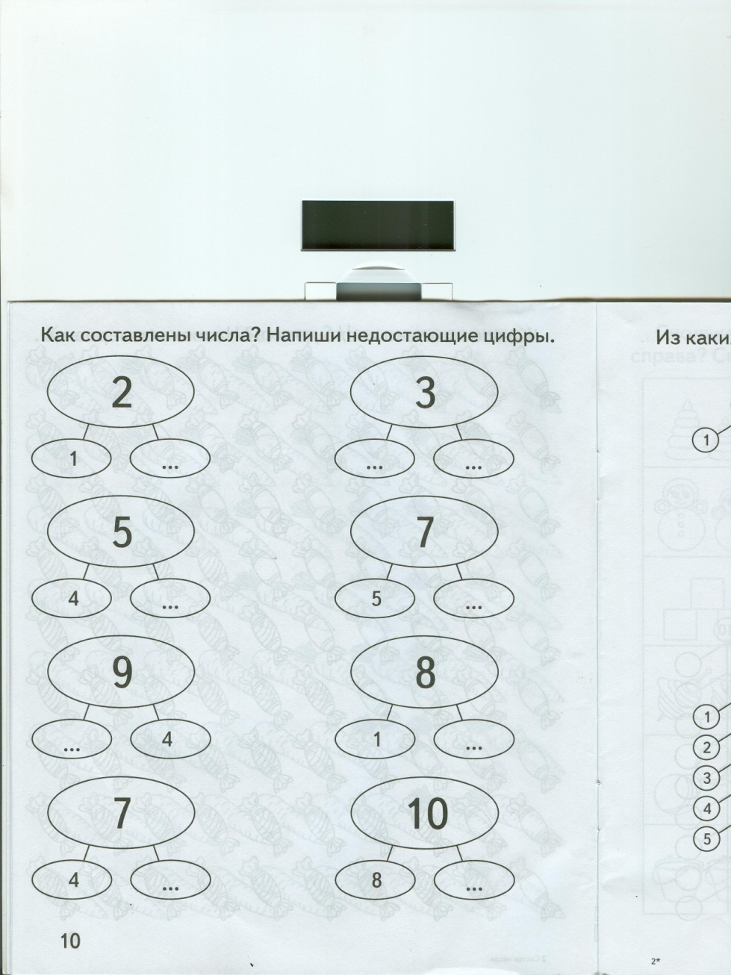

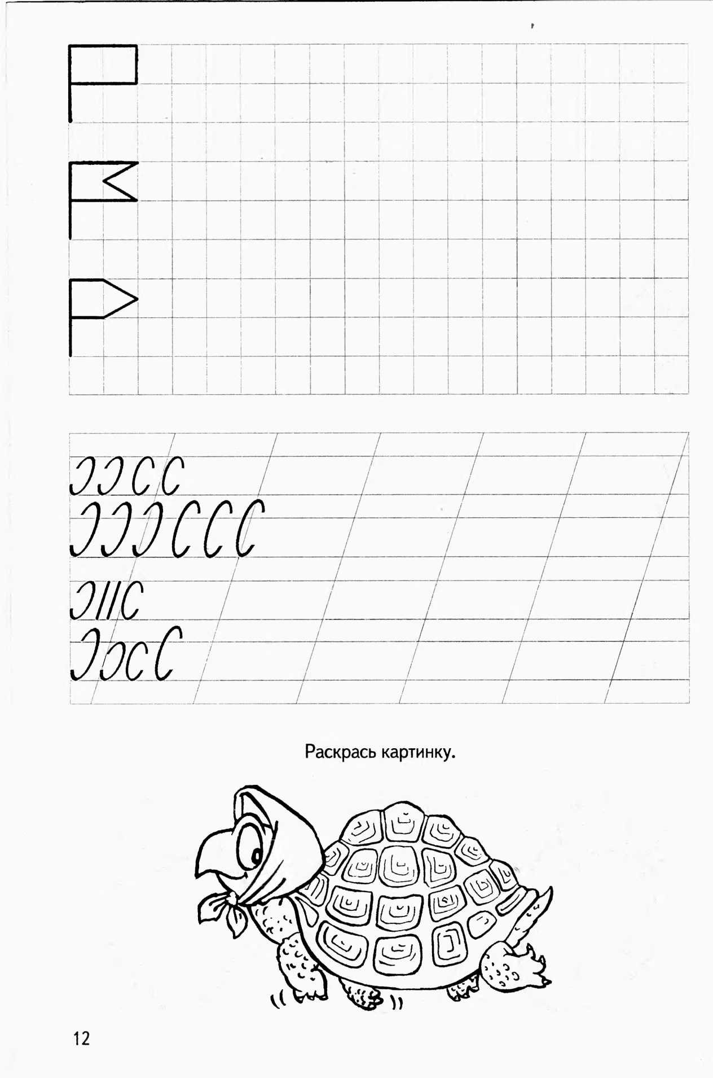

|  |  |  |  |  |  |  |  |  |  |  |  |  |  |  |  |  |  |  |  |  |  |
| --- | --- | --- | --- | --- | --- | --- | --- | --- | --- | --- | --- | --- | --- | --- | --- | --- | --- | --- | --- | --- | --- |
| 3 |  |  |  |  |  |  |  |  |  |  |  | 2 |  |  |  |  |  |  |  |  |  |
| ё |  |  |  |  |  |  |  |  |  |  |  |  |  |  |  |  |  |  |  |  |  |
| 4 |  | 4 |  |  |  |  |  |  |  |  |  |  |  |  |  |  |  |  |  |  |  |

