Как научить ребенка правильно держать ручку-карандаш. Только что наткнулась. Не могла не поделиться :-)

[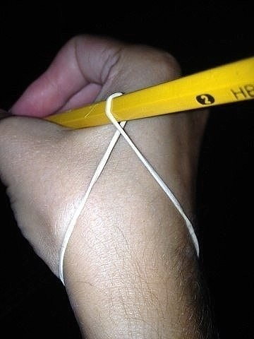](http://ok.ru/dk?cmd=PopLayerPhoto&st.layer.cmd=PopLayerPhotoOuter&st.layer.type=GROUP&st.layer.revNav=off&st.layer.limitedUi=false&st.layer.sphotoIds=803539297238;803539296982;803539296726;803539296470&st.layer.fre=on&st.layer.showNav=on&st.layer.photoAlbumId=52178190336214&st.layer.epm=off&st.layer.photoId=803539297238&st.layer.opl=off&st.layer.navStartPhotoId=803539297238&st.layer.sbd=off&st.cmd=userMain&st._aid=GroupTopicLayer_openPhotoLayer)

[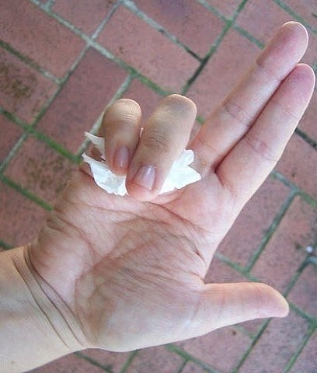](http://ok.ru/dk?cmd=PopLayerPhoto&st.layer.cmd=PopLayerPhotoOuter&st.layer.type=GROUP&st.layer.revNav=off&st.layer.limitedUi=false&st.layer.sphotoIds=803539297238;803539296982;803539296726;803539296470&st.layer.fre=on&st.layer.showNav=on&st.layer.photoAlbumId=52178190336214&st.layer.epm=off&st.layer.photoId=803539296982&st.layer.opl=off&st.layer.navStartPhotoId=803539296982&st.layer.sbd=off&st.cmd=userMain&st._aid=GroupTopicLayer_openPhotoLayer)

[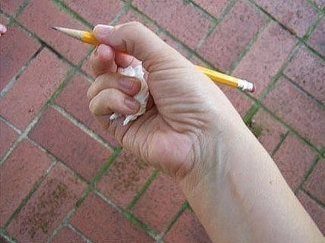](http://ok.ru/dk?cmd=PopLayerPhoto&st.layer.cmd=PopLayerPhotoOuter&st.layer.type=GROUP&st.layer.revNav=off&st.layer.limitedUi=false&st.layer.sphotoIds=803539297238;803539296982;803539296726;803539296470&st.layer.fre=on&st.layer.showNav=on&st.layer.photoAlbumId=52178190336214&st.layer.epm=off&st.layer.photoId=803539296726&st.layer.opl=off&st.layer.navStartPhotoId=803539296726&st.layer.sbd=off&st.cmd=userMain&st._aid=GroupTopicLayer_openPhotoLayer)

[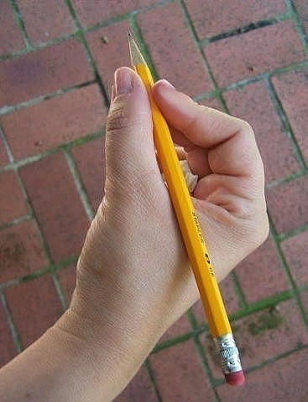](http://ok.ru/dk?cmd=PopLayerPhoto&st.layer.cmd=PopLayerPhotoOuter&st.layer.type=GROUP&st.layer.revNav=off&st.layer.limitedUi=false&st.layer.sphotoIds=803539297238;803539296982;803539296726;803539296470&st.layer.fre=on&st.layer.showNav=on&st.layer.photoAlbumId=52178190336214&st.layer.epm=off&st.layer.photoId=803539296470&st.layer.opl=off&st.layer.navStartPhotoId=803539296470&st.layer.sbd=off&st.cmd=userMain&st._aid=GroupTopicLayer_openPhotoLayer)

СОВЕТ 1: Учимся Играя!

[](http://ok.ru/dk?cmd=PopLayerPhoto&st.layer.cmd=PopLayerPhotoOuter&st.layer.type=GROUP&st.layer.revNav=off&st.layer.limitedUi=false&st.layer.sphotoIds=812476016942;812476016686;812476016430;812476016174;812476015918;812476018734;812476018478;812476018222;812476017966;812476017710;812476017454;812476017198&st.layer.fre=on&st.layer.showNav=on&st.layer.photoAlbumId=56877625770030&st.layer.epm=off&st.layer.photoId=812476016942&st.layer.opl=off&st.layer.navStartPhotoId=812476016942&st.layer.sbd=off&st.cmd=friendStatuses&st.friendId=564822219613&st._aid=GroupTopicLayer_openPhotoLayer)

[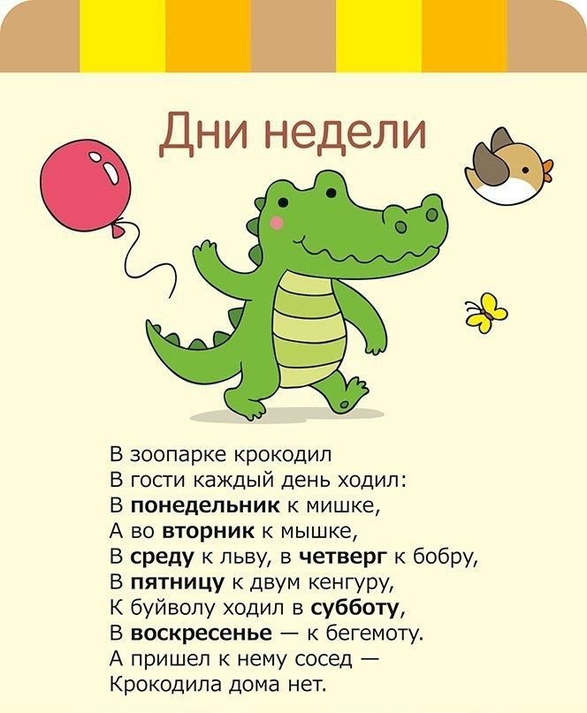](http://ok.ru/dk?cmd=PopLayerPhoto&st.layer.cmd=PopLayerPhotoOuter&st.layer.type=GROUP&st.layer.revNav=off&st.layer.limitedUi=false&st.layer.sphotoIds=812476016942;812476016686;812476016430;812476016174;812476015918;812476018734;812476018478;812476018222;812476017966;812476017710;812476017454;812476017198&st.layer.fre=on&st.layer.showNav=on&st.layer.photoAlbumId=56877625770030&st.layer.epm=off&st.layer.photoId=812476016430&st.layer.opl=off&st.layer.navStartPhotoId=812476016430&st.layer.sbd=off&st.cmd=friendStatuses&st.friendId=564822219613&st._aid=GroupTopicLayer_openPhotoLayer)

[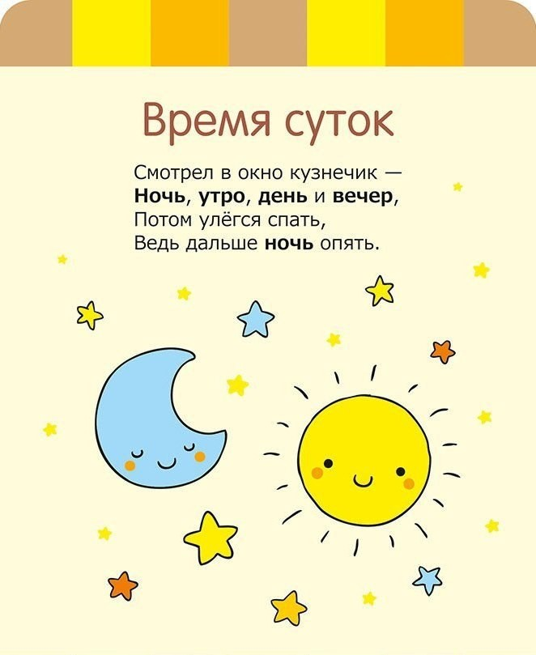](http://ok.ru/dk?cmd=PopLayerPhoto&st.layer.cmd=PopLayerPhotoOuter&st.layer.type=GROUP&st.layer.revNav=off&st.layer.limitedUi=false&st.layer.sphotoIds=812476016942;812476016686;812476016430;812476016174;812476015918;812476018734;812476018478;812476018222;812476017966;812476017710;812476017454;812476017198&st.layer.fre=on&st.layer.showNav=on&st.layer.photoAlbumId=56877625770030&st.layer.epm=off&st.layer.photoId=812476016174&st.layer.opl=off&st.layer.navStartPhotoId=812476016174&st.layer.sbd=off&st.cmd=friendStatuses&st.friendId=564822219613&st._aid=GroupTopicLayer_openPhotoLayer)

[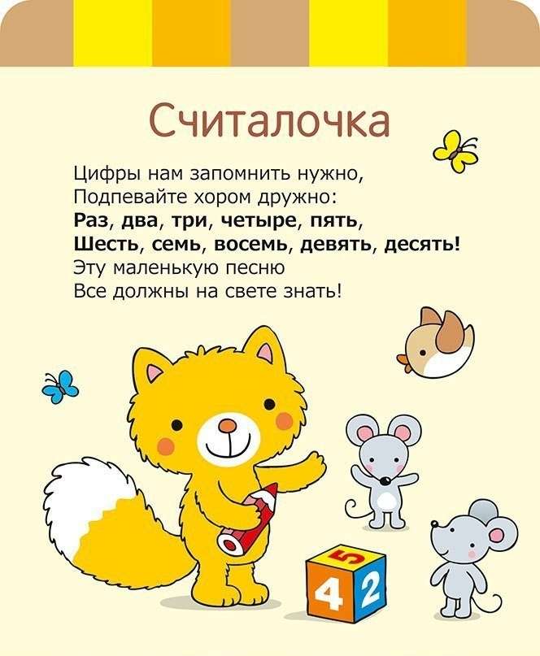](http://ok.ru/dk?cmd=PopLayerPhoto&st.layer.cmd=PopLayerPhotoOuter&st.layer.type=GROUP&st.layer.revNav=off&st.layer.limitedUi=false&st.layer.sphotoIds=812476016942;812476016686;812476016430;812476016174;812476015918;812476018734;812476018478;812476018222;812476017966;812476017710;812476017454;812476017198&st.layer.fre=on&st.layer.showNav=on&st.layer.photoAlbumId=56877625770030&st.layer.epm=off&st.layer.photoId=812476015918&st.layer.opl=off&st.layer.navStartPhotoId=812476015918&st.layer.sbd=off&st.cmd=friendStatuses&st.friendId=564822219613&st._aid=GroupTopicLayer_openPhotoLayer)

СОВЕТ 2: Это важно! Это нужно! Что мы вложим в ребёнка, то потом и получим...

[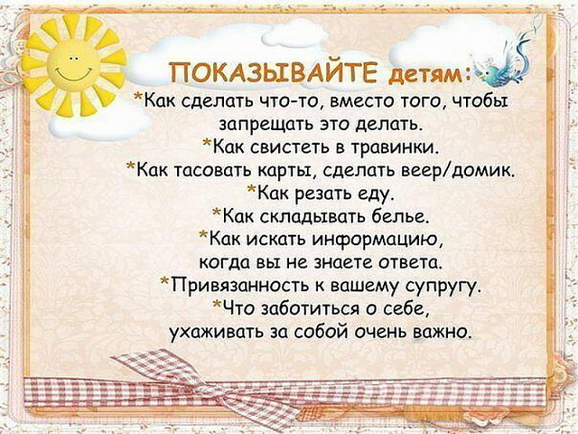](http://ok.ru/dk?cmd=PopLayerPhoto&st.layer.cmd=PopLayerPhotoOuter&st.layer.type=GROUP&st.layer.revNav=off&st.layer.limitedUi=false&st.layer.sphotoIds=812476016942;812476016686;812476016430;812476016174;812476015918;812476018734;812476018478;812476018222;812476017966;812476017710;812476017454;812476017198&st.layer.fre=on&st.layer.showNav=on&st.layer.photoAlbumId=56877625770030&st.layer.epm=off&st.layer.photoId=812476018734&st.layer.opl=off&st.layer.navStartPhotoId=812476018734&st.layer.sbd=off&st.cmd=friendStatuses&st.friendId=564822219613&st._aid=GroupTopicLayer_openPhotoLayer)

[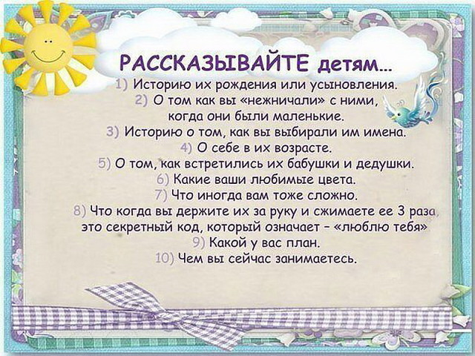](http://ok.ru/dk?cmd=PopLayerPhoto&st.layer.cmd=PopLayerPhotoOuter&st.layer.type=GROUP&st.layer.revNav=off&st.layer.limitedUi=false&st.layer.sphotoIds=812476016942;812476016686;812476016430;812476016174;812476015918;812476018734;812476018478;812476018222;812476017966;812476017710;812476017454;812476017198&st.layer.fre=on&st.layer.showNav=on&st.layer.photoAlbumId=56877625770030&st.layer.epm=off&st.layer.photoId=812476018478&st.layer.opl=off&st.layer.navStartPhotoId=812476018478&st.layer.sbd=off&st.cmd=friendStatuses&st.friendId=564822219613&st._aid=GroupTopicLayer_openPhotoLayer)

[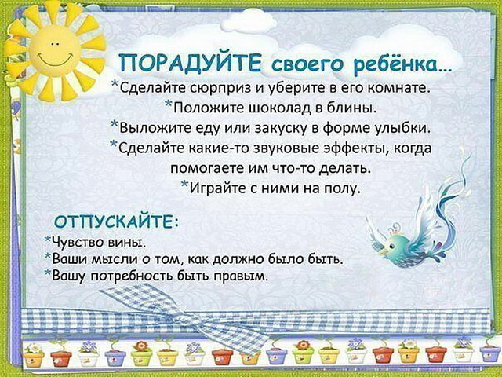](http://ok.ru/dk?cmd=PopLayerPhoto&st.layer.cmd=PopLayerPhotoOuter&st.layer.type=GROUP&st.layer.revNav=off&st.layer.limitedUi=false&st.layer.sphotoIds=812476016942;812476016686;812476016430;812476016174;812476015918;812476018734;812476018478;812476018222;812476017966;812476017710;812476017454;812476017198&st.layer.fre=on&st.layer.showNav=on&st.layer.photoAlbumId=56877625770030&st.layer.epm=off&st.layer.photoId=812476018222&st.layer.opl=off&st.layer.navStartPhotoId=812476018222&st.layer.sbd=off&st.cmd=friendStatuses&st.friendId=564822219613&st._aid=GroupTopicLayer_openPhotoLayer)

[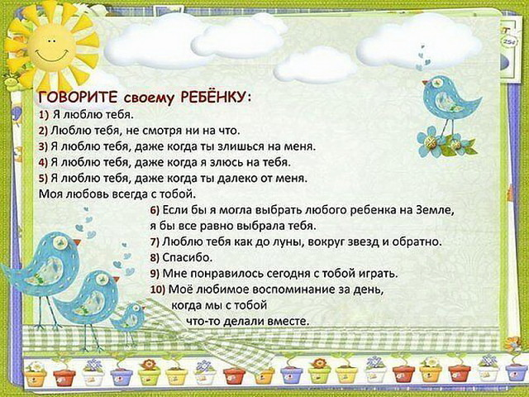](http://ok.ru/dk?cmd=PopLayerPhoto&st.layer.cmd=PopLayerPhotoOuter&st.layer.type=GROUP&st.layer.revNav=off&st.layer.limitedUi=false&st.layer.sphotoIds=812476016942;812476016686;812476016430;812476016174;812476015918;812476018734;812476018478;812476018222;812476017966;812476017710;812476017454;812476017198&st.layer.fre=on&st.layer.showNav=on&st.layer.photoAlbumId=56877625770030&st.layer.epm=off&st.layer.photoId=812476017966&st.layer.opl=off&st.layer.navStartPhotoId=812476017966&st.layer.sbd=off&st.cmd=friendStatuses&st.friendId=564822219613&st._aid=GroupTopicLayer_openPhotoLayer)

[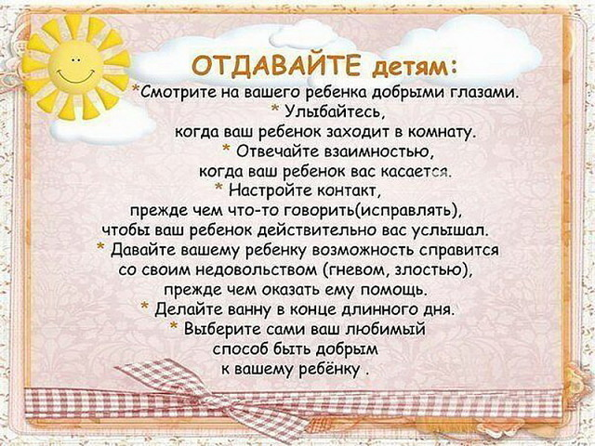](http://ok.ru/dk?cmd=PopLayerPhoto&st.layer.cmd=PopLayerPhotoOuter&st.layer.type=GROUP&st.layer.revNav=off&st.layer.limitedUi=false&st.layer.sphotoIds=812476016942;812476016686;812476016430;812476016174;812476015918;812476018734;812476018478;812476018222;812476017966;812476017710;812476017454;812476017198&st.layer.fre=on&st.layer.showNav=on&st.layer.photoAlbumId=56877625770030&st.layer.epm=off&st.layer.photoId=812476017710&st.layer.opl=off&st.layer.navStartPhotoId=812476017710&st.layer.sbd=off&st.cmd=friendStatuses&st.friendId=564822219613&st._aid=GroupTopicLayer_openPhotoLayer)

[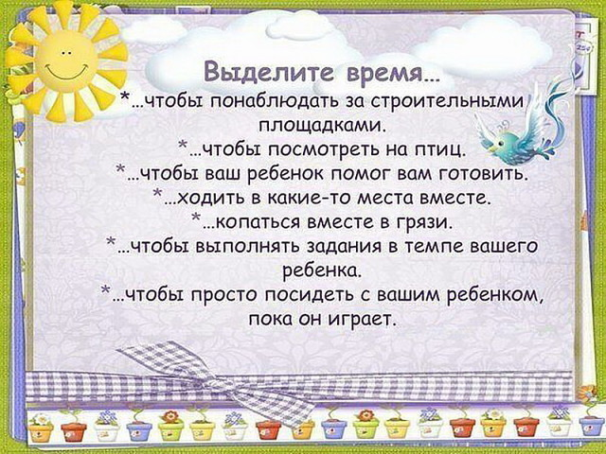](http://ok.ru/dk?cmd=PopLayerPhoto&st.layer.cmd=PopLayerPhotoOuter&st.layer.type=GROUP&st.layer.revNav=off&st.layer.limitedUi=false&st.layer.sphotoIds=812476016942;812476016686;812476016430;812476016174;812476015918;812476018734;812476018478;812476018222;812476017966;812476017710;812476017454;812476017198&st.layer.fre=on&st.layer.showNav=on&st.layer.photoAlbumId=56877625770030&st.layer.epm=off&st.layer.photoId=812476017454&st.layer.opl=off&st.layer.navStartPhotoId=812476017454&st.layer.sbd=off&st.cmd=friendStatuses&st.friendId=564822219613&st._aid=GroupTopicLayer_openPhotoLayer)

[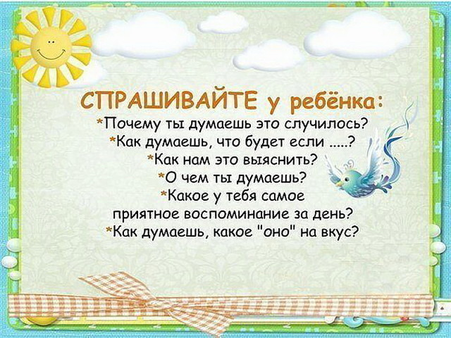](http://ok.ru/dk?cmd=PopLayerPhoto&st.layer.cmd=PopLayerPhotoOuter&st.layer.type=GROUP&st.layer.revNav=off&st.layer.limitedUi=false&st.layer.sphotoIds=812476016942;812476016686;812476016430;812476016174;812476015918;812476018734;812476018478;812476018222;812476017966;812476017710;812476017454;812476017198&st.layer.fre=on&st.layer.showNav=on&st.layer.photoAlbumId=56877625770030&st.layer.epm=off&st.layer.photoId=812476017198&st.layer.opl=off&st.layer.navStartPhotoId=812476017198&st.layer.sbd=off&st.cmd=friendStatuses&st.friendId=564822219613&st._aid=GroupTopicLayer_openPhotoLayer)