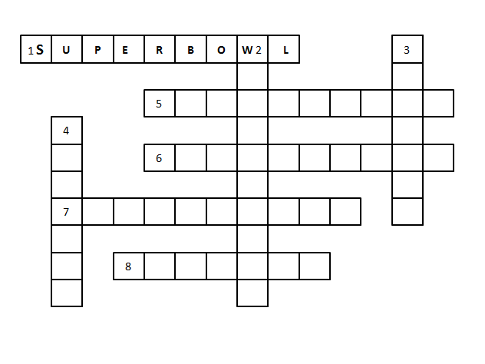
CLUES ACROSS
1 An American football match.
5 A tall building.
6 A state on the West Coast of the USA.
7 The capital of the USA.
8 The biggest city in the USA.

CLUES DOWN
2 An American president’s name.
3 The United States of _____________
4 A tall tree.

CLUES ACROSS
1 An American football match.
5 A tall building.
6 A state on the West Coast of the USA.
7 The capital of the USA.
8 The biggest city in the USA.

CLUES DOWN
2 An American president’s name.
3 The United States of _____________
4 A tall tree.

