«Муниципальное бюджетное общеобразовательное учреждение «Верхнесиметская средняя общеобразовательная школа Сабинского района Республики Татарстан»

научно исследовательская работа по теме:

«Влияние английского языка на различные сферы жизни

человека».

“The influence of English Language in different spheres of human activity”.

Выполнила: ученица 9 класса
Шакирзянова Гульфина Наилевна
Научный руководитель:
учитель английского языка
Низамиева Алина Тагировна

2014/2015 учебный год

Content:
1. Introduction 3
1.1. The aim of our project 3
1.2. The hypothesis of our project 3
1.3. The urgency of the project 3
1.4. The practical importance 4
1.5. Object of study 4
1.6. Methods 4

2.English in the world 5
2.1. History of the English Language 5
2.2. Old English (450-1100 AD) 6
2.3. Middle English (1100-1500) 7
2.4. Early Modern English (1500-1800) 7
2.5. Late Modern English (1800-Present) 8
2.6. English as a global language 9
2.7. English in Education 10
2.8. English in Travelling 11
2.9. English and Jobs 12
2.10. Internet and Communication 14
2.11. English in Culture 17
3. Conclusion 18
Bibliography 19
Supplement
[1] A brief chronology of English
[2] English – Speaking Countries

1.Introduction
Today we are living in a "Global Village". As the Internet explosively grows, ever more people are becoming aware of this "Global Village" on a personal level. People correspond with others from around the globe on a regular basis, products are bought and sold with increasing ease from all over the word and "real time" coverage of major news events is taken for granted. English plays a central role in this "globalization" and it has become the de facto language of choice for communication between the various peoples of the Earth.
English is one of the world languages. It is the language of progressive science and technology, trade and business. It is the language of international aviation. It is also a major language of diplomacy. Hundreds of books, magazines and newspapers are printed in English. Half of the world’s literature is printed in English. English is spoken by 350 million people. Geographically it is the most widespread language on earth after Chinese. It is the official language of the UK, the USA, of Australia and New Zealand, it is used as one of the official languages in Canada, and in South Africa. Millions of people study and use English as a foreign language.
English also plays an important role in teenagers’ world. It is a dominant language in youth style and is one way which teenagers across the world can communicate with each other.
Learning a foreign language isn't an easy tiling. Nowadays it's especially important to know foreign languages. Some people learn languages because they need them for their work, others travel abroad, for the third studying foreign languages is a hobby.
1.1. The aims of our project are:
- to show up the scale of spreading and fields of use of English language
- to analyze the dynamics of their development
- to bring out the difficulties that our students face in learning English
- to draw the students’ attention to the needs of foreign companies.

1.2. The hypothesis of our project is that more and more people learn English as a foreign language.

1.3. The urgency of the project
English is the main way of communication among people nowadays. It is extremely important for being successful.

1.4. The practical importance
The materials of the project can be used at the English lessons. They can help to raise the motivation of our students in learning English. These materials can also draw the students’ attention to the needs of foreign companies.

1.5. Object of study.
We investigated the practical role of English language in various spheres of human activity, such as:
- Travelling
- Education
- Internet
- Jobs
- Culture

1.6. Methods of the research:

- Historical
- Statistical
- Survey
- Information retrieval

2. English in the World
2.1. History of the English Language

A short history of the origins and development of English.
The history of the English language really started with the arrival of three Germanic tribes who invaded Britain during the 5th century AD. These tribes, the Angles, the Saxons and the Jutes, crossed the North Sea from what today is Denmark and northern Germany. At that time the inhabitants of Britain spoke a Celtic language. But most of the Celtic speakers were pushed west and north by the invaders - mainly into what is now Wales, Scotland and Ireland. The Angles came from England and their language was called Englisc - from which the words England and English are derived.
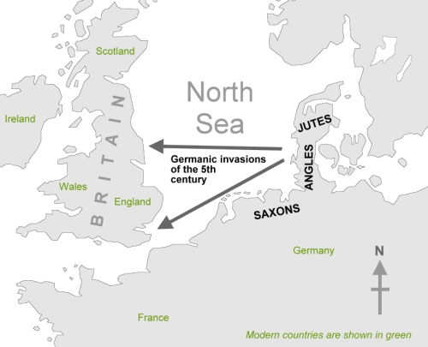
Germanic invaders entered Britain on the east and south coasts in the 5th century.

2.2. Old English (450-1100 AD)
The invading Germanic tribes spoke similar languages, which in Britain developed into what we now call Old English. Old English did not sound or look like English today. Native English speakers now would have great difficulty understanding Old English. Nevertheless, about half of the most commonly used words in Modern English have Old English roots. The words be, strong and water, for example, derive from Old English. Old English was spoken until around 1100.

Middle English (1100-1500)
In 1066 William the Conqueror, the Duke of Normandy (part of modern France), invaded and conquered England. The new conquerors (called the Normans) brought with them a kind of French, which became the language of the Royal Court, and the ruling and business classes. For a period there was a kind of linguistic class division, where the lower classes spoke English and the upper classes spoke French. In the 14th century English became dominant in Britain again, but with many French words added. This language is called Middle English. It was the language of the great poet Chaucer (c1340-1400), but it would still be difficult for native English speakers to understand today.

An example of Middle English by Chaucer.

2.3. Middle English (1100-1500)
In 1066 William the Conqueror, the Duke of Normandy (part of modern France), invaded and conquered England. The new conquerors (called the Normans) brought with them a kind of French, which became the language of the Royal Court, and the ruling and business classes. For a period there was a kind of linguistic class division, where the lower classes spoke English and the upper classes spoke French. In the 14th century English became dominant in Britain again, but with many French words added. This language is called Middle English. It was the language of the great poet Chaucer (c1340-1400), but it would still be difficult for native English speakers to understand.
An example of Middle English by Chaucer.

2.4. Early Modern English (1500-1800)
Towards the end of Middle English, a sudden and distinct change in pronunciation started, with vowels being pronounced shorter and shorter. From the 16th century the British had contact with many peoples from around the world. This, and the Renaissance of Classical learning, meant that many new words and phrases entered the language. The invention of printing also meant that there was now a common language in print. Books became cheaper and more people learned to read. Printing also brought standardization to English. Spelling and grammar became fixed, and the dialect of London, where most publishing houses were, became the standard. In 1604 the first English dictionary was published.

Hamlet's famous "To be, or not to be" lines, written in Early Modern English by Shakespeare.
2.5. Late Modern English (1800-Present)
The main difference between Early Modern English and Late Modern English is vocabulary. Late Modern English has many more words, arising from two principal factors: firstly, the Industrial Revolution and technology created a need for new words; secondly, the British Empire at its height covered one quarter of the earth's surface, and the English language adopted foreign words from many countries.
Today, American English is particularly influential, due to the USA's dominance of cinema, television, popular music, trade and technology (including the Internet). But there are many other varieties of English around the world, including for example Australian English, New Zealand English, Canadian English, South African English, Indian English and Caribbean English.
2.6. English as a global language
English is a language belonging to the Germanic languages branch of the Indo-European language family, widely spoken on six continents. The primary language of the U.S., Britain, Canada, Australia, Ireland, New Zealand, and various Caribbean and Pacific island nations, it is also an official language of India, the Philippines, and many sub-Saharan African countries. It is one of the most widely spoken languages in the world (approximately 1.5 billion speakers), the mother tongue of more than 350 million people, and the most widely taught foreign language.
English is one of the most widely spoken languages in the world. In more than 70 countries English is an official language (See supplement [2]). Estimates range from 309 million to over 400 million native speakers worldwide, and a very high number of people speak English as a second language. The British Council have forecast that there will be 2 billion learners of English as a foreign language by 2016.
According to research by the British Council, "English has official or special status in at least seventy-five countries with a total population of over two billion. English is spoken as a native language by around 375 million and as a second language by around 375 million speakers in the world. Speakers of English as a second language will soon outnumber those who speak it as a first language. Around 750 million people are believed to speak English as a foreign language*. One out of four of the world's population speak English to some level of competence. Demand from the other three-quarters is increasing."
English Speakers in the World
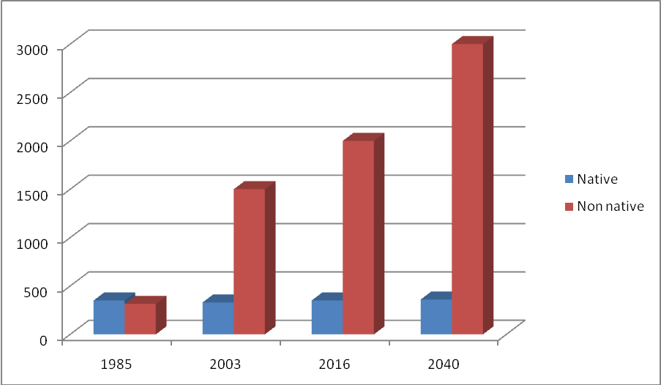

Here is the proportion of native and non-native speakers of English. In 1985 there were between 320 and 380 mln people speaking English as the first language and between 250 and 380 mln people who speak English as a second or third language. By 2003 the balance had changed and there were 329 mln native speakers in comparison to 1.5 billion non-native speakers using English for communication. We have noticed that English is spoken by at least a quarter of the worlds population. It is important to realize that this means that it’s not spoken by three quarters of that same population. Even if this number (75%) is not going to be converted to “users of English, non-native speakers” – because of a big number of Mandarin, Spanish, Hindu and Arabic speakers – we will still have a good a big number of students willing to learn English. Statistics analysts say that by the year of 2040 there will 3 billion people speaking English as a foreign language. At the same time they say that around 40% of world’s population will hardly become functional users of English.
English is the language most often studied as a foreign language in the European Union, by 89% of schoolchildren, ahead of French at 32%, while the perception of the usefulness of foreign languages amongst Europeans is 68% in favour of English ahead of 25% for French. Among some non-English speaking EU countries, a large percentage of the adult population can converse in English — in particular: 85% in Sweden, 83% in Denmark, 79% in the Netherlands, 66% in Luxembourg and over 50% in Finland, Slovenia, Austria, Belgium, and Germany.
2.7. English in Education
Most of the universities worldwide include English as one of their major subject. If you are a student, it is almost inevitable that you will come across an important book in English. On the other hand, it is unlikely that you won't find an important book or an article that was not translated into English. English is the universal Internet language: many foreign websites have English versions. Learning English will improve you chances to graduate with a higher score. If you learn English, you will be able to get your degree abroad because many foreign universities offer programs in English.

Our research.
We wanted to find out what problems the students have in studying English. We asked students and analyzed their answers.
Most of the students mentioned idioms and phrasal verbs (about 80%) and irregular forms (about 70%). About 65% told that spelling is rather difficult for them. 40% of students have difficulties with pronunciation. About 55% have problems with grammar. On the other hand English punctuation is not too difficult for them. Only 30% of students have problems with it.
Difficulties in Learning English among Our Students
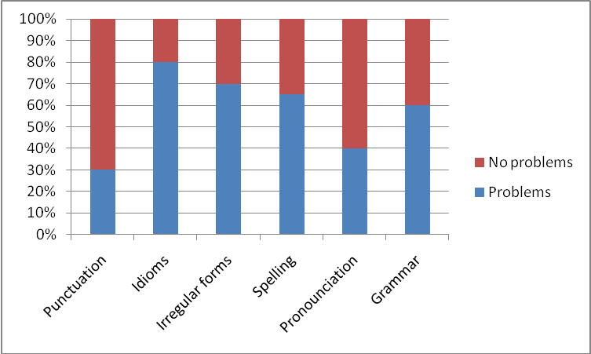
2.8. English in Travelling
For many people tourism is one of the most exiting activity in the world. It broadens our minds. We have an opportunity to meet interesting people, go sightseeing, learn fascinating traditions.
Even if you go to another country where you don't speak the native tongue and the country's primary language is not English, you probably will be able to find someone who can speak at least a little English. More than 900 million people in the world are either native English speakers or speak English as a second language. If you know English, you have a chance to communicate almost anywhere you travel.
If you don't know the language of the country you are traveling to, you might not end up enjoying your trip. However, knowing English is enough to go by in most big cities in the world. All major airports have directions in their native language and in English.

2.9. English and Jobs
English is very important to find a good job. The job market today is very competitive. If you learn English you will improve your chances of getting a dream job or simply a job that pays more. Many computer applications exist only in English; learning the language will help you use your computer more efficiently. If you own a business, English proficiency will help you grow it. All international business is done in English. You will be able to go to international business meetings and read international business newspapers and magazines.
Some businesses that deal with international clients and suppliers rely on English-speaking employees to help with day-to-day operations to interpret, translate and communicate directly with English-speaking customers and clients. Being fluent in English can improve employment opportunities. International business is done in English and all business today is international. So if you want to play, you have to know English — to contact other businesspeople, go to conferences, read international business newspapers and magazines, etc.
If you know English you can become a better scientist. You can contact scientists from other countries, go to international conferences, visit academic centers abroad. You can also learn about new scientific discoveries by reading papers, books, and magazines.
Almost all international conferences and competitions are conducted in English. For example, the Olympics and the Miss World contest. Diplomats and politicians from different countries use English to communicate with each other. English is the main language of organizations like the United Nations, NATO, and the European Free Trade Association.

The results:

79 % of people have difficulties in participation in meetings.

77 % of people have difficulties in communication with foreign business partners

74 % of people have problems with communication on the phone

70 % of people - in making presentations

54 % of people - in writing formal letters

48 % of people – in processing of information streams

40 % of people – in following oral and written instructions

32 % of people – in reading of specialized magazines

27 % of people – in documentation reading
So, we came to the conclusion that anyone who intends to work in a foreign company should pay attention to these skills.
2.10. Internet and communication
The main language used throughout the world on the internet is English. Most pages on the Web are in English. That's over a billion (1,000,000,000) pages of information! It's amazing that learning just one language gives you access to almost all knowledge on the Internet.The media that make up the Internet are overwhelmingly American in origin, so it is no wonder that the mother tongue of the Web is English. Four factors determine the degree to which a given language finds use on the Internet:
1. The number of users of the language
2. The extent of its use as an official language
3. The economic power of the language
4. The volume of information disseminated in that language
Today, English reigns supreme in all four respects. It is studied as a foreign language throughout the world and employed by a majority of Internet users. Of the 163 member nations of the U.N., more use English as their official language than any other. The easiest way to calculate the economic influence of a language may be to add up the gross domestic products (GDP) of all the nations where it is spoken. People who count English as their mother tongue make up less than 10% of the world's population, but possess over 30% of the world's economic power. Therefore, in terms of the quantity of transmitted information, English is the leader by far. After English, 26 nations in the U.N. cite French as their official tongue, 21 Spanish and 17 Arabic. Each of these three languages forms a sizable linguistic constituency on the Internet.
Top Ten Languages Used in the Web
( Number of Internet Users by Language )
TOP TEN LANGUAGES  IN THE INTERNET | Internet Users  by Language | Internet  Penetration  by Language | Growth  in Internet  (2000 - 2010) | Internet Users  % of Total | World Population  for this Language  (2010 Estimate)
English | 536,564,837 | 42.0 % | 281.2 % | 27.3 % | 1,277,528,133
Chinese | 444,948,013 | 32.6 % | 1,277.4 % | 22.6 % | 1,365,524,982
Spanish | 153,309,074 | 36.5 % | 743.2 % | 7.8 % | 420,469,703
Japanese | 99,143,700 | 78.2 % | 110.6 % | 5.0 % | 126,804,433
Portuguese | 82,548,200 | 33.0 % | 989.6 % | 4.2 % | 250,372,925

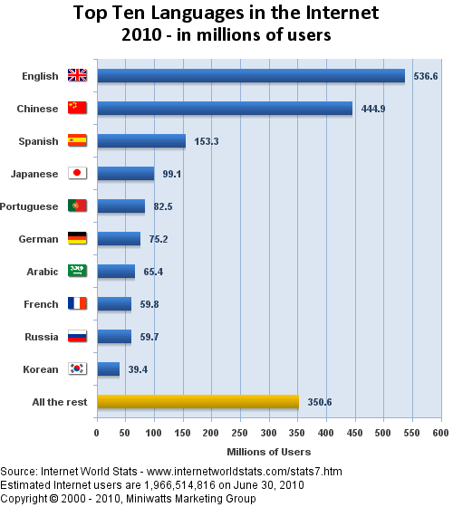

Generally speaking, English is the universal language on the Internet, but it has no official status, and it will never have. The reasons for the position of English are the imperialism and economical and political importance of English-speaking countries.
The importance of the Internet grows rapidly in all fields of human life, including not only research and education but also marketing and trade as well as entertainment and hobbies. This implies that it becomes more and more important to know how to use Internet services and, as a part of this, to read and write English.
But although Internet services themselves are, generally speaking, easy to learn and use, you will find yourself isolated on the Internet if you are not familiar with English. This means that knowledge or lack of knowledge of English is one of the most severe factors that cause polarization. Learning to use a new Internet service or user interface may take a few hours, a few days, or even weeks, but it takes years to learn a language so that you can use it in a fluent and self-confident manner. Of course, when you know some English, you can learn more just by using it on the Internet, but at least currently the general tendency among Internet users is to discourage people in their problems with the English language. Incorrect English causes a few flames much more probably than encouragement and friendly advice. In different countries and cultures, English has different positions. There are countries where English is the native language of the majority, there are countries where English is a widely known second language, and there are countries where English has no special position. These differences add to the above-mentioned polarization. Specifically, it is difficult for people in previous colonies of other countries than Great Britain (e.g. France, Spain, the Netherlands) to adapt to the necessity of learning English. Locally, it may be necessary to learn the language of the previous colonial power since it is often an official language and the common language of educated people; globally, English is necessary for living on the Internet. And the more languages you have to learn well, the less time and energy you will have for learning other things.
Almost all international conferences and competitions are conducted in English. For example, the Olympics and the Miss World contest. Diplomats and politicians from different countries use English to communicate with each other. English is the main language of organizations like the United Nations, NATO, and the European Free Trade Association.
If you can communicate in English, you can contact people from all over the world. Talk about your ideas and opinions on Internet discussion groups. Send e-mail to interesting people. Learn about their life and culture.
2.11. English in Culture
English language is a wonderful language. It's the language of the great literature. It's the language of William Shakespeare, Charles Dickens and others. Half of the world's scientific literature is in English. The great German poet Goette once said, "He, who knows no foreign language, doesn't know his own one". That's why in order to understand oneself and environment one has to learn foreign languages.
Many movies and popular songs are in English. If you learn English, you will be able to watch Hollywood movies in original non-dubbed version, and you will understand what famous songs are about. Almost all international events are conducted in English, from the Olympic games to the Miss Universe beauty pageant. Knowing English will give you an opportunity to communicate with people from all over the world. You will be able to join interesting Internet discussions forum, share your ideas and learn new things.
Speaking a foreign language you can read papers, magazines and original books by great writers, watch satellite TV Programs.
You can read books by British or American authors, and books translated from other languages. Whatever you're interested in, you can read about it in English.
English lets you feel the culture of the world like no other language. With a good knowledge of the English language, you can do wonderful things:
Watch American and British films in the original. Once you try it, you'll never go back to dubbed versions!
Read great books. Every famous book was written in English or it was translated into English. There is an amazing number of titles — from classic plays like Hamlet to modern thrillers like Jurassic Park.
Enjoy English-language music more. Music is much better if you can understand the words.

3. Conclusion
The materials of the project gave us the opportunity to conduct the research of character and degree of influence of English language on people’s life in the modern world. English language spreading is also has the essential features.
We’ve defined the main stages in historical development of English language. The scale of spreading of English language in the world is constantly increasing. English is a native language for more than 350 mln people. It is an official language in more than 70 countries. In everyday life English is used by almost 2bln people. The areas of English use are extending all the time. It is used in scientific, practical and social spheres of life. The most widely it is spread on the Internet, educational and tourist spheres.
We’ve analyzed the information about the past and future of English language and proved that it is the main means of modern international communication.
We have held the research on the difficulties in learning English among the students of our school. According to the results we have learnt that the most problems our students have with idioms, irregular forms and phrasal verbs. At the same time English punctuation is not too difficult for them. Only 30% of students have problems with it.
The other research was devoted to the problems which Russian employees face in foreign companies. We analyzed their demands and problem areas. We came to the conclusion that anyone who intends to work in a foreign company should pay attention to the skills which are necessary for their work.
The materials of the project can be used at the English lessons. They can help to raise the motivation of our students in learning English. These materials can also draw the students’ attention to the needs of foreign companies.

Bibliography

1. Г. Гумовская «LSP. English of Professional Communication / Английский язык профессионального общения»-М.: Аспект Пресс, 2008

2. В. Д. Аракин «История английского языка» -М.:ФИЗМАТЛИТ, 2009 г.

3. К. Бруннер «История английского языка»-М.:ЛКИ, 2010 г.

4. Д. Кристал «Английский язык как глобальный»-М.:Весь Мир, 2001 г.

5. http://www.guruken.ru/katal/297.html

6. http://www.iqschool.ru/articles/communicative_method/

7. http://www.englishplus.ru/category/anglijskij-yazyk/

8. http://www.br.com.ua/articles/34

9. http://www.kolomnareg.ru/raion/694-news.php

10. http://www.internetworldstats.com/stats7.htm
11. http://en.wikipedia.org
12. https://www.cia.gov/library/publications/the-world-factbook
13. http://www.worldatlas.com
14. http://www.vec.ca/english/2/culture.cfm

