|  |  |  |  |  |
| --- | --- | --- | --- | --- |
| 16 | http://deti-online.com/images/raskraski/raskraski-dlya-malyshey--derevya--17.jpg19 | 6 | 15 | 30 |

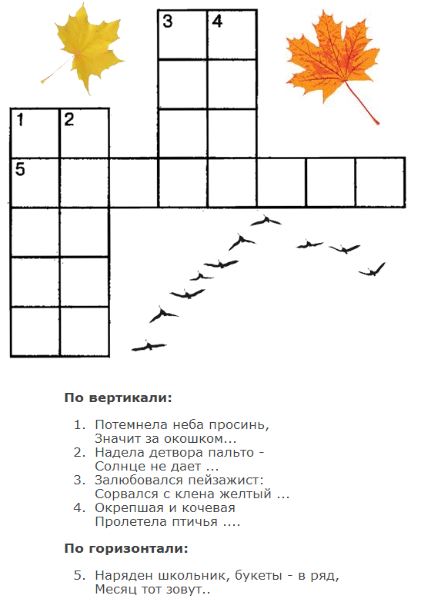



|  |  |
| --- | --- |
| 1 |  |
| 2 |  |
| 3 |  |
| 4 |  |
| 5 |  |
| 6 |  |
| 7 |  |
| 8 |  |
| 9 |  |
| 10 |  |

|  |  |
| --- | --- |
| 1 |  |
| 2 |  |
| 3 |  |
| 4 |  |
| 5 |  |
| 6 |  |
| 7 |  |
| 8 |  |
| 9 |  |
| 10 |  |

|  |  |  |  |  |
| --- | --- | --- | --- | --- |
| 16 | http://nsportal.ru/sites/default/files/2012/3/listya_1.jpg19 | 6 | 15 | 30 |