**Открытый урок по теме «Семья», 3 класс.**

1. Good afternoon, dear children. My name is Tatyana Petrovna. And today I’m going to be your teacher.
2. Please, look at the pictures on the screen and tell me what the topic of our lesson is? (slide 1)

Right. That’s Family.

So today we’re going to read and talk about our families. (2 min.)

1. First of all, let’s revise family members. Look at the board and name the characters (slides2-9) (2 min)
2. Good. Now when we remember all the family words. Let’s read about my friend’s family.

Here are the texts. There is a family tree above the story. As you see it has some gaps. Please, look through the text and write the names in the boxes. (you have 2 minutes to do it).

Ok. Let’s check. Thank you.

1. Now let’s read it all together (1 абзац - 1ученик). (5 min.)
2. Do you like the story? Then answer my questions, please.

* *What animals have grandparents got?* cows, pigs and chickens
* *Who has got the most beautiful garden?* mother
* *How many children do Emma and Ben have?* Three
* *What does Julia like to do?* She likes to play with her dolls, blocks and puzzles
* *What is Lisa?* – a teacher
* *Who is a cook?* – uncle Ted.
* *How many cousins has Alice got?* Three (5 min.)

1. Match family members and the pictures. And say what they like to do (4 min.)

Julia likes to play with her dolls.

Alice likes to write letters.

Mother Emma likes flowers.

Lisa likes to teach.

Father Ben likes fishing.

Grandpa John likes his farm.

Brother Mark likes computer games.

Uncle Ted likes to cook.

1. Good job! Are you tired? Let’s do some exercise. I will read a sentence from the text if it’s true – stand up, if it’s not true sit down. Are you ready. So listen (3 min)

|  |  |
| --- | --- |
| 1. My grandparents live in a town. | 5. My brother plays with puzzles. |
| 2. My grandpa has got farm animals. | 6. My sister is older than me. |
| 3. My brother likes fishing. | 7. My aunt has got one daughter. |
| 4. I have got a sister. | 8. My cousin has got many friends. |

**3.** 1F, 2T, 3F, 4T, 5F, 6F, 7T, 8T

Well done!

1. Unscramble family words and find the hidden message. (5 min.)

parents

brother

children

father

son

sister

daughter

grandparents

uncle

grandpa

mother

grandma

child

family

aunt

**I LOVE MY FAMILY.**

10.and do You love your families? Then tell me about them. I offer you to make your own family trees.

You have 8 leaves.

Draw your family members.

Cut the leaves.

Glue them to the tree.

There is an example on the board.

And on the other side of the paper write 2-3 sentences about your relatives. (7min.)

Ok. Now I’d like to listen to about your families. Go to the board and tell us about your families. (7 min.)

1. Thanks a lot. I like your projects and to thank you I want to play BINGo with you.

You’ve got a chart. Please, write down 5 any family words in it.

I’m going to say words – if you have a word – just cross it out. When you’ve crossed all 5 words – stand up and say bingo! (5 min)

1. Thank you for the lesson. I hope you liked it because I did!

Goodbye.

Раздаточный материал

meet my family

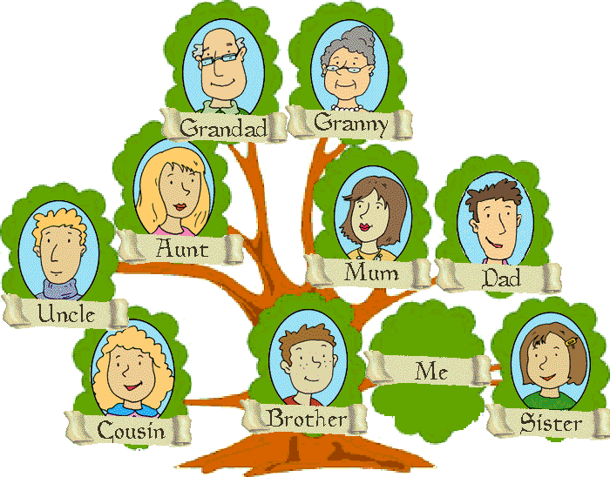

**1. Read and write the names in the boxes.**

My name is Jane. I am 10 years old. I have a big family. And I want to tell you about it.

My grandpa and my grandma live on a small farm. They're old. My grandpa's name is John and my grandma's name is Amelia. They have got many farm animals like cows, pigs and chickens.

My mum Emma likes flowers very much. She has got the most beautiful garden. My dad's name is Ben. He likes fishing.

I have got one brother and a sister. My brother is 12 years old and he plays computer games all day. His name is Mark. My sister is younger than me. She likes to play with her dolls, blocks and puzzles. Her name is Julia. She is 8 years old.

My uncle and aunt live in a big town. My aunt's name is Lisa. She is a teacher. She works at school. My uncle's name is Ted. He is a cook. They have got a daughter. She is my cousin. Her name is Alice. She likes to write letters. She has got friends all over the world.

**2. Match family members with the pictures.**

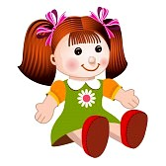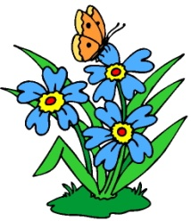****

****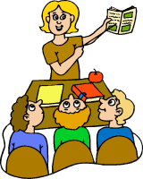



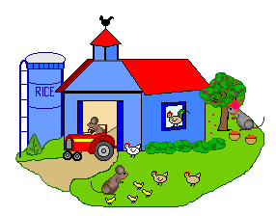

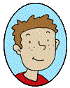

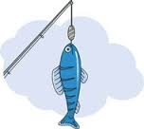



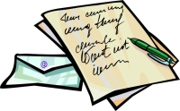

**3. Unscramble family words and find the hidden message.**

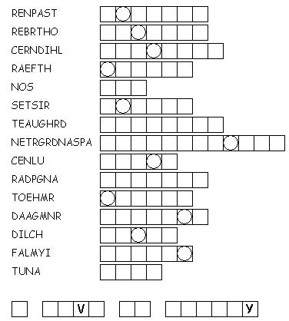

## The Family Bingo

|  |  |  |
| --- | --- | --- |
| **B I N G O** | | |
|  |  |  |
|  | **http://jennellestewart.com/websp10/gevork/images/family.jpg** |  |
| B I N G O | | |
| http://jennellestewart.com/websp10/gevork/images/family.jpg |  |  |
|  |  |  |