Рубежный контроль по английскому языку в 5-х классах
22.12.2015
N. Surname____________________________
Form__________________________________

I Listening (W-B ex.4, p. 29)  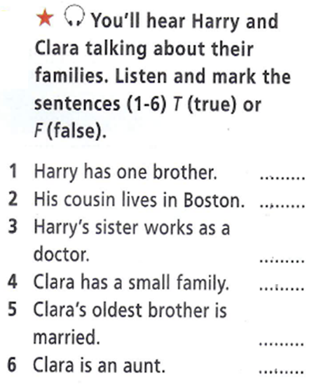 | II Writing  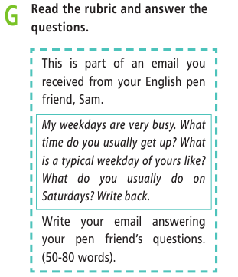

E-mail:
____________________________________________________________________________________________________________________________________________________________________________________________________________________________________________________________________________________________________________________________________________________________________________________________________________________________________________________________
______________________________________________________________________________________________________________________________________________________________________________________________________________________________
____________________________________________________________________________________________________________________________________________________
__________________________________________________________________________
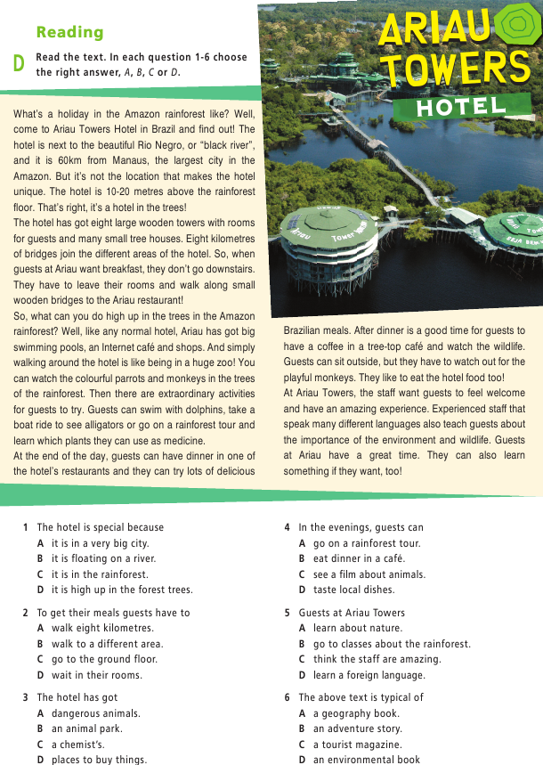
III Reading

1-5

Keys
I Listening
1 F
2 T
3 F
4 F
5 T
6 T

III Reading
1 D
2 A
3 B
4 D
5 A

