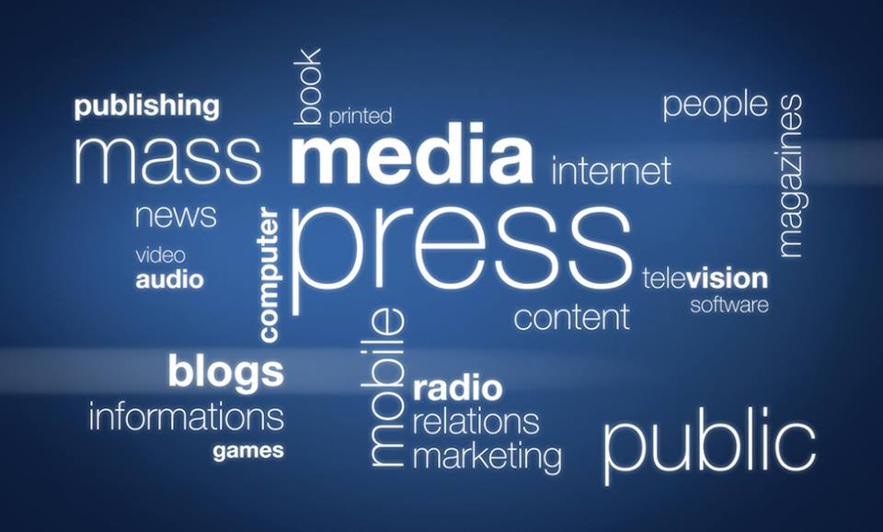

Мероприятие на тему “Mass Media” на английском языке в 9 классе

Задачи
практические:
- формирование навыков коммуникативной компетенции в чтении, говорении, аудировании, письме;
- расширение запаса слов;
- коррекция фонетических навыков;
развивающие
- развитие творческих способностей обучающихся;
- развитие самостоятельности;
- развитие памяти, мышления, воображения;

воспитательные

- повышение мотивации к изучению иностранного языка;
- воспитание чувства взаимопомощи, умения работать в команде;
образовательные
- знакомство с печатными изданиями Великобритании, т.е. развитие социокультурной компетенции;

УУД (универсальные учебные действия)

- определение тематического поля;
- целеполагание;
- умение планировать деятельность;
- умение создать продукт и презентовать его;
- умение работать с информацией из разных источников;
- умение рефлексии;
- умение работать в команде.

Ход урока:

1. Оргмомент
Good afternoon, girls and boys! I am glad to see you! Sit down, please! Today we live in the time of information. Where can we get information? What Mass Media do you know?
2. «Мозговой штурм»: виды СМИ
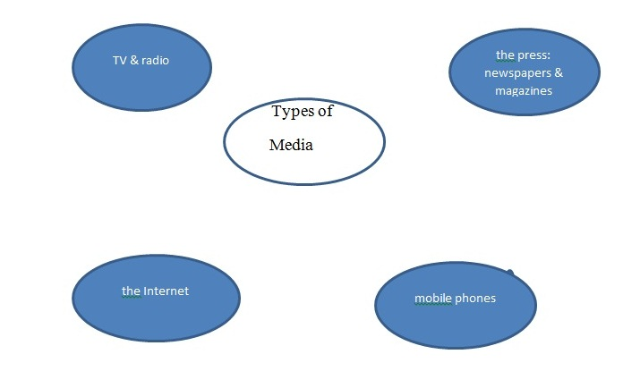
3.Фонзарядка с одновременным просмотром текста на слайде презентации:
Speak all together after me, please!
Newspaper, paper, tabloid, quality paper, heavy paper, local paper, magazine, feature, brochure, rag, “The Guardian”, “The Financial Times”, foreign correspondent, columnist, review, front page, was mentioned, broadsheet, sheet of paper, to be in charge of, to be divided into, an editor, a creative director, a proof reader, a designer,, section, low/high opinion.
4.Знакомство с печатными изданиями Великобритании (презентация Power Point)
Look at the presentation and remember which newspapers are printed in GB. You should answer some questions after it:
- What popular British newspapers do you know?
- What quality British newspapers can you remember?
- What types of media are used for broadcasting news?
- What is the home of British press?
- Which 2 groups are British papers divided in?
- What other types of papers were mentioned?
5. Практика чтения (Работа в группах “Matching-exercise”)
Match the words with the right description!
Group “PINK” (1-8) & Group “GREEN” (9-16)
1 brochure | a) a newspaper with small pages, short articles and lots of photos;
2 rag | b) a newspaper that is printed on large sheets of paper; is considered to be more serious than other papers;
3 tabloid | c) a magazine or booklet with pictures that gives information about a product or service;
4 broadsheet | d) people refer to a newspaper as a rag when they have low opinion of it;
5 review | e) one of the parts into which a newspaper is divided
6 front page | f) the title of a newspaper story, printed in large letters at the top of it;
7 section | g) a report in a newspaper or magazine in which someone gives their opinion of a new book, film, concert ect.
8 headline | h) a front page article or picture appears on the front page because it’s very important or interesting;
9 article | i) a correspondent who sends news reports from a foreign country;
10 feature | j) the person who is in charge of a newspaper and who decides what will be published in it;
11 supplement | k) a journalist who is in charge of a particular section of a newspaper;
12 reporter | l) some sensational information catching everybody’s attention;
13 editor | m) someone who writes new articles or reports;
14 journalist | n) a prominent or special article or section in a periodical;
15 columnist | o) a piece of writing in a newspaper or magazine;
16 foreign correspondent | p) a person whose job is to collect news or other information and write about it or talk about it on TV or radio;
6. Проверка работы в группах по ключу в презентации: Now take pens or pencils of another color and check your work, correct if you find mistakes!
7. Создание продукта и его защита:
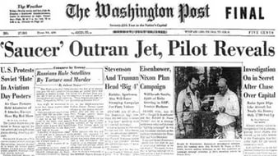
Let’s create our own newspapers.

You are divided into 2 groups.

Each group has a sheet of paper, some articles , pictures for making a poster.
Decide who will be an editor, a designer, a proof reader, a secretary, a correspondent.
Choose information and create a front page of your own paper.
One of you will be ready to present your work and tell us about your mass media.
Help each other and good luck!
Roles:
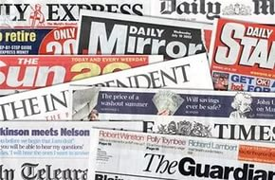
- an editor –is in charge of a newspaper and decides what will be printed
- a creative director – generates smart ideas;
- a designer – makes the poster look attractive;
- a proof reader – checks for mistakes;
- a presenter – presents the poster when it is finished;
- a secretary – does technical work;
- a foreign correspondent – collects news from a foreign country;

Предполагаемый рассказ ученика:
Our newspaper is called “ Tabloid Teen”.

It is a tabloid. It is devoted to some events in GB.
On the front page you can find information about the Queen, popular singers, sport events ect.
The feature is an article about a popular actor.
You can see his photo here. The columnist tells us about teens' problems.
There is a humor corner with funny pictures and jokes.
Health, education and accidents are mentioned, too.
The newspaper publishes a lot of adverts.
They advise us to buy computers, mobile phones and so on.
In my opinion the tabloid is worth spending time.
9.Домашнее задание: составить мини-словарик по теме «СМИ»
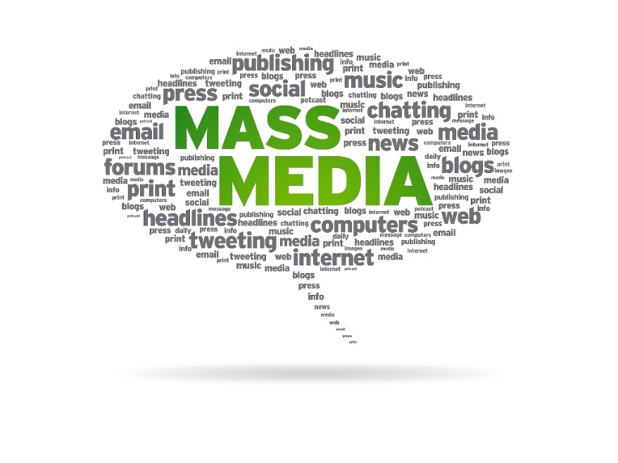
My “Mass-Media” mini-dictionary
Aa – advertisement
Bb – broadcast, brochure
Cc – CNN, chat room, chat show, creative director
…

