Christmas in Great Britain
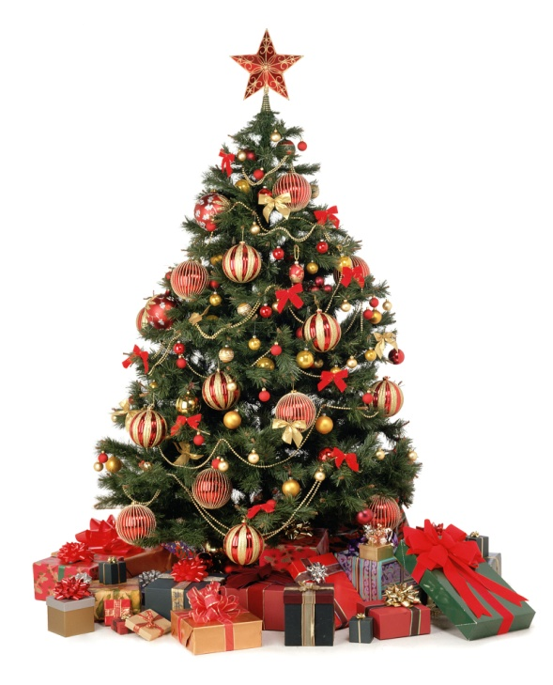
Christmas Day, December 25, is probably the most popular holiday in Great Britain. It is a family holiday. Traditionally all relatives and friends give each other presents. So, before Christmas all the department stores and shops are crowded, everybody is choosing a present.
In general, people get prepared for this holiday very carefully. They decorate their houses in the traditional way. Christmas trees are set up in houses, in the streets and churches. They are always decorated with fairy lights, angels and small toys. In addition, little packets with nuts, candies and special biscuits are hung on the tree. Presents are put around the tree and artificial «frost» is scattered over the branches.
In Great Britain, the Christmas tree became popular while Queen Victoria ruled the country.
Besides the Christmas tree, 12 30 Мошкин
are used to decorate the house. Branches of holly are put up behind pictures and mistletoe is hung over doors, so the young people have a chance to kiss the girls under it, plucking each time a red berry from the mistletoe. It is said that the girl who was not kissed under it at Christmas would not get married that year.
On the eve of Christmas children hang their stockings, so that Santa Claus could put presents into them: oranges, sweets, nuts and if the child didn't behave properly Santa Claus can put there a piece of coal as punishment.
Usually children come around in the evening to the front doors and start singing carols and people who live in these houses give children candies, nuts, pies and so on, to thank them for carol singing.
A typical Christmas lunch includes turkey and pudding. Every young woman in each household helps to stir the Christmas pudding, if she wishes to be married that year. Usually a coin or two are hidden inside the pudding and part of the fun is to see who finds it.
After the lunch they go to the sitting room to listen to the Christmas speech of the Queen, shown on TV.
So, Christmas is a merry family holiday for all the people of Great Britain. Christmas comes but once a year.

