***Healthy Food***

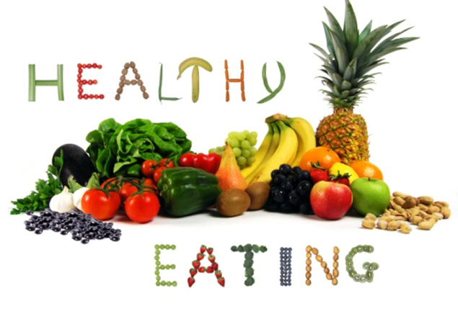

**All food is made up of nutrients which our bodies use. There are different kinds of nutrients: carbohydrates, proteins, fats, vitamins and minerals. Different foods contain different nutrients.**

**Before we cut down on fat, sugar and salt, we have to know a bit more about the kind of food these things might be in. The biggest problem comes when these things are hidden in other foods: biscuits, crisps, sausages, meat pies, soft drinks and so on**.

The best way is to get into the habit of checking the ingredients and nutritional value on the sides of packets although this isn't always easy to do. Another thing to know is, for example, that we do need fat to live, it's an essential part of our diet and physically we couldn't exist without it.

But we all know that to eat much fat is bad for our health. The matter is that there are different kinds of fat. There are fats that are good for us and fats that are bad for us. Eating less of the bad ones and more of the good ones can actually help us to live longer! Bad fats are the saturated fats, found in animal productions, like red meat, butter and cheese.

Friendly fats are the unprocessed fats found naturally in foods like nuts and seeds, olives, avocados and oily fish, including tuna.

One more thing to know is that when food is cooked, its structure changes. It can change the vitamin and nutrient contents of food.

More and more people feel strongly about the way, their food is produced. Nowadays so much of the basic food we eat — meat, fish, fruit and vegetables — is grown using chemicals and additives.

Although fertilizers and pesticides have greatly increased the quantity of food and helped to improve its appearance, there is a growing concern about the effects of these chemicals in the food chain. This concern has led to a growth in the demand for organically grown products.

Today there is another problem. It is modified food, which is cheaper that ordinary one. There is a rumour that such food can cause cancer and other problems. Nobody knows, either it is just an imagined fear or a real problem. This problem could be solved and examined, but it will take some time.

The food we eat, depends on lots of things. Taste is a big factor. Culture, religion and health also play a part in what food we eat. Advertising and social factors also have a big influence.

Income is also an important factor. That is why not surprisingly, money, rather than a lack of knowledge about how to eat well, is at the heart of the problem.  
Finally, there are three main messages to follow for healthy eating:  
First, we should eat less fat, particularly saturated fat.  
Secondly, we are to cut down on sugar and salt.  
Thirdly, we must eat more fresh fruit and vegetables.

**Questions:**

1. What nutrients do you know?  
2. What are the main things to know about food we eat?  
3. What fats are good?  
4. What fats are dangerous for our health?  
5. What are the main factors that determine the food we eat?  
6. What are three main messages to follow for healthy eating?

**Vocabulary:**

nutrient — питательное вещество  
carbohydrate — углевод  
protein — белок, протеин  
fat — жир  
to contain — содержать  
to cut down on —уменьшить прием чего-л.  
to hide (past hid, p.p. hidden) — прятать, спрятать   
crisp — ломкий, хрупкий  
to get into the habit of —взять за привычку   
essential — существенный, жизненно важный   
saturated fat — жиры с высоким содержанием насыщенных жирных кислот   
butter — масло  
unprocessed fat — необработанные жиры   
seed — семя, семечко   
avocado — авокадо, аллигаторова груша   
tuna — тунец   
additive — добавка  
fertilizer — удобрение   
pesticide — пестицид, ядохимикат   
to increase — увеличить   
to improve — улучшить  
concern — интерес, участие, заинтересованное отношение   
food chain — пищевая цепочка  
to lead (past led, p.p. led) — вести, приводить   
demand — потребность   
modified food — модифицированная еда   
rumour — молва, слух(и), слушок, толки   
to cause — быть причиной, вызывать   
cancer — рак (онкология)   
fear — страх, боязнь, опасение   
to solve — решать   
to depend on — зависеть от   
income — прибыль; заработок   
lack — недостаток, нужда; отсутствие чего-л.