**Date_________________________________________Name__________________________________________**

**Form_____________**

**Mark_____________**

**Итого баллов _________ (50)**

**Итоговый тест по английскому языку**

**для учащихся 4-ых классов**

**1. Прослушайте и выберите правильный вариант ответа.**

***Example: What’s Dan’s favourite subject?***

***a) sports b) P.E. c) English***

**1**. When is the History lesson?

**a)** Monday **b)** Wednesday **c)** Friday

**2.** What’s in the pencil case?

**a)** an eraser **b)** a ruler **c)** a pen

**3.** How old is John?

**a)** 14 **b)** 40 **c)** 4

**4.** What school is Sam at?

**a)** Green **b)** Merton **c)** Hill

**5.**Where is the Art lesson?

1. Room A **b)** Room D **c)** Room F

________ (5 баллов)

**2. Выберите и обведите правильный вариант.**

**1**. These tomatoes are bad. Don't buy______ .

**a)** they **b)** it **c)** them **d)** its

**2**. There _____ a train in the box.

**a)** was **b)** were **c)** aren’t **d)** are

**3.** Dan and Mary _____ go to the shop every day.

**a)** gos **b)** go **c)** goes **d)** are going

**4.** Eat these oranges. ______ good for you.

**a)** Are there **b)** They are **c)** There are **d)** its are

**5.** There is … juice in the bottle.

**a)** any **b)** some **c)** a **d)** an

**6.** Look! My little brother ________ at a pig.

**a)** looks **b)** look **c)** is looking **d)** are looking

**7.** The boots ____ in the box.

**a)** is **b)** have **c)** are **d)** was

**8.** Do you often meet those ____?

**a)** woman **b)** policeman **c)** sportsman **d)** sportsmen

**9.** Mary ____ her Music classes.

**a)** is liking **b)** don't like **c)** doesn’t like **d)** like

**10.** She never ____ his books.

**a)** take **b)** takes **c)** doesn't take **d)** don’t take

**11.** What ____ in the box?

**a)** there is **b)** is it **c)** is there **d)** there are

**12**. ______ he like P.E.?

**a)** Don’t **b)** Do **c)** Is **d)** Does

**13**. We _______ got any eggs to make an omelette.

**a)** have **b)** are **c)** haven’t **d)**aren’t

**14**. Look at _____ cake! It’s so nice.

**a)** it **b)** these **c)** those **d)** this

**15**. Martin _____ a good singer.

**a)** aren’t **b)** has got **c)** hasn’t got **d)** is

**16.** We like to play with _____ toys.

**a)** my **b)** we **c)** their **d)** our

**17.** There is ______ milk in the fridge.

**a)** a **b)** some **c)** any **d)** an

**18**. We haven’t got ______ lessons.

**a)**much **b)**a lot of **c)** many **d)**some

**19.** ______ there many monkeys at the zoo?

**a)** Have **b)** were **c)** is **d)** was

**20.** I don’t like _______ sugar in my tea.

**a)** much **b)**many **c)**some **d)**a lot of

______ (20 баллов)

**3. Напишите следующие предложения во множественном числе.**

1. This box is blue.

______________________________________________________________________________________

2. There was a toy under the bed.

______________________________________________________________________________________

3. He is a policeman.

______________________________________________________________________________________

4. Jenny’s photo is nice.

______________________________________________________________________________________

5. She has got a child.

______________________________________________________________________________________

6. That wolf is angry.

______________________________________________________________________________________

7. Is there a radio on the table?

______________________________________________________________________________________

8. Was there a glass in the kitchen?

______________________________________________________________________________________

9. This fox is red.

______________________________________________________________________________________

10. That cherry is sweet.

______________________________________________________________________________________

______ (10 баллов)

**4. Опишите картинку, используя выражения *There is или There are* (не менее одного раза) и следующие предлоги места: *between, on, under, in front of, near.***

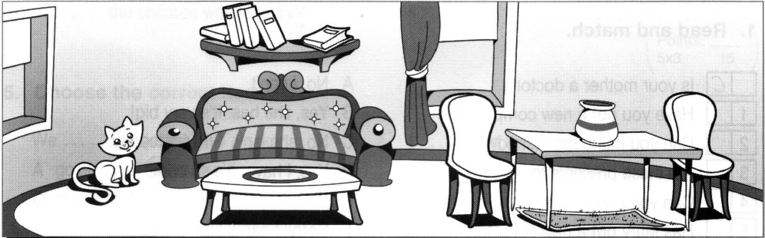

1. _________________________________________________________________________________

2. _________________________________________________________________________________

3. _________________________________________________________________________________

4. _________________________________________________________________________________

5. _________________________________________________________________________________

________ (5 баллов)

**5. Раскройте скобки, употребляя глаголы в *The Present Simple Tense* или *The Present Continuous Tense.***

1. She_____________________________________________________________ (to eat) meat every day.

2. Dad ________________________________________________________________ (to watch) TV now.

3. Mary ___________________________________________________________ (to run) very quickly. Look!

4. They _______________________________________________ (not to like) to play football at P.E. classes.

5. __________ he _____________________________________________________ (to want) a piece of cake?

6. __________ they __________________________________________________ (to swim) at the moment?

7. Ted ________________________________________________________________ (not to cook) fish now.

8. Listen! Mary and Bob ________________________________________________ (to sing) in the living room.

9. Mother always __________________________________________________________ (to wash) the dishes.

10. He often ______________________________________________________________ (to go) to the cinema.

________ (10 баллов)

**6.* Прочитайте текст и напишите *True* или *False* рядом с каждым утверждением. (Задание НЕобязательно для выполнения)**

This is our classroom. It is light, clean and large. The room is nice. Its ceiling and walls are white, its floor is brown. There is one door and three windows in it. When it is warm, they are open. When it is cold, they are shut. The door is always shut when we have our lessons.There is a blackboard on the wall. We write on it. On the blackboard there are some words. They are English words. We read them: "We want to know English." We sit on chairs in front of desks. The desks are nice and green.  
The teacher's desk in near the blackboard. There are not many pupils in our class. There are only seventeen in it. Today fifteen pupils are present, two are absent. We learn many subjects at school. They are: Russian, English, Нistory, Literature, Mathematics, Physics, Chemistry, Biology, Geography and Physical Training (or PT).

1. The pupil is describing (описывает) his classroom.__________

2. The walls of the classroom are white. ____________________

3. There are four windows in the classroom. _________________

4. The windows are open, when it’s warm. __________________

5. There are some written words on the blackboard. ___________

6. The chairs are in front of the desks. ______________________

7. The teacher’s desk is under the blackboard. _______________

8. There are seventeen pupils in the class. __________________

9. Today not all the pupils are in the class. __________________

10. The pupils learn ten different subjects at school. ____________