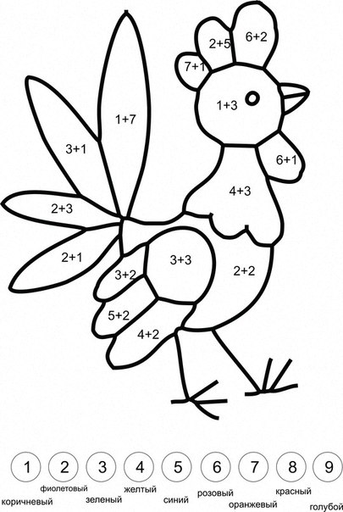
4+2=
6+2=
8+2=
9-2=
7-2=
6-2=

