Открытое мероприятие в 3а классе
“Бременские музыканты.”

Цели и задачи:
1. Развитие речевых и познавательных способностей ребёнка, опираясь на речевой опыт в родном языке.
2. Развитие речемыслительных способностей ребёнка.
3. Формирование личности через приобщение к культуре и быту другого народа, через воспитание дружелюбного отношения ко всем людям, независимо от языка, на котором они говорят.
4. Развитие творческой личности.
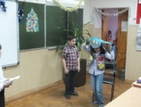
Ход мероприятия.
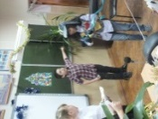
A certain man had a donkey, which had carried the corn sacks to the mill loyally for many a long year; but his strength was going, and he was growing more and more unfit for work. His master began to wonder if it was worth his while by keeping this old donkey much longer.

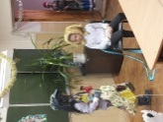
The donkey, seeing that no good wind was blowing, ran away and set out on the road to Bremen. “There,” he thought, “I can surely be town musician.”

When he had walked some distance, he found a dog lying on the road, gasping like one who had run until he was tired. “What are you gasping so for, you big fellow?” Asked the donkey.
“Ah,” replied the dog, “as I am old, and grow weaker daily; I can no longer hunt. My master wanted to kill me, so I ran away, but now how am I to earn my bread?”
“I’ll tell you what,” said the donkey, “I am going to Bremen, and shall be a town musician there; come with me and work also as a musician. I will play the lute, and you shall beat the kettledrum.”
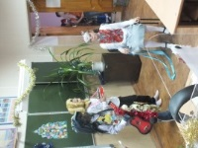
The dog agreed, and so on they went. Not before long they came to a cat, sitting on the path with a face like three rainy days! “Now then, old fluff and claws, what has gone so wrong with you?” Asked the donkey.

“Who can be merry when his neck is in danger?” Answered the cat. “Because I am now getting old, my teeth are worn to stumps, and I prefer to sit by the fire and spin, rather than hunt about after mice. My mistress wanted to drown me, so I ran away. Now good advice is scarce. Where am I to go?”
“Go with us to Bremen. You understand night music so you can be a town musician.”
The cat thought well of it and decided to go with them. After this the three runaways came to a farmyard, where the cockerel was sitting upon the gate, cock-a-doodle-doing with all his might. “Your cock-a-doodle-do goes through and through my skull,” said the donkey. “What is the matter?”
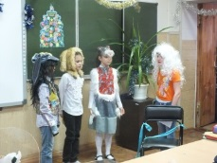
“Guests are coming on Sunday and the housewife has no pity,” said the cockerel, “and has told the cook that she intends to eat me in the soup tomorrow, and this evening I am to have my head cut off. Now I am cock-a-doodle-doing at full pitch while I can.”

“Ah you red-headed bird,” said the donkey, “you had better come away with us. We are going to Bremen; you can find something better than death everywhere. You have a good voice, and if we make music together it must have some quality!”
The cockerel agreed to this plan, and all four went on together. They could not, however, reach the city of Bremen in one day, and in the evening they came to a forest where they meant to pass the night. The donkey and the dog laid themselves down under a large tree, the cat and cockerel settled themselves in the branches – but the cockerel flew right to the top, where he was most safe. Before he went to sleep, he called out to his companions that there must be a house not far off, for he saw a light. The donkey said: “If so, we had better get up and go on, for the shelter here is bad.” The dog thought that a few bones with some meat on would do him good too!
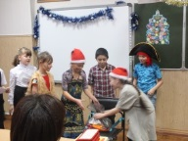
So they moved further on, and soon saw the light shine brighter and grow larger, until they came to a well lit robber’s house. The donkey, as the biggest, went to the window and looked in: “What do you see, my grey horse?” Asked the cockerel. “What do I see?” Answered the donkey. “A table covered with good things to eat and drink, and robbers sitting at it enjoying themselves.”

“That would be just the sort of thing for us,” said the cockerel. “Yes, yes. Ah, how I wish we were there!” Said the donkey.
Then the animals put their heads together and schemed how to best win an invitation to come inside and join the robbers at the table.
“Come, come my friends,” said the donkey. “We are musicians, so let us sing for our supper.”
They began to perform their music together: The donkey brayed, the dog barked, the cat mewed, and the cockerel cock-a-doodle-do’ed. Then they burst through the window into the room, so that the glass clattered! At this horrible din, the robbers sprang up, thinking no otherwise than a ghost had come in, and they fled in a great fright out into the forest. The four companions now sat down at the table, well content with what was left, and ate as if they were going to fast for a month.
As soon as the four musicians had done, they put out the light, and each found a sleeping place according to his nature and to what suited him. The donkey laid himself down upon some straw in the yard, the dog behind the door, the cat upon the hearth near the warm ashes, and the cockerel perched himself upon a beam of the roof; and being tired from their long walk, they soon went to sleep.
When it was past midnight, the robbers saw from afar that the light was no longer burning in their house. Appearing quiet, the captain said: “We ought not to have let ourselves be frightened out of our wits,” and ordered one of them to go and examine the house.
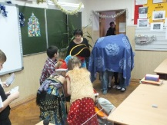
The messenger finding all was still, went into the kitchen to light a candle, and taking the glistening fiery eyes of the cat for burning coals, he held the candle to them to light it. The cat did not understand what he meant to do, however, and flew in his face, spitting and scratching. He was dreadfully frightened, and ran to the back door, but the dog, who lay there sprang up and bit his leg. As he ran across the yard by the straw heap, the donkey gave him a smart kick with its hind foot. The cockerel too, who had been awakened by the noise, had become lively, and cried down from the beam, “Cock-a-doodle-doo!”
Then the robber ran back as fast as he could to his captain and said: Ah, there is a horrible witch sitting in the house, who spat on me and scratched my face with her long claws; and by the door stands a man with a knife who stabbed me in the leg, and in the yard there lies a black monster who beat me with a wooden club. Above, upon the roof, sits the judge, who called out: “Bring the rogue here to me!” So I got away as well as I could.”
After this the robbers did not trust themselves in the house again; but it suited the four musicians of Bremen so well that they did not care to leave it anymore.

