4 кл. Фамилия, имя, класс____________________________________

I. Прочитайте текст.
Bobby-Doggy
(1) Bobby-Doggy is a little white and grey dog. He sees a ball. The ball is in the basket (корзина). It is big and red. Bobby-Doggy wants to have the ball. "Bow-wow," says Bobby-Doggy, "I want to play with the ball. I like the ball very much. It can jump. I can run and jump too."
(2) On and on Bobby jumps. He wants to have the ball but he cannot. Suddenly the basket falls down (падает). The ball falls down and Bobby-Doggy falls down, too. "Bow-wow, now I can't run, I can't jump, I haven't got the ball," says he.
(3) Nick runs in. He sees Bobby. "Poor Doggy," says Nick. "Do you want to play with the ball?" "I'd love to but I can't. I am not well." "Oh, no, don't worry, you are fine. Let's play," says Nick. "Bow-wow! OK. Let's..."
Now Nick and his friend Bobby-Doggy have a lot of fun. They are happy.
II. К каждому абзацу подберите соответствующую картинку.
A B C
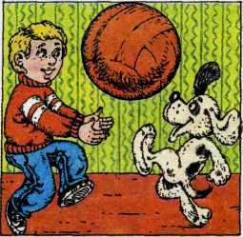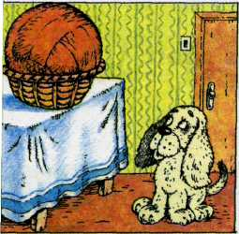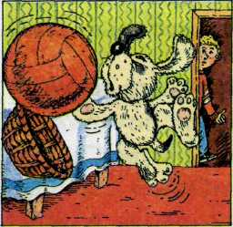

1_____ 2_____ 3_____
III. Обведите правильный вариант ответа.
1. The dog is …
a) black and white b) white and grey c) black and grey
2. The dog’s name is …
a) Boogie-Woogie b) Bumpty-Dumpty c) Bobby-Doggy
3. The dog wants …
a) a ball b) a doll c) a basket
4. The ball is …
a) red and big b) white and big c) grey and big
6. The ball is in the …
a) box b) bag c) basket
7. Bobby-Doggy can …
a) swim and play b) run and jump c) swim and jump
8. The ball …
a) runs away b) cut down c) falls down
9. … sees Bobby-Doggy.
a) Nick b) Mike c) Pete
10. The boy and the dog are …
a) sad b) happy c) ugly
IV. Выберите и обведите правильный вариант ответа.
1. Do you like to skip? – No, …
a) you don`t b) I am not c) I don`t

2. We have …… tomatoes.
a) many b) much c) a

3. They have …… milk.
a) many b) much c) a

4. …… ten carrots?
a) Does she b) Has she c)Is she

5. What does she like …… ?
a) to buy b) buy c) buys

6. Does he …… to school?
a) goes b) go c) to go

7. She can …… well.
a) ski b) skis c) to ski

8. The …… have a lot of cars.
a) boy b) boys c) boys`

9. The …… cars are big.
a) boy b) boys c) boys`

10. We have a horse. …… horse is strong.
a) Our b) Your c) Their

V. Вставьте артикли там, где это необходимо.

1. My friend is …… teacher. …… Kate’s friends are …… teachers too.

2. Do you go to …… school in …… morning?

3. Would you like to go to …… Africa?

4. I have …… red pen. …… Alice can take …… pen.

5. …… cats don`t eat …… honey.

Ответы.

II.
1B, 2C, 3A.

III.
1b, 2c, 3a, 4a, 6c, 7b, 8c, 9a, 10b.

IV.
1c, 2a, 3b, 4b, 5a, 6b, 7a, 8b, 9c, 10a.

V.
1. a, -, -.
2. -, the.
3. –.
4. a, -, the.
5. -, -.

