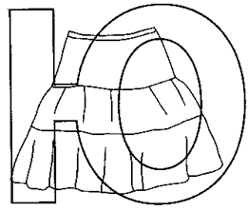 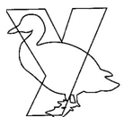

|  |  |  |  |
| --- | --- | --- | --- |
|  |  |  |  |
| К___РИЦА | Л___ДИ | КАП___СТА | ПЕТ___Х |
|  |  |  |  |
|  |  |  |  |
| КЛ____ШКА | Г___СЕНИЦА | ГР___ША | ____Т____Г |
|  |  |  |  |
|  |  |  |  |
| КАСТР___ЛЯ | СТ___Л | БЛ___ДЦЕ | КЛ___БОК |
|  |  |  |  |
| <http://raskraska.narod.ru/toys/jeans-bw.gif> |  |  |  |
| БР____КИ | Л___К | КЛ____Ч | Т_____ЛЬПАН |

|  |  |
| --- | --- |
|  |  |
|  |  |

1. __ ЛЮ __ К__

2. __ЛЮ __ К __

3. __ ЛЮК __

4. __ ЛЮ __ К__

5. __ ЛЮК __

6. __ __ ЛЮ __ К __

7. __ ЛЮ __ __ __ К __

8. __ ЛЮК __ __

9. __ ЛЮ __ __ К

10. __ __ ЛЮ __ К __

