Sir Rowland Hill, the inventor of the postage stamp

[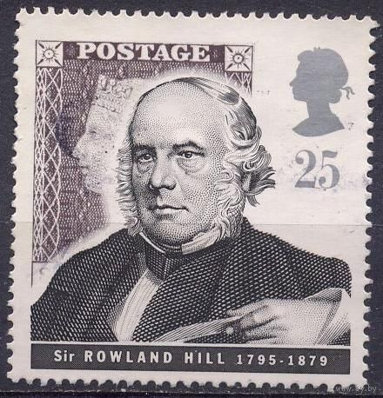](http://images.yandex.ru/yandsearch?text=Sir%20Rowland%20Hill&img_url=http://upload.wikimedia.org/wikipedia/ru/thumb/3/36/RowlandHill-gb1995-stamp-large.jpg/210px-RowlandHill-gb1995-stamp-large.jpg&pos=2&rpt=simage&lr=114678&noreask=1&source=wiz) 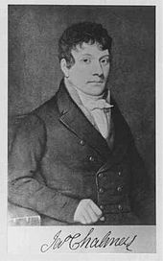

James Chalmers was the inventor of the adhesive postage stamp

The first adhesive postage stamps

[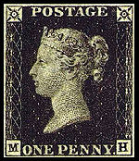](http://en.wikipedia.org/wiki/File:Penny_black.jpg) 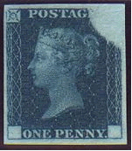

The first collectors of stamps.

Jean-Baptiste Moens is considered the "father of philately."

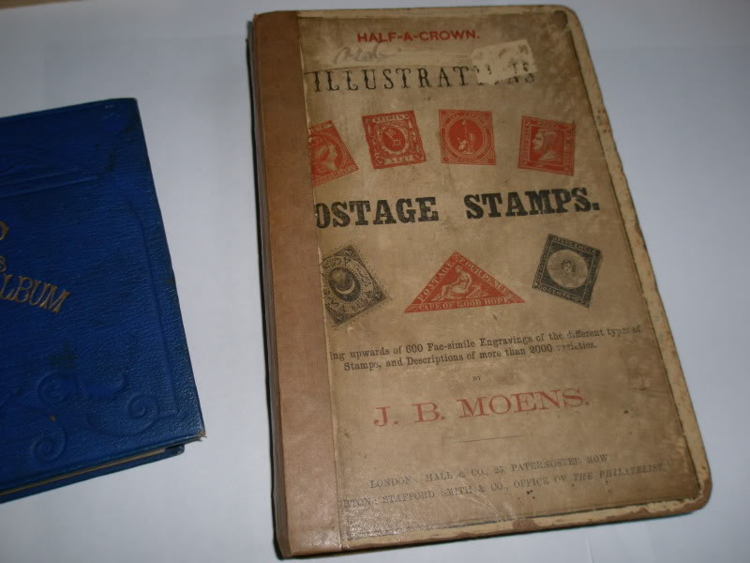 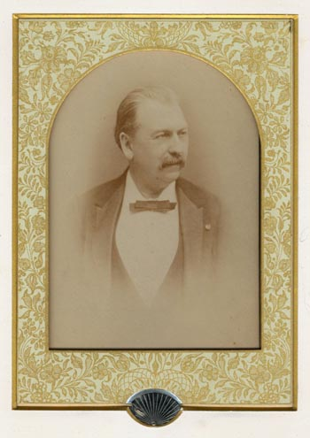

King George V became President of the Royal Philatelic Society.

.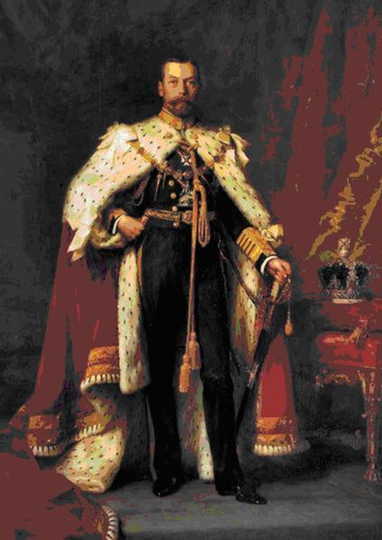

Queen Victoria's profile

[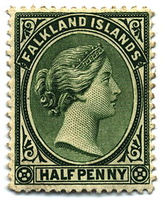](http://schools-wikipedia.org/images/1184/118453.jpg.htm)

"Bull's Eyes"

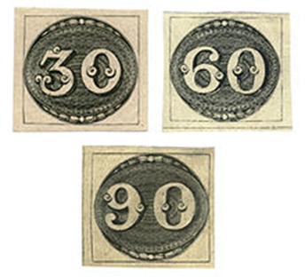

’’Inverted Jenny,’’ a 24-cent stamp of 1918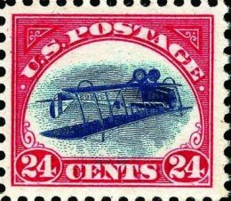

The famous collectors of stamps many years later.

Franklin Roosevelt Nicolas Sarkozy

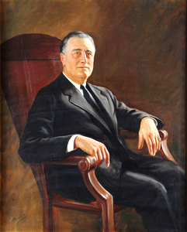 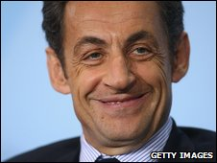

Freddie Mercury

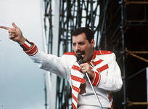

John Lennon

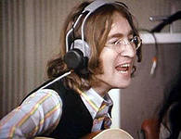

[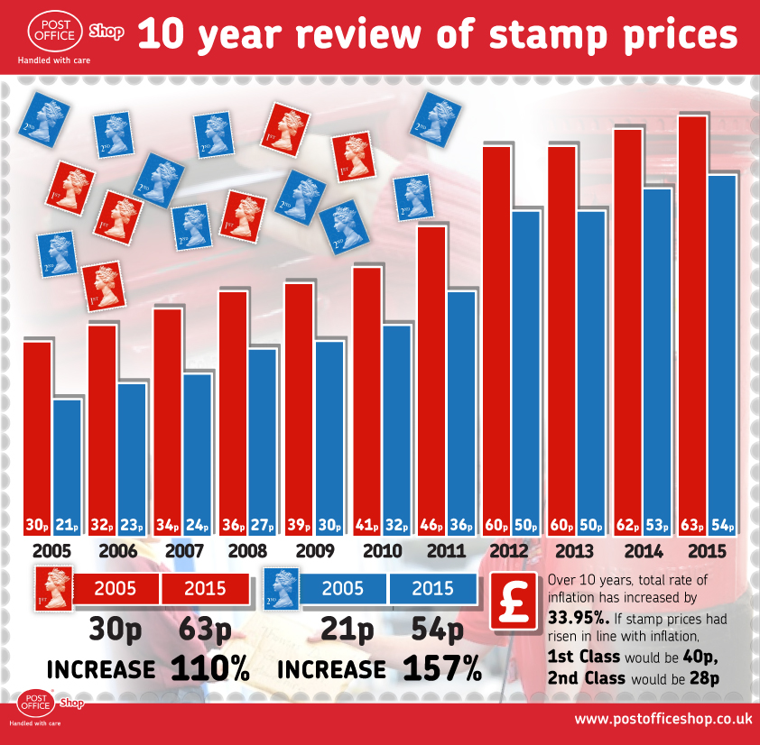](http://filatelistovstandarty.apbb.ru/click.php?http://fastpic.ru/)

[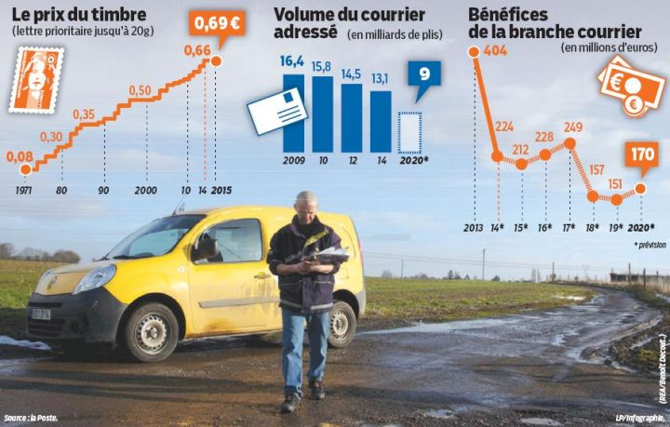](http://filatelistovstandarty.apbb.ru/click.php?http://fastpic.ru/)

**Do we need a postage stamp nowadays?**

🞏 More than 5% of respondents are were confused. They didn’t know to say.

🞏 More than 7% of teenagers and adults think that postage stamps are needed to send letters

🞏One in every four respondents thinks that a postage stamp is need to collectors as the subject of art and history. (25%)

🞏The rest of teens and adults believe that postage stamps are a survival of the past. They are not needed at all. (63%)