[](http://images.yandex.ru/yandsearch?source=wiz&fp=0&img_url=http%3A%2F%2Fraskrasko.ru%2Fimages%2Fcms%2Fthumbs%2F688d832b8bd80bedf5206140a90a13ed5058e599%2Fsvekla_20_auto_700.jpg&text=%D1%80%D0%B0%D1%81%D0%BA%D1%80%D0%B0%D1%81%D0%BA%D0%B0%20%D1%81%D0%B2%D0%B5%D0%BA%D0%BB%D0%B0%20%D0%B4%D0%BB%D1%8F%20%D0%B4%D0%B5%D1%82%D0%B5%D0%B9&noreask=1&pos=16&lr=39&rpt=simage) [](http://images.yandex.ru/yandsearch?source=wiz&fp=0&img_url=http%3A%2F%2Fimg3.proshkolu.ru%2Fcontent%2Fmedia%2Fpic%2Fstd%2F2000000%2F1444000%2F1443785-7928ce99bb1af788.jpg&text=%D1%80%D0%B0%D1%81%D0%BA%D1%80%D0%B0%D1%81%D0%BA%D0%B0%20%D1%80%D0%B5%D0%B4%D0%B8%D1%81%20%D0%B4%D0%BB%D1%8F%20%D0%B4%D0%B5%D1%82%D0%B5%D0%B9&noreask=1&pos=3&lr=39&rpt=simage)

[](http://images.yandex.ru/yandsearch?source=wiz&fp=0&img_url=http%3A%2F%2Fboyama.info%2Fboyama%2Fsebze-meyve%2Fturnip.jpg&text=%D1%80%D0%B0%D1%81%D0%BA%D1%80%D0%B0%D1%81%D0%BA%D0%B0%20%D1%80%D0%B5%D0%BF%D0%B0%20%D0%B4%D0%BB%D1%8F%20%D0%B4%D0%B5%D1%82%D0%B5%D0%B9&noreask=1&pos=5&lr=39&rpt=simage) [](http://images.yandex.ru/yandsearch?source=wiz&fp=0&img_url=http%3A%2F%2Fboyama.info%2Fboyama%2Fsebze-meyve%2Fradish-s.jpg&text=%D1%80%D0%B0%D1%81%D0%BA%D1%80%D0%B0%D1%81%D0%BA%D0%B0%20%D1%80%D0%B5%D0%B4%D0%B8%D1%81%20%D0%B4%D0%BB%D1%8F%20%D0%B4%D0%B5%D1%82%D0%B5%D0%B9&noreask=1&pos=14&lr=39&rpt=simage)

[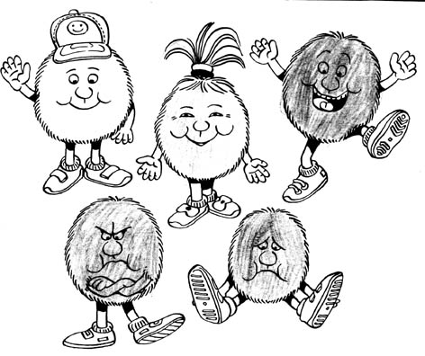](http://images.yandex.ru/yandsearch?source=wiz&fp=0&text=%D1%80%D0%B8%D1%81%D1%83%D0%BD%D0%BA%D0%B8%20%D0%BC%D0%BE%D1%80%D0%B4%D0%B0%D1%88%D0%BA%D0%B8%20%D0%BF%D1%83%D1%88%D0%B8%D1%81%D1%82%D0%B8%D0%BA%D0%B8&noreask=1&pos=1&lr=39&rpt=simage&uinfo=ww-1285-wh-598-fw-1060-fh-448-pd-1.0499999523162841&img_url=http%3A%2F%2Fms.znate.ru%2Ftw_files2%2Furls_15%2F35%2Fd-34667%2F34667_html_m218354ee.jpg)