[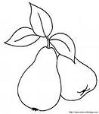](http://images.yandex.ru/yandsearch?p=5&text=%D1%80%D0%B0%D1%81%D0%BA%D1%80%D0%B0%D1%81%D0%BA%D0%B8%20%D0%B2%D0%B8%D1%88%D0%BD%D0%B8%20%20%D0%B4%D0%BB%D1%8F%20%D0%B4%D0%B5%D1%82%D0%B5%D0%B9&fp=5&img_url=http://bonne.ucoz.ru/_ld/0/35624111.gif&pos=152&uinfo=ww-1285-wh-598-fw-1060-fh-448-pd-1.0499999523162841&rpt=simage)

[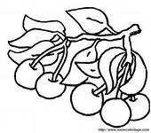](http://images.yandex.ru/yandsearch?p=10&text=%D1%80%D0%B0%D1%81%D0%BA%D1%80%D0%B0%D1%81%D0%BA%D0%B8%20%D0%B2%D0%B8%D1%88%D0%BD%D0%B8%20%20%D0%B4%D0%BB%D1%8F%20%D0%B4%D0%B5%D1%82%D0%B5%D0%B9&fp=10&img_url=http://allforchildren.ru/paint/cherry_s/cherry16.gif&pos=327&uinfo=ww-1285-wh-598-fw-1060-fh-448-pd-1.0499999523162841&rpt=simage)

[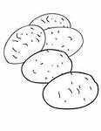](http://images.yandex.ru/yandsearch?p=1&text=%D1%80%D0%B0%D1%81%D0%BA%D1%80%D0%B0%D1%81%D0%BA%D0%B8%20%D0%BA%D0%B0%D1%80%D1%82%D0%BE%D1%84%D0%B5%D0%BB%D1%8C%20%20%D0%B4%D0%BB%D1%8F%20%D0%B4%D0%B5%D1%82%D0%B5%D0%B9&fp=1&img_url=http://assets.handipoints.com/stamps/healthy/root_vegetables/potato_ink.jpg&pos=49&uinfo=ww-1285-wh-598-fw-1060-fh-448-pd-1.0499999523162841&rpt=simage)

[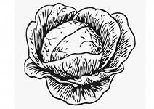](http://images.yandex.ru/yandsearch?text=%D1%80%D0%B0%D1%81%D0%BA%D1%80%D0%B0%D1%81%D0%BA%D0%B8%20%D0%BA%D0%B0%D0%BF%D1%83%D1%81%D1%82%D0%B0%20%20%D0%B4%D0%BB%D1%8F%20%D0%B4%D0%B5%D1%82%D0%B5%D0%B9&fp=0&img_url=http://www.tv3.cat/cuines/media/fotos/20100206/minithumb_colt12898.jpg&pos=12&uinfo=ww-1285-wh-598-fw-1060-fh-448-pd-1.0499999523162841&rpt=simage)

[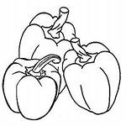](http://images.yandex.ru/yandsearch?text=%D1%80%D0%B0%D1%81%D0%BA%D1%80%D0%B0%D1%81%D0%BA%D0%B8%20%D0%BF%D0%B5%D1%80%D0%B5%D1%86%20%20%D0%B4%D0%BB%D1%8F%20%D0%B4%D0%B5%D1%82%D0%B5%D0%B9&fp=0&img_url=http://online-raskraski.ru/media/icons/1/peretc_small.jpg&pos=14&uinfo=ww-1285-wh-598-fw-1060-fh-448-pd-1.0499999523162841&rpt=simage)

[](http://images.yandex.ru/yandsearch?p=1&text=%D1%80%D0%B0%D1%81%D0%BA%D1%80%D0%B0%D1%81%D0%BA%D0%B0%20%D1%83%D0%BB%D1%8B%D0%B1%D0%BA%D0%B8&fp=1&img_url=http://img1.liveinternet.ru/images/attach/c/7/94/188/94188939_large_r3.gif&pos=52&uinfo=ww-1285-wh-598-fw-1060-fh-448-pd-1.0499999523162841&rpt=simage)

[](http://images.yandex.ru/yandsearch?p=1&text=%D1%80%D0%B0%D1%81%D0%BA%D1%80%D0%B0%D1%81%D0%BA%D0%B0%20%D1%83%D0%BB%D1%8B%D0%B1%D0%BA%D0%B8&fp=1&img_url=http://img1.liveinternet.ru/images/attach/c/7/94/188/94188939_large_r3.gif&pos=52&uinfo=ww-1285-wh-598-fw-1060-fh-448-pd-1.0499999523162841&rpt=simage)

[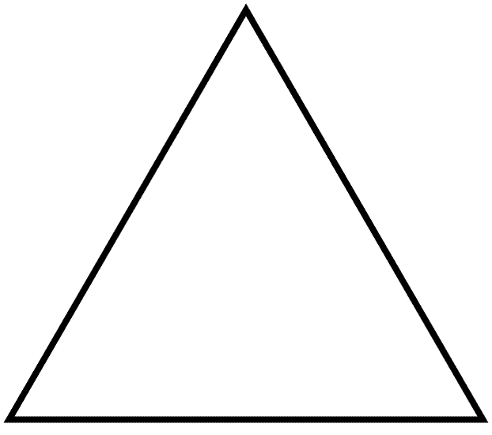](http://images.yandex.ru/yandsearch?text=%D0%B3%D0%B5%D0%BE%D0%BC%D0%B5%D1%82%D1%80%D0%B8%D1%87%D0%B5%D1%81%D0%BA%D0%B8%D0%B5%20%D1%84%D0%B8%D0%B3%D1%83%D1%80%D1%8B%20%D1%82%D1%80%D0%B5%D1%83%D0%B3%D0%BE%D0%BB%D1%8C%D0%BD%D0%B8%D0%BA&fp=0&pos=8&uinfo=ww-1285-wh-598-fw-1060-fh-448-pd-1.0499999523162841&rpt=simage&img_url=http://www.math-salamanders.com/images/basic-geometric-shapes-equilateral-triangle-ns-bw.gif)

[](http://images.yandex.ru/yandsearch?p=1&text=%D0%B3%D0%B5%D0%BE%D0%BC%D0%B5%D1%82%D1%80%D0%B8%D1%87%D0%B5%D1%81%D0%BA%D0%B8%D0%B5%20%D1%84%D0%B8%D0%B3%D1%83%D1%80%D1%8B%20%D0%BE%D0%B2%D0%B0%D0%BB&fp=1&pos=30&uinfo=ww-1285-wh-598-fw-1060-fh-448-pd-1.0499999523162841&rpt=simage&img_url=http://900igr.net/data/tsvet-i-forma/Figury-1.files/0022-084-Oval.png)

[](http://images.yandex.ru/yandsearch?text=%D0%B3%D0%B5%D0%BE%D0%BC%D0%B5%D1%82%D1%80%D0%B8%D1%87%D0%B5%D1%81%D0%BA%D0%B8%D0%B5%20%D1%84%D0%B8%D0%B3%D1%83%D1%80%D1%8B%20%D0%BA%D1%80%D1%83%D0%B3&fp=0&pos=0&uinfo=ww-1285-wh-598-fw-1060-fh-448-pd-1.0499999523162841&rpt=simage&img_url=http://900igr.net/datas/tsvet-i-forma/Figury-1.files/0007-007-Figura-Krug.jpg)