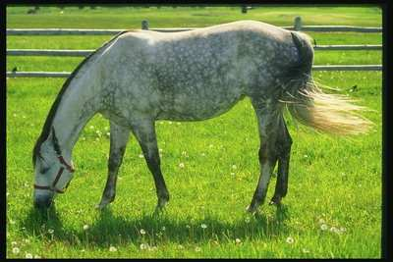[](http://www.bing.com/images/search?q=%d0%ba%d0%b0%d1%80%d1%82%d0%b8%d0%bd%d0%ba%d0%b8+%d0%b4%d0%be%d0%bc%d0%b0%d1%88%d0%bd%d0%b8%d1%85+%d0%b6%d0%b8%d0%b2%d0%be%d1%82%d0%bd%d1%8b%d1%85&id=FEE9050A109E2854E1CD30457AEE1B81229CFFD3&FORM=IQFRBA#view=detail&id=4183D6F826D89C7D46C8AB0A48855515872B68E9&selectedIndex=817)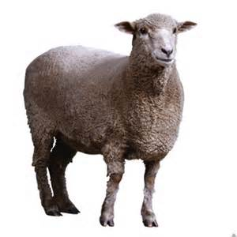[](http://www.bing.com/images/search?q=%d0%ba%d0%b0%d1%80%d1%82%d0%b8%d0%bd%d0%ba%d0%b8+%d0%b4%d0%be%d0%bc%d0%b0%d1%88%d0%bd%d0%b8%d1%85+%d0%b6%d0%b8%d0%b2%d0%be%d1%82%d0%bd%d1%8b%d1%85&id=FEE9050A109E2854E1CD30457AEE1B81229CFFD3&FORM=IQFRBA#view=detail&id=AB184E0DC44F29E6F78B7DDB934A79EA7D9E1984&selectedIndex=49)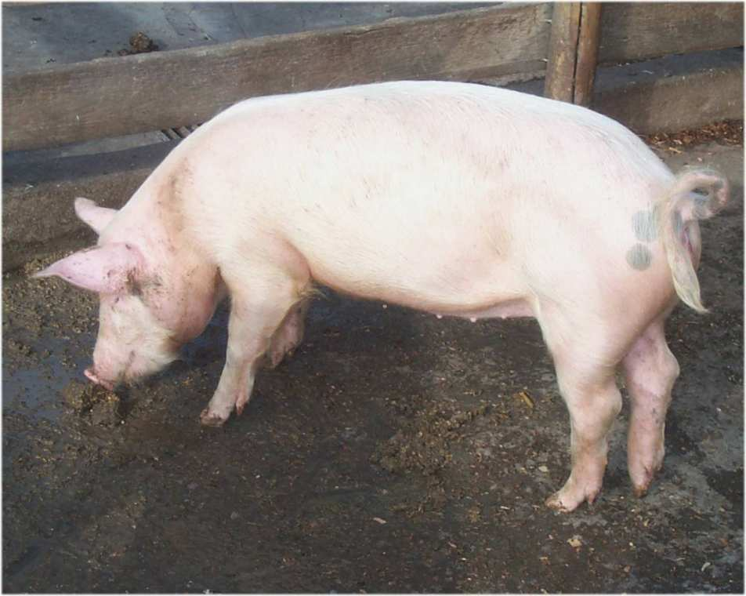[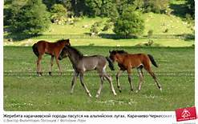](http://www.bing.com/images/search?q=%d1%84%d0%be%d1%82%d0%be+%d0%b6%d0%b5%d1%80%d0%b5%d0%b1%d1%8f%d1%82&qpvt=%d1%84%d0%be%d1%82%d0%be+%d0%b6%d0%b5%d1%80%d0%b5%d0%b1%d1%8f%d1%82&FORM=IGRE#view=detail&id=0BC1AA8C4E3AA8E0B209CE38891365D2A5F7C71E&selectedIndex=173)

[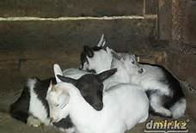](http://www.bing.com/images/search?q=%d1%84%d0%be%d1%82%d0%be+%d0%ba%d0%be%d0%b7%d0%bb%d1%8f%d1%82&qpvt=%d1%84%d0%be%d1%82%d0%be+%d0%ba%d0%be%d0%b7%d0%bb%d1%8f%d1%82&FORM=IGRE#view=detail&id=C2BD48BC00B5D308BB751BC4C4542B4D41B2C0AF&selectedIndex=150)[](http://www.bing.com/images/search?q=%d1%84%d0%be%d1%82%d0%be+%d1%8f%d0%b3%d0%bd%d1%8f%d1%82&qpvt=%d1%84%d0%be%d1%82%d0%be+%d1%8f%d0%b3%d0%bd%d1%8f%d1%82&FORM=IGRE#view=detail&id=74B55E693FA1711FBA27F3E34ED9FBF3D44325B9&selectedIndex=45)

