A.
If you are a teenager, you probably thought about smoking already. About 3,000 teenagers pick up the smoking habit each day in America, or one million new teenage smokers a year. That means lots of new smokers, and it also means there's a good chance that you or one of your friends is smoking right now.
Have you ever asked a question: why do you see millions of adults smoking everywhere? Look at the following graph which shows the age at which people begin smoking.
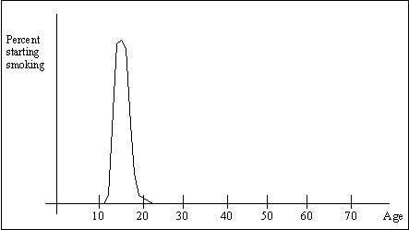
On this graph you can see that some 11 and 12 year-olds start, but in general the ages 13 through 18 are the big "start smoking" years - nearly everyone who starts smoking starts between these ages. Here is the important thing to notice: No one starts smoking after age 20 or so. So if you can make it to age 20 without smoking, you will never start. This is an extremely interesting fact of life. No adult ever makes the decision to smoke.

B.
What I would like to do in this article is help you, as a teenager, to understand why so many teenagers start smoking. If you understand why teenagers start smoking, chances are you won't smoke. It is sort of like a magic trick. The first time you see the trick it looks really cool and mysterious. But then if someone tells you how it's done it's not mysterious at all anymore and the trick loses a lot. Smoking is the same.
Let's start at the beginning - why do teenagers start smoking? If you ask teenagers, here are the four most common reasons:
- If their friends smoke, many teenagers will begin smoking too.
- Many teenagers start smoking because they know it make their parents and other adults angry. They think they are "independent".
- Some teenagers believe that by smoking they are acting like an adult.
- If parents leave cigarettes on places where a teenager can easily get them, it also can start a smoking habit.
If you are considering smoking, here is something to try: think about waiting until you are 20 to start using cigarettes. They will still be there - cigarettes are never going away. See what you think about them at that point. You will be surprised!

