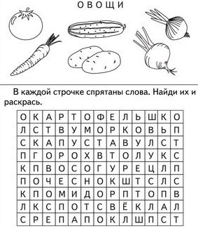**_________________________________________________________**

**Звуки и буквы.**

М А Л И Н А

С В Е Т О Ф О Р

Ч А Й Н И К

К Р О Т

М а л ь ч и к и г р а л и

р а з б и л ч а ш к у.

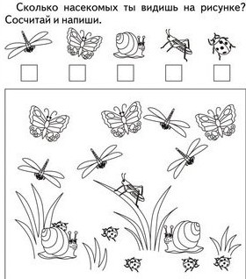**Математика.**

6 + 2 =

4 + 3 =

8 – 1 =

9 – 4 =

0 + 3 =

7 – 0 =

10 – 1 =

4 + 2 =

5 – 3 =

Задача.

БЫЛО **?** зв.

ПОЯВИЛОСЬ

|  |  |  |  |  |  |  |  |  |  |  |  |  |  |  |  |  |  |
| --- | --- | --- | --- | --- | --- | --- | --- | --- | --- | --- | --- | --- | --- | --- | --- | --- | --- |
|  |  |  |  |  |  |  |  |  |  |  |  |  |  |  |  |  |  |

Ответ: _________________________________________