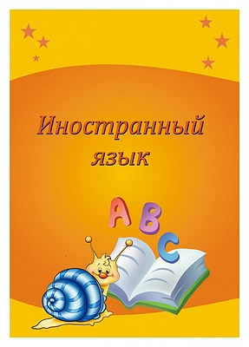

English

**Name:** Alexandr

**Surname:** Mirzaev

**Age:** 9

**Address:** 32, Yunykh Pionerov

**School:** bazovaya

**Class:** 2 “a”

My world.

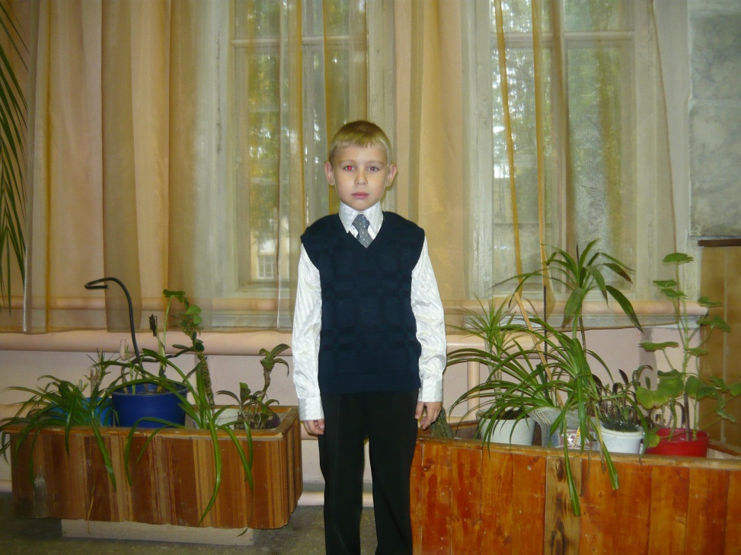About myself.

My name is Alexandr. I am 9. My birthday is on the 21st of June. I am from Russia. I live in Omutninsk. It is nice. Welcome to our town!

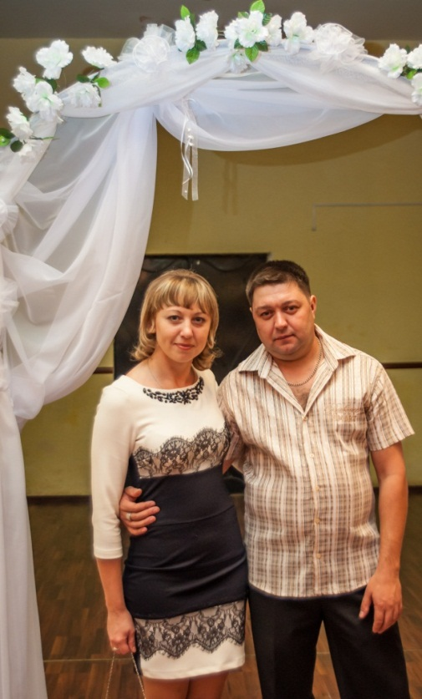My family is not very big but happy. I have got a mother, a father, a grandmother and a grandfather.

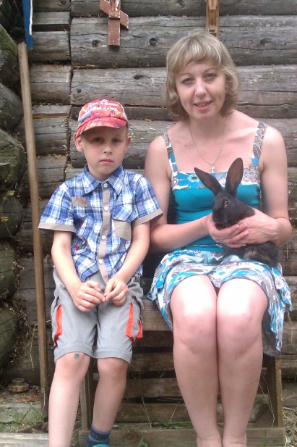I have not got a pet. It is a rabbit. Its name is Tim. It is black. It can jump and run. It likes carrots.

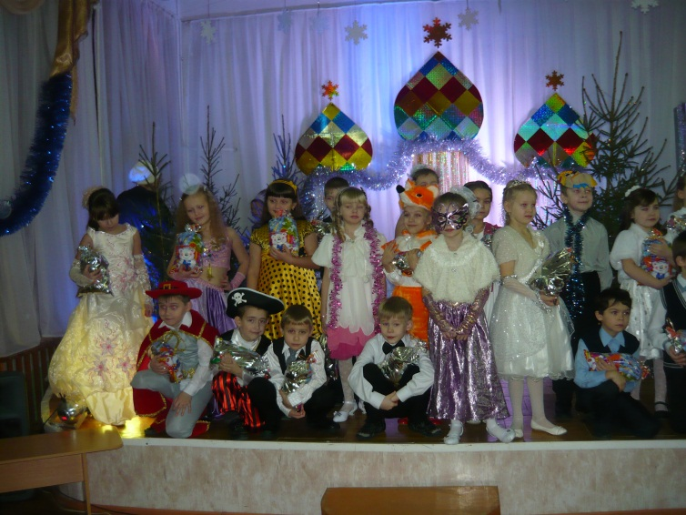I have got a lot of friends: Fofanov Ivan, Ustugova Sonya, Gruzdev Kirill, Malygina Zhenya, Nazarov Dima.

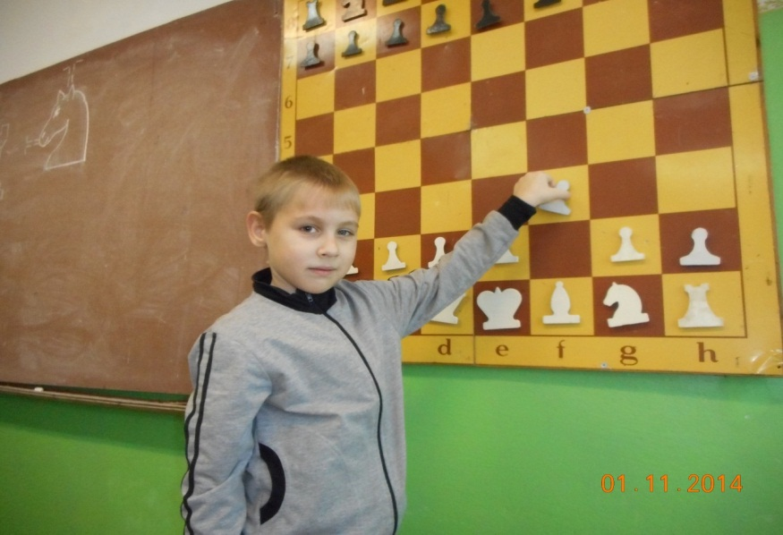I can ride a bike. My bike is blue. I cannot swim. I like to read and write. I don’t like to sing. My hobby is chess. My favourite sport is badminton.

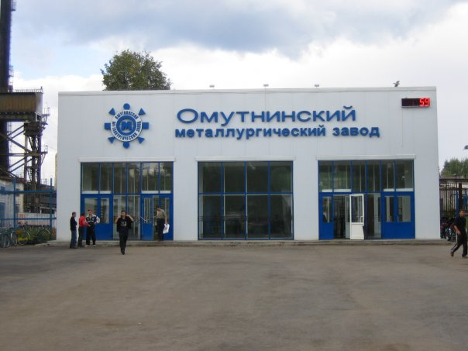

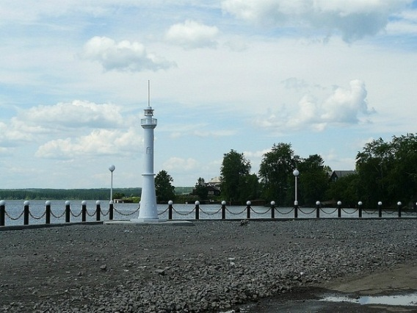

My dossiers.

My study.

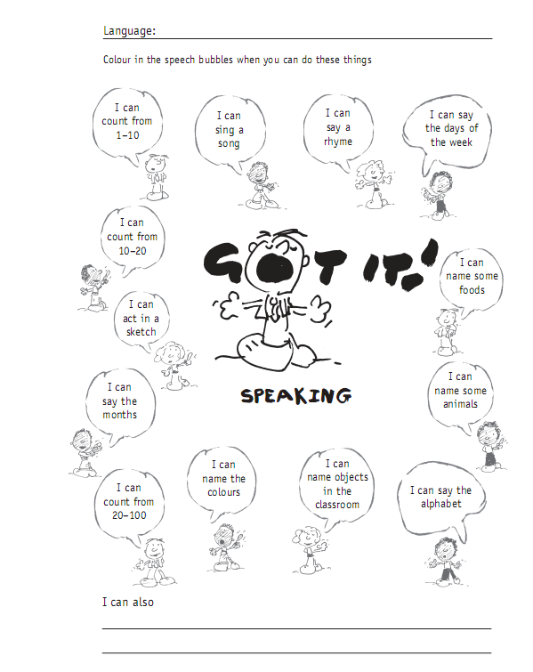

My projects.

My video and audio collection.

My grammar.

My vocabulary.

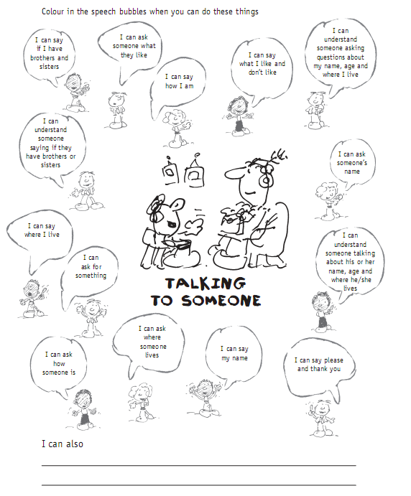

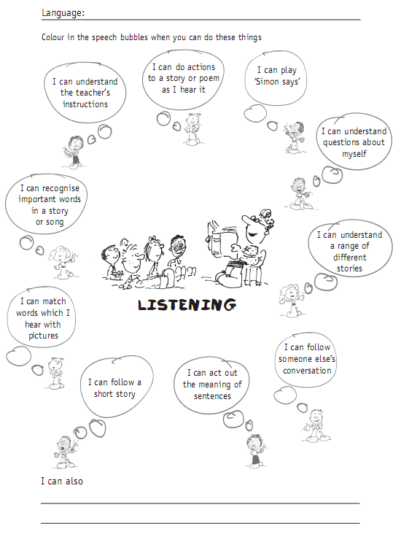

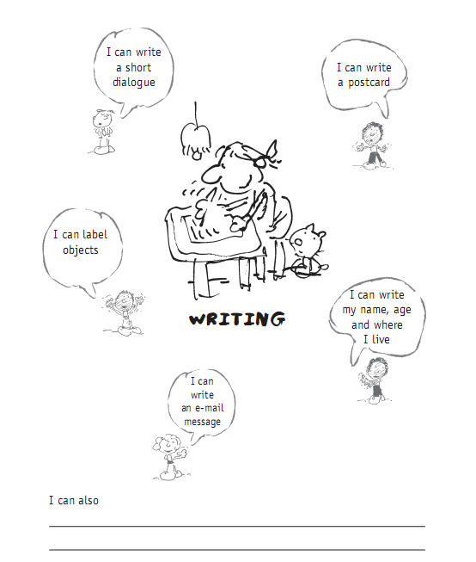

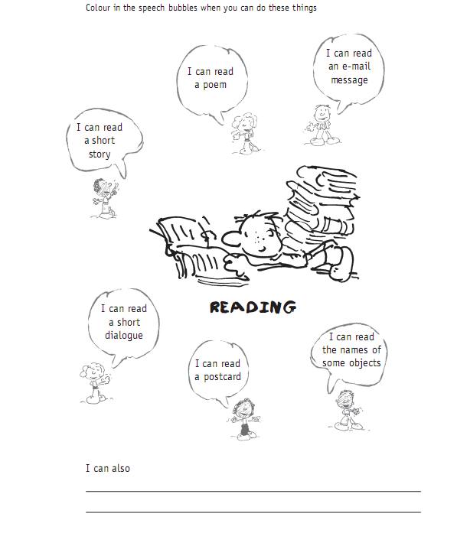

It is interesting.

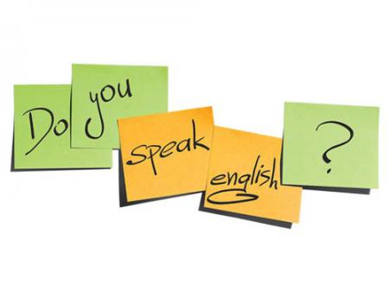

* Допишите букву к звуку.

|  |  |  |  |  |  |
| --- | --- | --- | --- | --- | --- |
| буква | звук | буква | звук | буква | звук |
|  | [f] |  | [ai] [i] |  | [w] |
|  | [t] |  | [s] [z] |  | [ks] |
|  | [d] |  | [ei] [æ] |  | [k] |
|  | [z] |  | [kw] |  | [m] |
|  | [p] |  | [i:] [e] |  | [l] |
|  | [h] |  | [3U] [ɒ] |  | [r] |
|  | [n] |  | [g] [ʤ] |  | [ʤ] |
|  | [v] |  | [s] [k] |  | [b] |
|  |  |  | [ju:] [Ʌ] |  |  |

* Подчеркните слова, в которых буква а читаетмя как звук [æ]:

cat, snake, fat, bad, dad, skate, black, Ann, sad, hat, name, take, brave.

* Подчеркните слова, в которых буква i читаетмя как звук [i]:

hi, with, pig, big, it, ride, stupid, stick, is, in, bike, nine, six, sit, kind.

* Подчеркните слова, в которых буква o читаетмя как звук [ɒ]:

no, not, dog, on, rose, nose, home, go, box, fox, frog, Tom, got, hello.

* Подчеркните слова, в которых буква e читаетмя как звук [e]:

Ben, hen, he, she, we, see, pen, ten, red, pet, pencil, merry, leg, tennis.

* Подчеркните слова, в которых буква u читаетмя как звук [ᴧ]:

mum, you, must, music, stupid, pupil, duck, run, jump, up, funny.

* Подчеркните слова, в которых буква y читаетмя как звук [ai]:

shy, my, merry, happy, why, fly, funny, lazy,

* Заполни таблицу.

|  |  |  |
| --- | --- | --- |
| my |  |  |
|  | [boks] |  |
|  |  | утка |
| ride |  |  |
|  | [ʤᴧmp] |  |
|  |  | черный |
| skate |  |  |
|  | [hɜƱm] |  |

* Разделите слова по столбикам: go, red, rule, stupid, got, you, bee, fox, pen, no, we, box, music, what, hen, frog, pupil, nose, he, to, home, see, Ben, blue, rose, ten, hello, green.

|  |  |  |  |  |  |
| --- | --- | --- | --- | --- | --- |
| [ɒ] | [3U] | [u:] | [i:] | [e] | [ju:] |
|  |  |  |  |  |  |
|  |  |  |  |  |  |
|  |  |  |  |  |  |
|  |  |  |  |  |  |
|  |  |  |  |  |  |

* Разделите слова по столбикам: ride, music, pig, brave, his, bike, you, dad, must, my, bad, fat, hi, cat, is, lazy, funny, sad, jump, name, stupid, with, take, run, stick, duck, skate,fly, pupil

|  |  |  |  |  |  |
| --- | --- | --- | --- | --- | --- |
| [æ] | [ei] | [ai] | [i] | [ju:] | [Ʌ] |
|  |  |  |  |  |  |
|  |  |  |  |  |  |
|  |  |  |  |  |  |
|  |  |  |  |  |  |
|  |  |  |  |  |  |

* Разделите слова по столбикам: she, the, think, they, black, dogs, cats, shy, three, fish, seven, zebra, them, shake, pigs, finish, with, pencil, parrots, sad, zoo, pens.

|  |  |  |  |  |  |
| --- | --- | --- | --- | --- | --- |
| [k] | [z] | [s] | [ʃ] | [θ] | [ð] |
|  |  |  |  |  |  |
|  |  |  |  |  |  |
|  |  |  |  |  |  |
|  |  |  |  |  |  |
|  |  |  |  |  |  |

|  |  |
| --- | --- |
| 1 вариант.  №1. Выбери нужный вариант.  1. I … sad.  a) am; b) is; c) are;  2. You … fat.  a) am; b) is; c) are;  3. She … nice.  a) am; b) is; c) are;  4. Tom … ten.  a) am; b) is; c) are.  5. My cats … black.  a) am; b) is; c) are.  №2. Выбери нужный вариант.  1. She …got a dog.  a) has; b) have;  2. They … got a parrot.  a) has; b) have;  3. He … got a cat.  a) has; b) have;  4. My friends … got pink pigs.  a) has; b) have;  5. My cat … got funny nose.  a) has; b) have.  №3. Выбери нужный вариант.  1. I … got a crocodile.  a) has; b) have; c) am;  2. Tom … bad.  a) am; b) is; c) has;  3. Ann … swim.  a) is; b) has; c) can;  4. They … got a green frog.  a) has; b) have; c) are;  5. My friends … slim.  a) have; b) are; c) can. | 2 вариант.  №1. Выбери нужный вариант.  1. He … brave.  a) am; b) is; c) are;  2. It … cunning.  a) am; b) is; c) are;  3. We … slim.  a) am; b) is; c) are;  4. My friends … merry.  a) am; b) is; c) are;  5. My cat … black.  a) am; b) is; c) are.  №2. Выбери нужный вариант.  1. We … got a friend.  a) has; b) have;  2. You … got a fox.  a) has; b) have;  3. I … got a crocodile.  a) has; b) have;  4. My friend … got a black cat.  a) has; b) have;  5. My dogs … got black noses.  a) has; b) have.  №3. Выбери нужный вариант.  1. We … got a pig.  a) has; b) have; c) are;  2. Ann … fat.  a) am; b) is; c) are;  3. Bob … skip.  a) is; b) has; c) can;  4. I … got a green pen.  a) has; b) have; c) am;  5. My friends … funny.  a) have; b) are; c) can. |

* Прочитай отрывок из письма Элис. Угадай о ком она рассказывает.

a) a cat; b) a dog; c) a hen.

I have got a pet. It is black and white. It is strong. It is brave. It is not lazy. It is nice. It can’t fly. It can run and jump well. It likes to swim. Its name is Bob. It is five. It lives with me, my mum and dad. It likes my home. We like Bob.

* Кто это?.

1. It can’t fly. It likes to swim. It lives in the zoo. It is green and long.

a) a hen; b) a crocodile; c) a dog.

2. It can’t skip. It likes to run. It lives on the farm. It is fat and pink.

a) a cat; b) a fox; c) a pig.

3. It can’t ride a bike. It likes to fly. It lives in the house. It is red and blue.

a) a parrot; b) cockerel; c) snake.

4. It can’t sing and dance. It likes to swim. It is black and red.

a) a dog; b) crocodile; c) a fish.

5. It can’t swim and fly. It likes jump and run. It lives on the farm. It is black.

a) a pig; b) a rabbit; c) bee.

* Выберите подходящую реплику.

|  |  |  |
| --- | --- | --- |
| 1. Can he swim?  2. Have they got a pig?  3. What is your name?  4. How old are you?  5. What is her name?  6. Is it big?  7. Where do you live?  8. Has she got a fox?  9. Can you sing?  10. Has he got a cat? | a) I am ten.  b) No, she hasn’t.  c) Yes, it is.  d) Yes, he has.  e) Yes, I can.  f) Her name is Kate.  g) No, he can’t.  f) My name is Bob.  g) No, they haven’t  h) I live in the house. |  |

|  |  |  |
| --- | --- | --- |
| 1. Goodbye.  2. Hello.  3. Can you sing?  4. Have you got a pet?  5. What is your name?  6. How old are you?  7. Is it green?  8. Where do you live?  9. Has he got a crocodile?  10. What is his name? | a) No, he hasn’t.  b) I live in the forest.  c) I am nine.  d) Bye.  e) Yes, I can.  f) Hi  g) Yes, I have.  f) My name is Jill.  g) No, it isn’t.  h) His name is Jim. |  |

* Расскажи о себе.

My name is …………

I am 7 (8,9,10………)

I am from Russia.

I live in Omutninsk.

I have got a mother, a father, a sister, a brother.

I have got a friend. His\her name is Vanya\Sonya.

I have got a pet.

It is a rabbit (cat, dog………..)

It is black (red, white, brown…)

I can ride a bike (play football, count, dance…..)

I cannot swim (fly, skip, sing…………………..)

I like to play chess.

I do not like to run (jump, write, read………)

* Расскажи о своем друге.

His\her name is …..

He\she is 7 (8, 9, 10…..).

He\she is nice (strong, brave, merry…..).

He\she can …..

He\she likes to …..

He\she lives in the house.

He\she is from Russia (Africa, USA).

* Расскажи о своем питомце.

It is a ……

It is 2 (3, 4, 5…..).

It is nice (angry, big, black…..).

It can …..

It likes to …..

It lives in the house (on the farm).

* Вставьте пропущенные буквы. Подчеркните только гласные буквы.

W…, A…, C…, F…, G…, H…, B…, J…, D…, I…, E…, K…, O…, N…, L…, P…, M…, R…, Q…, T…, V…, X…, U…, S…, Y…,Z…

* Вставьте пропущенные буквы. Подчеркните только согласные буквы.

z…, w…, y…, a…, s…, c…, u…, f…, x…, h…, v…, b…, t…, j…, q…, d…, r…, i…, m…, e…, p…, k…, o…, n…, l…

* Допишите недостающие заглавные буквы.

… b, …q, … ɡ, …h, …r.

2. Допишите недостающие строчные буквы.

F…, N…, D…, E…, J…

3. Подчеркните гласные буквы.

x a z o b y q u ɡ r e h i.

4. Расставьте буквы в алфавитном порядке.

V S A L Z P Y M W T.

……………………………………………

5. Вычеркните лишнюю букву.

k b z r h q y ɡ t x c.

Соедини точки в алфавитном порядке.

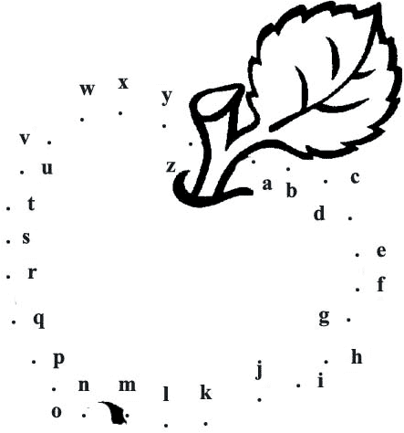

The content:

* My world………………………………………………………………………..
* My dossiers…………………………………………………………………..
* My progress in learning language……………………………..
* My study………………………………………………………………………
* My projects……………………………………………………….
* My vocabulary…………………………………………………..
* My phonetic………………………………………………………
* My grammar……………………………………………………..
* My video and audio collection………………………..
* It is interesting…………………………………………………………