My poems and songs

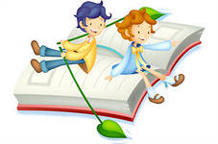

The ABC
A  Apples here, apples there.  Apples, apples everywhere. | 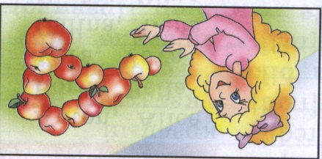
B  Bounce! Bounce! It is my ball.  It doesn’t want to stop at all. | 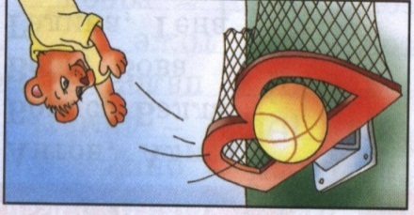
C  I am the cat.  My name is Hat. | 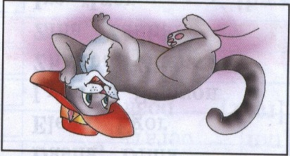
D  I am the dog.  My name is Jack.  My coat is white.  My nose is black. | 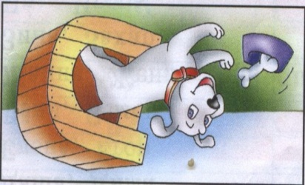
E  Little yellow bee, bee, bee.  How many flowers can you see? | 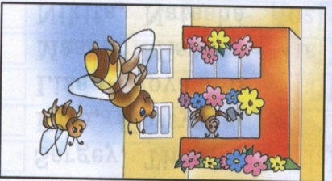
F  One, two, three and four, and five.  I have got a fish alive. | 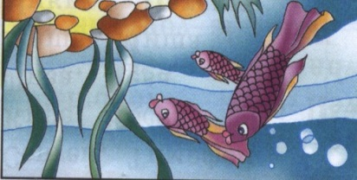
G  I am a girl.  I have got a doll.  Her name is May.  We like to play. | 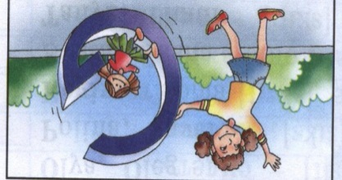
H  Little mouse, little mouse.  Where is your house? | 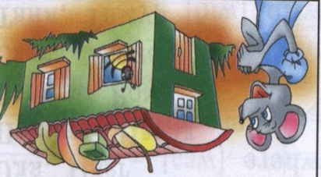
I  Spring is coming! Warm and nice.  Ice is melting! Poor ice! | 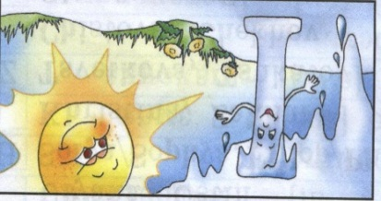
J  Merry Jimmy Jinn is jumping in his jeans. | 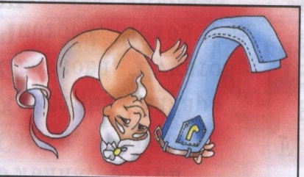
K  The king is strong.  The king is brave.  What is his name?  His name is Nick Grey. | 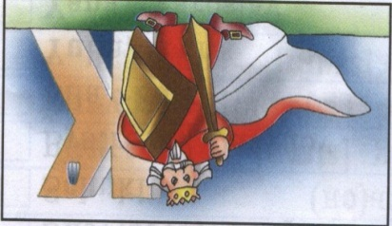
L  Who lives in Africa?  He, she or me?  One lion, two lions, three. | 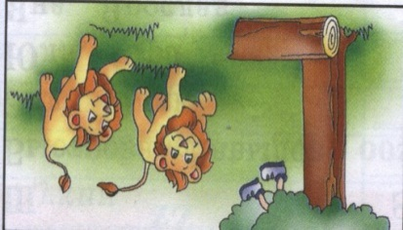
M  Little mice, little mice!  Would you like a piece of ice?  We would like a piece of cheese.  Yes, please! | 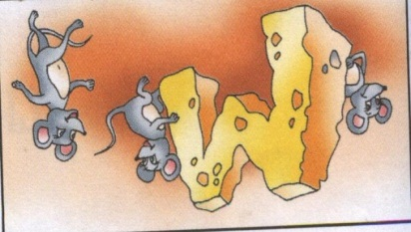
N  How much is one plus one?  Two big nuts for little son. | 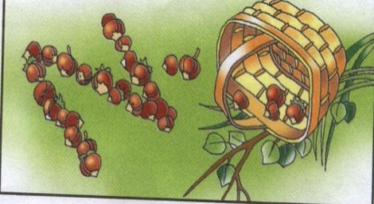
O  “Tick-tock! Tick-tock  Play and walk” says the clock. | 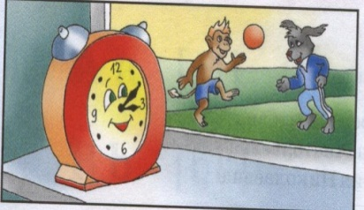
P  I have got a pet.  My pet is a pig.  His name is Pick.  He is not big. | 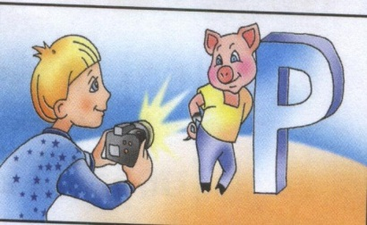
Q  Marry the queen can dance and sing. | 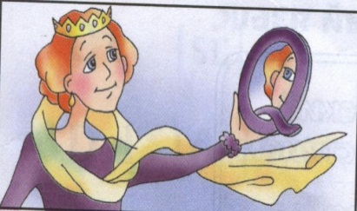
R  One, two, three,  One, two, three.  Nice red roses you can see! | 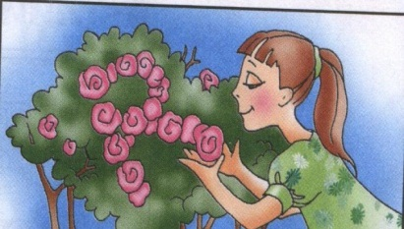
S  Mary! Come and see!  A big snake is in the tree. | 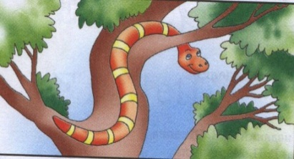
T  Where is Tricky?  Where is he?  He is under the table.  Oh I see. | 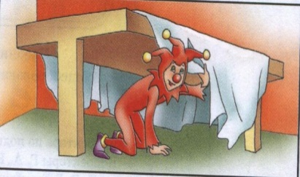
U  I have got a flower above my head. Blue and yellow, green and red. (an umbrella) | 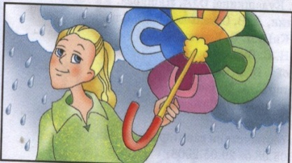
V  Can you dance?  Can you sing?  I can play the violin. | 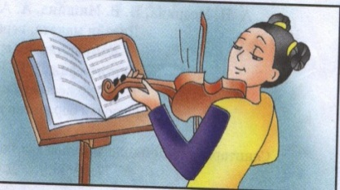
W  Tim is slim, Tim is tall.  He can sit on the wall. | 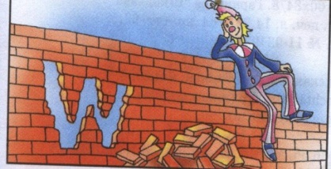
X  I see two funny foxes  With two small boxes. | 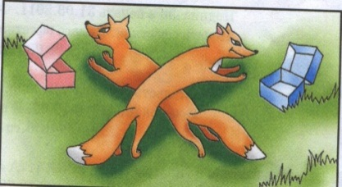
Y  Fly! Fly! In the sky!  My nice and funny kite! | 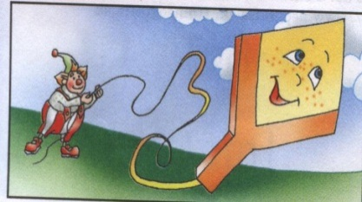
Z  We go, we go, we go to the zoo.  We can see a tiger and a zebra too. | 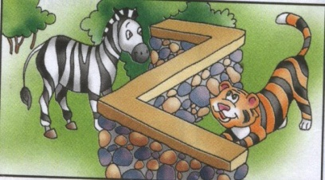

My songs.
The more we are together.
The more we are together, together, together,
The more we are together, the happier we are.
For my friend is your friend, and your friend is my friend
The more we are together the happier we are.

The ABC.
A, B, C, D, E, F, G
H, I, J, K, L, M, N, O, P
Q, R, S, T, U, V, W
Q, R, S, T, U, V, W
X, Y, Z
Oh, well you see,
Now I know the ABC

What is your name?
What is your name? What is your name?
Can you tell me, what is your name?
My name is Alex, my name is Alex.
You won’t forget it, my dear friend.

How old are you? How old are you?
Can you tell me, how old are you?
I am just seven, I am just seven.
And are you older, my dear friend?

Where do you live? Where do you live?
Can you tell me, where do you live?
I live in London, sometimes in Oxford,
Sometimes in Cambridge, my dear friend.

Clap, clap, clap your hands.
Clap, clap, clap your hands,
Clap your hands together.
Stamp, stamp, stamp your feet,
Stamp your feet together.
Touch, touch, touch your cheeks,
Touch your cheeks together.
Shake, shake, shake your hands,
Shake your hands together.
Smile, smile at your friends.
Let us smile together.

Hello! Hello! Hello! What’s your name?
Hello! Hello! Hello! What’s your name?
Hello! Hello! Hello!
My name is John, my name is John.
Hello, John! Hello, John! Hello!
Hello! Hello! Hello! What’s your name?
Hello! Hello! Hello!
My name is Kate, my name is Kate.
Hello, Kate! Hello, Kate! Hello!
Hello! Hello! Hello! What’s your name?
Hello! Hello! Hello!
My name is Andy, my name is Andy.
Hello, Andy! Hello, Andy! Hello!
Hello! Hello! Hello! What’s your name?
Hello! Hello! Hello!
My name is Jenny, my name is Jenny.
Hello, Jenny! Hello, Jenny! Hello!
Hello! Hello! Hello! What’s your name?
Hello! Hello! Hello!
My name is Liza, my name is Liza.
Hello, Liza! Hello, Liza! Hello!
Hello! Hello! Hello! What’s your name?
Hello! Hello! Hello!
My name is Scot, my name is Scot.
Hello, Scot! Hello, Scot! Hello!

My poems.
1.  One hen, two hens,  Three hens, four,  Five hens, six hens,  Seven hens, more. | 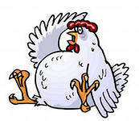
2.  One and two  I and you,  One, two, three  He and she. | 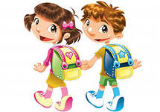
2.
I like to read,
I like to write,
I like to study every day.
I like to jump,
I like to run,
I like to play,
It’s fun.
3.  Green frog, green frog.  Where do you live?  I live in the forest,  I live in the zoo.  And what about you? | 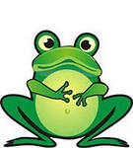
4.  Brown, brown bear.  Where do you live?  I live in the forest.  I live in the zoo.  And what about you? | 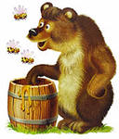
5.  A pig went to town to buy a stick  What? A pig with a stick?  A sick for a pig?  Who ever saw a pig with a stick? | 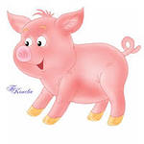
6.  I am slim.  He is fat.  He is merry.  I am sad. | 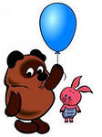
7.  A cat went to town to buy a hat  What? A cat with a hat?  A hat for a cat?  Who ever saw a cat with a hat? | 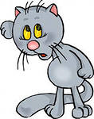
8.  A dog went to town to buy a frog  What? A dog with a frog?  A frog for a dog?  Who ever saw a dog with a frog? | 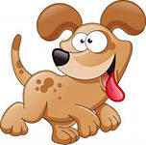
9.  He is a boy. His name is Jim.  She is a girl. Her name is Jill.  They sing together every day.  They can speak English, read and play! | 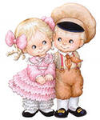
10.
Ssss! It’s a snake!
Zzzz! It’s a bee!
Sh! It’s she!
Bump! It’s me!
11.  I have got ten fingers.  I have got ten toes.  I have got two eyes.  And only one nose.  I touch with my fingers.  I dance on my toes.  I see with my eyes.  And everyone knows.  I smell with my nose. | 