Муниципальное автономное общеобразовательное учреждение

«Средняя общеобразовательная школа № 35»

***Внеклассное мероприятие по английскому языку***

***“Know How”***

***4 класс***

Учитель английского языка

Котова Г.С.

2014-15 уч. год

**Quiz “KNOW HOW”**

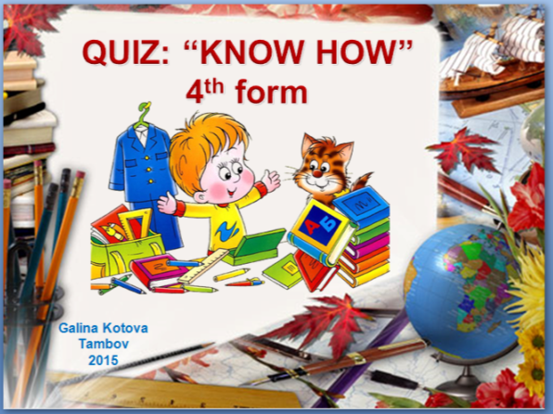

Данная игра представляет собой викторину на английском языке, составленную на основе шаблона «Своя игра».

Викторина предназначена для проведения внеклассного мероприятия в 4 классах.

**Цели:** расширение лексического запаса, обобщение лексико-грамматических знаний и повышение интереса к изучению языка.

Познавательно-развлекательная форма проведения мероприятия делает его востребованным приемом в групповой методике преподавания.

Викторина состоит из 3 разделов:

Vocabulary (упражнения на знание активной лексики)

Grammar (упражнения на знание английской грамматики)

Read & think (упражнения на умение работать с текстом, ребусы)

Каждый раздел включает в себя 5 вопросов, оценивающихся в 10, 20, 30, 40 и 50 баллов.

**Форма проведения:**

Две-три группы учащихся по 5-6 человек.

Желательно присутствие болельщиков.

Жюри из 2-3 учителей считает баллы и разрешает спорные вопросы.

**Оборудование:** PC, проектор, интерактивная доска, раздаточный материал для участников игры, цветные карандаши, призы победителям.

**Правила проведения**

1. Каждая группа выбирает капитана, в задачу которого входит объявление номера вопроса, который команда намерена открыть, а также подача сигнала о  готовности группы к ответу.
2. Капитаны поднимают руку только после того, как вопрос полностью озвучен. Если рука поднята раньше, команда лишается права ответа на данный вопрос.
3. Ответы на вопросы викторины должны звучать на английском языке. За правильный ответ на русском языке баллы уменьшаются вдвое.
4. Право первого хода получает команда, правильно ответившая на первый (внеконкурсный) вопрос ведущего.
5. Право на каждый следующий ход получает команда, правильно ответившая на предыдущий вопрос.
6. После раскрытия всех клеточек с вопросами викторины жюри объявляет баллы, набранные командами.
7. Награждение команды победителей.

**Vocabulary**

**Task1 / 10 points**

a) You can smell with your **…**

b) You can see with your **…**

c) You can touch with your **…**

d) You can eat with your **…**

e) You can hear with your **…**

f) You can kiss with your **…**

**Task2 / 20 points**

|  |  |
| --- | --- |
| 0 |  |
| 1 |  |
| 2 |  |
| 3 |  |
| 4 |  |
| 5 |  |

**Task 3 /30 points**

1. Which lesson does Lucy have on Mondays at ten o’clock?
2. Which lesson does Lucy have on Mondays at one o’clock?
3. Which lesson does Lucy have on Tuesdays at eleven o’clock?
4. Which lesson does Lucy have on Tuesdays at two o’clock?
5. Which lesson does Lucy have on Wednesdays at ten o’clock?

**Grammar**

**Task 1/10 points**

1. The apple is ______________ the table.

2. The pen is _______________the notebook

3. The pencil is ____________ the big apple.

4. The chair is ______________ the desk.

5. The girl is reading __________________ the chair.

6. The cat is _________________ the box.

7. The girl is standing _________________ the board.

**Task 2/20 points**

Dogs are ___________ than cats.

Elephants are the _____________animals in the world.

Tigers are as_____________ as wolves.

Swans are the _______________ birds in the world.

The kangaroo jumps________________ than rabbits.

**Task 3/30 points**

|  |
| --- |
|  |
|  |
|  |
|  |
|  |

**Task 4/40 points**

1.February is the _____________ month in a year.

2. **_______________** will you go next summer?

3.Tom doesn’t like to **_____________** his hands and face.

4. He **________________** this book tomorrow.

5. **__________________** the break we play games.

**Task 5/50 points**

Hi! I ____ Pow. I ___103 years old. I ___got three hands and three legs.My nose ___very big. I ___got two eyes. One eye ___small and the other ___big.

They ____my best friends: Fify and Mud. Fify ___102 years old. She ___ pretty. She ___got two hands and four legs. Her nose ___big and she ___got two eyes. Mud ___104 years old. He ___ funny. He ___got six legs and four arms. His nose ___very big and he ___ got five eyes!

4 - 5 - 6 -

**Read & think**

**Task 1/10 points**

**Read the text and fill in the blanks by using the past form of the verbs given (14 points):**

Yesterday Billy (get) ___up early. The weather (be) ___not fine. It (be) ___cloudy and cold. He (make) ___his bed, (do) ___morning exercises and (go) ____to the bathroom. There he (wash) ______ his face and hands and (clean) _______ his teeth. Then, he (have) ____ breakfast, (dress) _______, (take) _____ his schoolbag and (go) ____ to school.

In the street there (be) ____ many puddles. When he (get) ___ to school, he (not see) __________any students in the yard. “Oh, today is the first day of my holidays. Children don’t go to school on holidays. Wow!!!”

**Task 2/20 points**

|  |  |
| --- | --- |
| **A** |  |
| **B** |  |
| **C** |  |
| **D** |  |
| **E** |  |
| **F** |  |

**Task 4/40 points**

* The coldest place on the Earth is the Antarctic.
* Man can live in the Antarctic all the time.
* People from all over the world do science in the Antarctic.
* The African continent is the windiest.
* The biggest desert is in Africa.
* People in Africa do not speak many languages.

**Task 5/50 points**

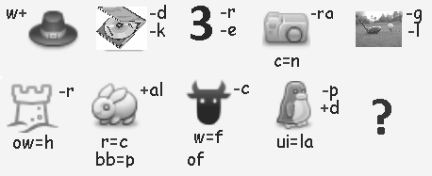

**Keys:**

**Vocabulary**

**Task 1**

a) You can smell with your **nose**

b) You can see with your **eyes**

c) You can touch with your **fingers**

d) You can eat with your **mouth**

e) You can hear with your **ears**

f) You can kiss with your **lips**

**Task 2**

|  |  |
| --- | --- |
| 0 | D |
| 1 | C |
| 2 | E |
| 3 | F |
| 4 | A |
| 5 | B |

**Task 3**

1. Which lesson does Lucy have on Mondays at ten o’clock? ***English***

2. Which lesson does Lucy have on Mondays at one o’clock? ***Maths***

3. Which lesson does Lucy have on Tuesdays at eleven o’clock? ***Swimming***

4. Which lesson does Lucy have on Tuesdays at two o’clock? ***Computer***

5. Which lesson does Lucy have on Wednesdays at ten o’clock? ***Science***

**Task 4**

There is no ball in the room.

There is no lamp in the room.

There is no cat in the room.

There is no flower in the room.

There is no computer in the room.

**Grammar**

**Task 1**

1. The apple is under the table.

2. The pen is near the notebook

3. The pencil is in front of the big apple.

4. The chair is next to the desk.

5. The girl is reading on the chair.

6. The cat is in the box.

7. The girl is standing at the board.

**Task 2**

Dogs are cleverer than cats.

Elephants are the bigger animals in the world.

Tigers are as dangerous as wolves.

Swans are the most beautiful birds in the world.

The kangaroo jumps better than rabbits.

**Task 3**

Don’t sit on that chair!

Have they got a new car ?

There are three children in the room.

They played football last Saturday.

Will the children go to their granny next weekend ?

**Task 4**

1.February is the shortest month in a year.

2. Where will you go next summer?

3.Tom doesn’t like to wash his hands and face.

4. He will read this book tomorrow.

5. During the break we play games.

**Task 5**

Hi! I am Pow. I am103 years old. I have got three hands and three legs. My nose is very big. I have got two eyes. One eye is small and the other is big.

They are my best friends: Fify and Mud. Fify is 102 years old. She is pretty. She has got two hands and four legs. Her nose is big and she has got two eyes. Mud is 104 years old. He is funny. He has got six legs and four arms. His nose is very big and he has got five eyes!

**5-Mud**

**6-Fify**

**4-Pow**

**Read & think**

**Task 1**

Yesterday Billy got up early. The weather was not fine. It was cloudy and cold. He made his bed, did morning exercises and went to the bathroom. There he washed his face and hands and cleaned his teeth. Then, he had breakfast, dressed, took his schoolbag and went to school.

In the street there were many puddles. When he got to school, he didn’t see any students in the yard. “Oh, today is the first day of my holidays. Children don’t go to school on holidays. Wow!!!”

**Task 2**

|  |  |
| --- | --- |
| **A** | **5** |
| **B** | **3** |
| **C** | **6** |
| **D** | **1** |
| **E** | **2** |
| **F** | **4** |