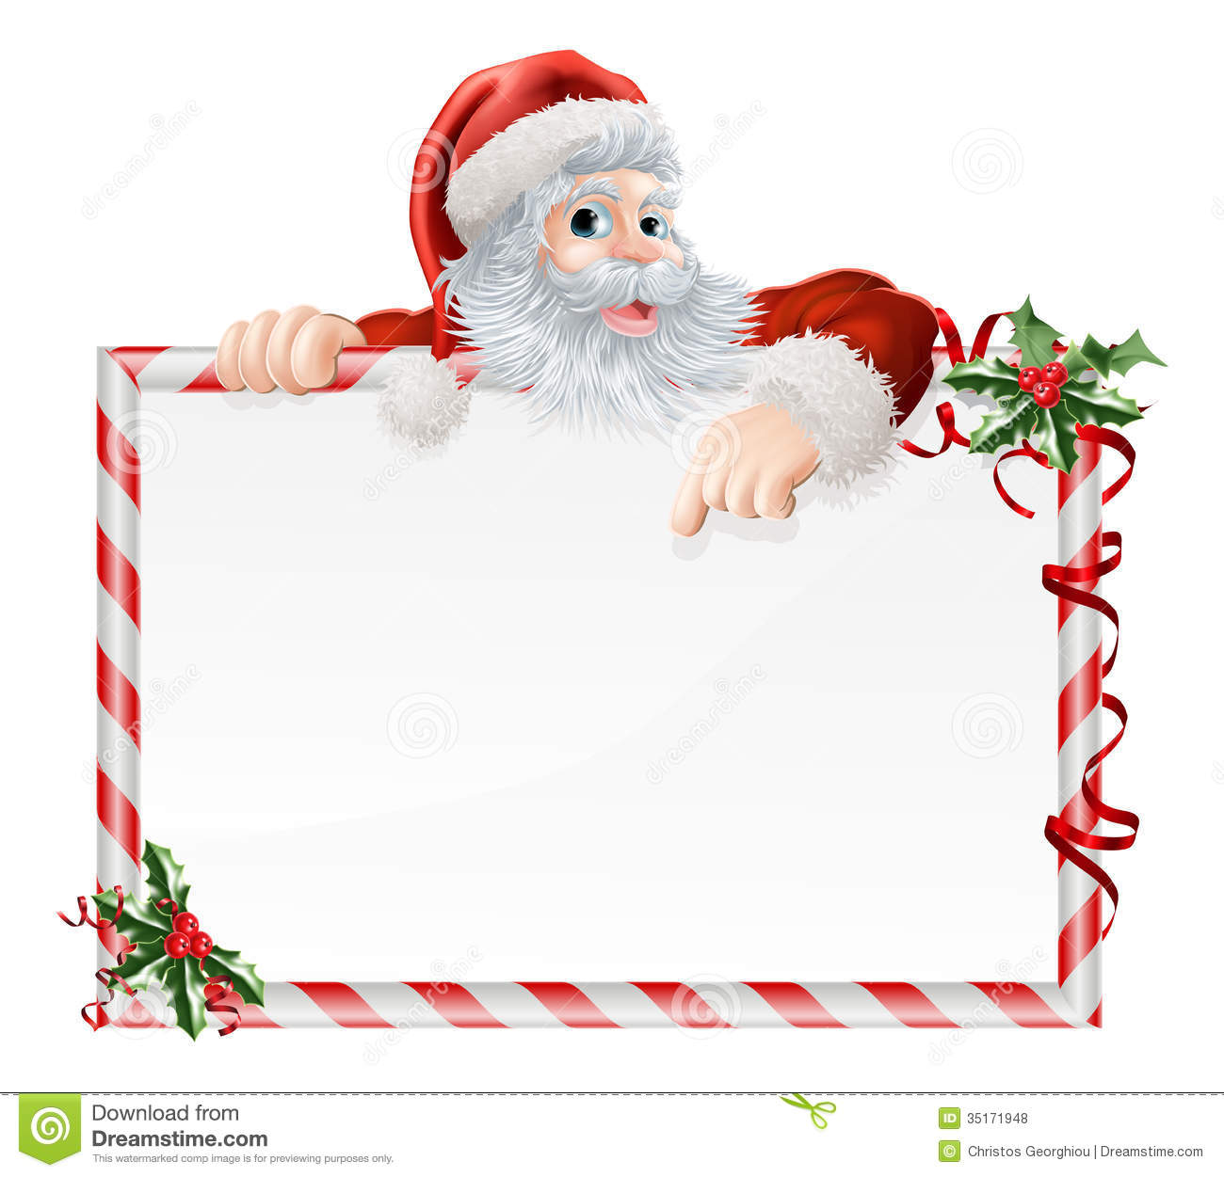v Santa’s List

*Name______________*

*Nice | Naughty*

*1 helping mum _____ _____*

*2 good at school _____ ______*