Читать
- I am playing the guitar, I am playing the piano, I am riding a horse, I am riding a bike, He is driving a car, He is swimming, He is running, He is jumping, She is flying, She is dancing, You are playing football, You are playing tennis, We are playing basketball, They are singing.
- Вставить нужную форму - To Be
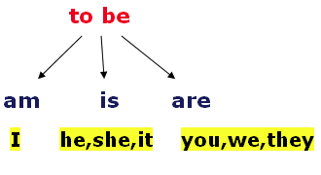

- I___ playing football.
I___flying
I___dancing
He____playing tennis
He____swimming
She____playing the piano
You___playing the guitar
They___singing.
- Составить предложения в длительном времени, прочитать, перевести.
Словарь: Play, dance, sing, run, fly, jump, walk, swim, ride. + ing
I am_________________
I am_________________
He is________________
He is_________________
She is_________________
She is_________________
You are________________
You are________________
They are_______________
- Новые слова с переводом: House-дом, Kitchen-кухня, Hall-прихожая, Living room - зал, room-комната, dining room-столовая, bed-кровать, bedroom-спальня, bathroom-ванная комната.

