[t]
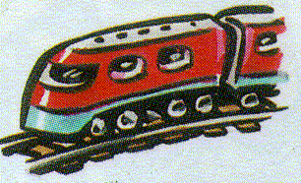
The trip by train took tiresome twenty-two hours.

