1 Listening Comprehension
Last year two British pupils, Jane Martin and Mark Kernel, were on exchange programme in the USA. Their teacher is asking them about their impressions.
Listen to the conversation. Mark the following information with T if it is true and with F if false. You will hear the recording twice. (true/false)
- Pupils in Britain have to go to school assembly every morning.
- In the USA schoolchildren have Religious Education.
- After school British children usually go home.
- In America there are a lot of after school activities for children.
- Jane and Mark wore a school uniform at their host school in America.
2 Reading Comprehension
Marcy is the character of Paula Danziger's book "The Cat Ate My Gymsuit".
Read the passage from the book and write down the letter of the picture that corresponds to description of Marcy best. (matching)
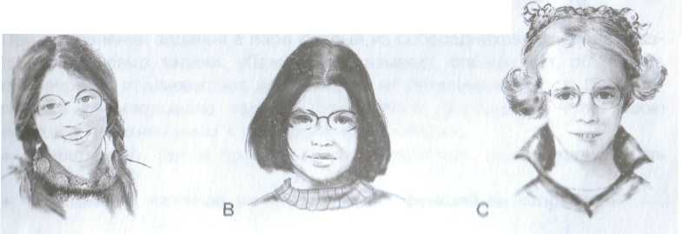
I hate my father. I hate school. I hate being fat. I hate the principal (Br headmaster) because he wanted to fire (уволить) Ms Finney, my English teacher
My name is Marcy Lewis. I'm thirteen years old and in the ninth grade Dwight D. Eisenhower Junior High.
All my life I've thought that I looked like a baby blimp (увалень) with glasses (очки) and mousy brown hair. Everyone always said that I'd become an adolescent (teenager) blimp with glasses, mousy brown hair, and acne (прыщи).
My life is not easy. I know I'm not poor. Nobody beats me. I have clothes to wear, my own room, a stereo, a TV, and a push-button (с кнопками) phone Sometimes I feel guilty being so miserable, but kids have problems too.
Stuart, my four-year-old brother, wants to be my best friend so that I can help him to put orange pits (косточки) in a hole in his teddy bear's head.
I never had any friends, except Nancy Sheridan. She's very popular, but her mother and mine are old friends, so I always believed that Mrs Sheridan made her talk to me — Beauty and the Blimp. School is a bummer (безделье). The only writing I could do was letters to the Student Council suggestion box. Lunches are lousy (отвратительные). We never learned anything good, at least till Miss Finney came along. So my life is not easy.
2) Complete the fact file about Marcy. Use the information from the passage. There is an example (0) at the beginning. (note making)
0. Name | Marcy Lewis
1. Age
2. Class
3. School's name
4. Family members
5. Friend's name

3) Mark the information about Marcy with T if it is true and with F if it is false. (true/false)
1. Marcy is from a poor family.
2. Marcy does not have a lot of friends.
3. Marcy has got a lot of problems.
4 . Marcy is not happy at school.
5. Marcy likes the way she looks.

3 Use of English (Grammar / Vocabulary)

1 . These are the notices at one of British schools.
Fill each of the gaps in the notices with the correct form of the words from the box. (modified cloze)
attentive bad careful clear hard neat polite quiet
SCHOOL NOTICE BOARD
Read each notice (1) _____ Do not make NOISE! Walk around the school (2)________. All pupils who behave (3) _______ must see the HEADMASTER. Do not be RUDE - talk (4)_______. In exams-REMEMBER! Read the questions (5)_______first. Answer the questions (6)_______. Write (7)_______. Work (8)_______!

2.. Read the explanations for each group of words (a-d) below.
Write down the word that does NOT match the explanation. There is an example (0) at beginning. (odd one out)
0. They are people at school.
a) teacher b) student c) scholarship d) pupil
1. The way you do things.
a) assembly b) properly c) slowly d) correctly
2. You can find them in your school timetable.
a) assembly b) registration c) break d) team
3. To achieve much you should ... .
a) try hard b) be back c) do your best d) practise a lot
4. These people need help.
a) homeless b) smart c) disabled d) poor
5. The way we help people around.
a) take care of b) care for c) look after d) look for
6. We can do with the money for charity.
a) raise b) collect c) help d) donate
3. Write about what these people want each other to do. Use the words in brackets. There is an example (0) at the beginning. (transformation)
- Mr Simpson, I want to become better at computers. What should I do? Сan you give me any advice? (I/ask) I ask Mr Simpson to give me some advice
- Jane, you're an ace in Maths. Can you help me with my homework? (David/ask)
- Steve, you're late again. (Teacher/want)
- The headmaster wrote a new rule for pupils at our school: all pupils should wear a school uniform. (The headmaster/want)
- Peter, your room is messy as usual. Clean it up, immediately! (Mum/make)
- I had a lot of fun in the camp. Pat, let's go there together next summer
holidays. (Peter/ask)

4. British children often write to the Young Telegraph (YT) to share their opinions and feelings. Here are some passages from their letters.
Guess how these children feel. Choose the appopriate word underlined. There is an example (0) at the beginning. (multiple choice)
- It's so unfair that there are a lot of football teams for boys. I am sorry/ sure /worry there should be girls' football teams.
- I am sorry/glad/worry that the YT ran an article about disabled children. I really want to help them.
- I am sorry/happy/believe I was born in this country because it is very beautiful.
- I am sorry/hope/believe to hear what some people say about Oxfam. The clothes may be second-hand but they're cheap and clean.
- My favourite sport is gymnastics. I hope/sorry/worry one day, I'll be good enough to represent my country at the Olympics.
- I am glad/hope/worry about how some animals are kept in some zoos. Why can't people look after them more carefully?
- I am glad/sorrv/sure to care for others is really good, because you learn about other people's feelings and needs.
- I believe/sorry/worry that school is the best place to develop your talent.

4.Writing
Different magazines ask their readers to make donations for charity.
Complete the coupon below. Ask for more information about the charity.(filling in a form)
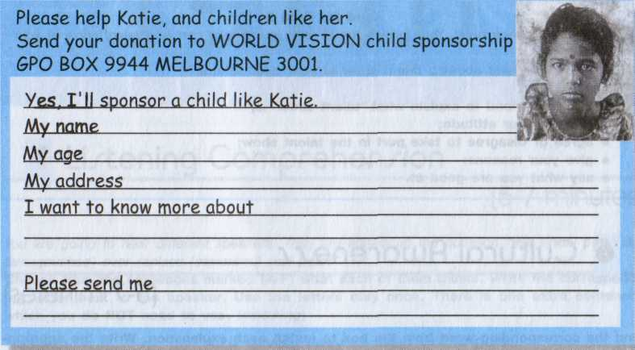

5 Cultural Awareness
Find the corresponding word from the box to match each explanation. Write the appropriate letter next to the explanation. There is an example (0) at the beginning. (matching)
a) the Duke of Edinburgh's Award b) exams c) holidays d) marks e) Mr/Mrs/Ms f) report g) terms h) voluntary organisation
0. с British children have at Christmas, in spring and summer.
1. British children usually have at the end of the school year.
2. British children usually add before the names of their teachers.
3. British schoolchildren have three of them (about 12 weeks each) in the year.
4. Russian schoolchildren have them in numbers, and British schoolchildren have them in the ABC.
5. British teachers write at the end of the year about schoolchildren progress.
6. If you like to help those in need, you can join it.
7. If you are over 14 and you do something useful for your country and people around you, you can have it Bronze, Silver or Gold.

