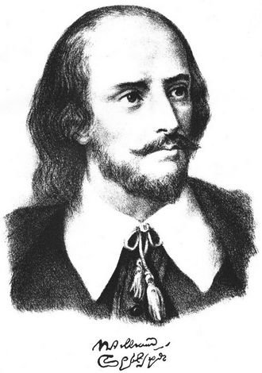
King Lear
(By William Shakespeare 1564 – 1616)

Many centures ago there lived an old king of Britain. His name was Lear. He had three daughters: Goneril, Regan and Cordelia. Cordelia was his favourite child. As Lear was very old, he decided
to divide his kingdom among three daughters.
“I want to divide my kingdom among you,” he said. “The one who loves me most will have the largest part.”
“I love you more than anything in the world”, said Goneril.
“I love you more than my life or my freedom”, said Regan.
“And what do you say, Cordelia?” asked the king.
Cordelia raised her head. “Father”, she said. “I love you no more than a daughter can love her father”.
King Lear was very angry. “Leave me!” he said. “I don’t want to see you ever again!”
He divided his kingdom between Regan and Goneril. Cordelia was given nothing.

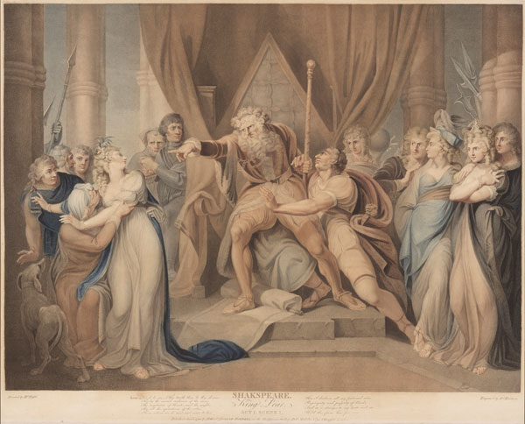
Some time later she left Britain and became the wife of the French king who loved her more than words can tell.
King Lear decided to stay with Goneril. But Goneril who was now rich and powerful did not want to have the old King near her. Lear went to Regan. But Regan said:”I’m not so rich as Goneril and I can’t invite you to stay at my house.”

Now King Lear had no home and no daughters. He was as poor as the poorest man in Britain.
One night a terrible storm broke out. It rained hard and the moon and the stars were behind the clouds. It was cold, wet and dark in the fields.
King Lear had only two friends with him. One was his fool and the other was a knight. The knight’s name was Kent. The fool tried to help the old King, but he could only make jokes
and sing songs.

Here is one of his songs which was translated by S.Marshak.
That, sir, which serves and seeks for gain,  And follows but for form,  Will pack when it begins to rain,  And leave three in the storm.  But I will tarry; the fool will stay,  And let the wise man fly:  The knave turns fool that runs away;  The fool no knave, perdu.  (Act Two, SceneFour) | Кто служит только для того,  Чтоб извлекать доходы,  Тебя оставит одного  Во время непогоды.  Но шут с тобой – твой верный шут.  Служил он не для денег.  Он жалкий шут,  Но он не плут, Дурак, но не мошенник!  (Акт второй, сцена четвертая)

King Lear was very ill and Kent decided to send a man to Cordelia. When Cordelia was told the truth about her father she came to Britain with many soldiers. King Lear was very happy to see his dearest daughter near him. But Goneril and Regan sent out their soldiers and Lear and Cordelia fell into their hands.
Goneril and Regan hated Cordelia and they told their soldiers to kill her.
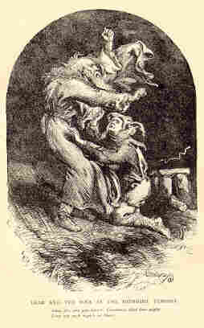
When old Lear saw her as she lay dead at his feet, his heart broke and he died.
Regan and Goneril enjoyed their victory. But there was no friendship between them. They hated each other no less they hated their youngest sister. Goneril killed Regan, but soon died too.

Kent could not live without King Lear, and he said he must go after his master. His words were:
“I have a journey, sir, shortly to go.
My master calls me, I must not say no.”

«Уехать вскоре должен я от вас:
Я слышу короля призывный глас».

Джон Гилберт, гравюра, 19 век

Tasks

- Answer the questions.
1. Have you ever read the story before?
2 Why did King Lear decide to divide the kingdom?
3. Why was Cordelia given nothing?
4. Why did King Lear die?
5. What did Kent’s words mean?
6. How did Regan and Goneril show their true characters?
7. Why did Kent decide to send a man to Cordelia?

- Give literary translation.
1. Cordelia was given nothing.
2. You had better go back to Goneril.
3. He was as poor as the poorest man in Britain.

- Make up sentences (to the story).
- go back on one’s word - нарушить своё слово
- break one’s word (promise) – нарушить своё слово (обещание)
- have one’s back to the wall – быть в безвыходном положении
- turn one’s back on (upon) smb. – отвернуться от кого-л., порвать отношения с кем-л.
- in a brown study – в размышлении, в мрачном раздумье
- as different as chalk from cheese – ничего общего; небо и земля;
- sail under false colours – лицемерить, обманывать; скрывать свои истинные намерения;

- Восстановите по памяти предложения из текста, используя следующие
слова и с/с.
1.favourite child
2. among
3.more than
4. French King
5. not so rich as
6.as poor as
7. two friends

- What is the moral of the tragedy?

Г. Фюзели
Иллюстрация к трагедии. Акт 1. сцена 1. 1792 г. (для варианта учителя)

Иллюстрации: http://images.yandex.ru/

