**КОНТРОЛЬНАЯ РАБОТА ПО АНГЛИЙСКОМУ ЯЗЫКУ ДЛЯ 4 КЛАССА UNIT 7.**

1. **Посмотри на рисунки. Напиши, что на них изображено.**

It’s a pencil box.**clip_image002.jpg** It’s a  **clip_image002.jpg**

It’s a  **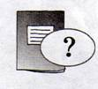** It’s a  **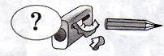**

It’s a  **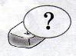**

1. **Прочитай, посмотри на рисунки и впиши недостающие слова.**

Hi! I’m Mag. Look at the photo of my **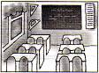** classroom.It’s big and nice. There are twenty desks, a **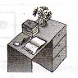\_\_\_\_\_\_\_\_\_ ,** a big **\_\_\_\_\_\_\_\_\_\_** on the wall, a bookshelf with books, three **\_\_\_\_\_\_\_\_\_** and a lot of **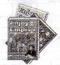\_\_\_\_\_\_\_\_\_\_ ,** a TV and ** \_\_\_\_\_\_\_\_\_\_** in my classroom. We also have a tape recorder and a lot of **\_\_\_\_\_\_\_\_\_\_.**

We like to listen and sing songs in our English lessons.

1. **a) Составь словосочетания.**

|  |  |
| --- | --- |
| sing | pictures |
| speak | songs |
| learn | from English into Russian |
| translate | English |
| draw | poems by heart |

1. **Используй составленные словосочетания и закончи предложения.**

Example: Mag and her friends **translate from English into Russian** in their Russian lessons.

1. They \_\_\_\_\_\_\_\_\_\_ in their English lessons.
2. They \_\_\_\_\_\_\_\_\_\_ in their Reading lessons.
3. They \_\_\_\_\_\_\_\_\_\_ in their Music lessons.
4. They \_\_\_\_\_\_\_\_\_\_ in their Art lessons.
5. **Посмотри на картинки и прочитай предложения. Выбери и обведи нужное слово.**

Example: This\that is my bag.

**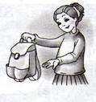 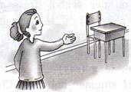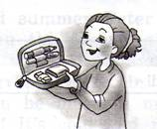**

This\that is my desk. This\that is my pencil box.

**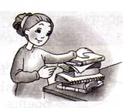 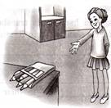**

These\those are my textbooks and workbooks. These\those are my coloured pencils.

1. **Прочитай текст. Раскрой скобки и поставь глаголы в Past Simple.**

Yesterday Mag (get) got up early. The weather (be) \_\_\_\_\_ fine. She (wash) \_\_\_\_\_ her hands and face, (clean) \_\_\_\_\_ her teeth in the bathroom. Then, Mag (put) \_\_\_\_\_ on her school dress and (take) \_\_\_\_\_ her bag. Then she (go) \_\_\_\_\_ to school.

It (be) \_\_\_\_\_ sunny and warm. When she (get) \_\_\_\_\_ to school, she didn’t see any pupils in the yard (во дворе). Mag (say) \_\_\_\_\_: “Oh! But today is the first day of summer holidays. Children don’t go to school on holidays”.