**КОНТРОЛЬНАЯ РАБОТА ПО АНГЛИЙСКОМУ ЯЗЫКУ ДЛЯ 4 КЛАССА UNIT 6.**

1. **Прочитай текст и раскрась картинку.**

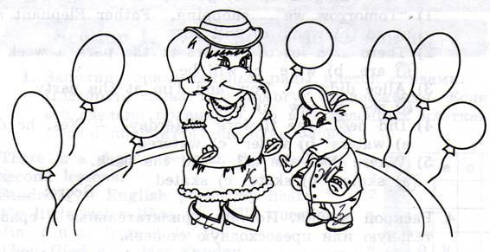

Look at Baby Elephant and his Mother Elephant! They are happy and merry.

Baby Elephant has his birthday today. His friends will come to his party. Baby Elephant has green trousers and a yellow T-shirt on. His shoes are brown. His cap is blue. Mother Elephant has a red dress on. Her hat and shoes are black. Mother Elephant and her Baby Elephant are ready (готовы) for the party.

1. **Закончи предложения. Употреби выделенные глаголы в Past Simple.**

Example: The Baby Elephant didn’t **go** to the park yesterday. He **went** shopping.

1. They didn’t **see** Martin. They _____ Billy and Tiny.
2. Alice didn’t **buy** mittens. She _____ a scarf.
3. Tiny didn’t **write** a new fairy tale last Sunday. He ___ a poem.
4. Mrs. Tiger didn’t **make** socks for Baby Elephant. She _____ new trousers.
5. His friends didn’t **have** tea at the party. They _____coffee.
6. **Выбери правильное слово. Обведи соответствующую букву.**

**Example:** Tiny … early every day. a) gets up b) got up c) will get up

1. “Tomorrow we … shopping,” Father Elephant said. a) go b) went c) will go
2. There … a lot of flowers in the park a week ago. a) are b) were c) will be
3. Alice didn’t … Tom and Tim at the party. a) see b) saw c) sees
4. Did he … the flowers yesterday? – Yes, he did a) waters b) water c) watered
5. Where does she … ? – In the park. a) skates b) skate c) skated
6. **Раскрой скобки. Поставь прилагательные в сравнительную или превосходную степень.**

**Example:** The trainers are **bigger** than his shoes. (big)

1. The blue scarf is _____ than the green scarf. (warm)
2. I think the blue jeans are the _____. (good)
3. Look! The red T-shirt is _____ than the yellow T-shirt. (small)
4. Mag’s dress is the _____. (beautiful)
5. This black umbrella is the _____. (bad)
6. **Вставь пропущенные слова: some, any, no.**
7. - Would you like _____ apple juice?

* Yes, please. I’d love _____.

1. Have you got _____ apples?

* No, sorry. I haven’t got _____ apples. But I have got _____ oranges.
* I’m afraid I don’t want _____ oranges. I would like apples.

1. – Mag, is there _____ bread at home?

* No, there is _____ bread at home.
* I hope you’ll go and buy some.