**КОНТРОЛЬНАЯ РАБОТА ПО АНГЛИЙСКОМУ ЯЗЫКУ ДЛЯ 4 КЛАССА UNIT 3.**

1. **Восстанови рисунки и напиши, что на них нарисовано.**

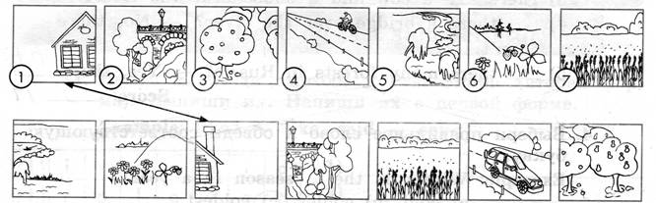

|  |  |  |
| --- | --- | --- |
| 1) a house | 4) ______ | 6) ______ |
| 2) ______ | 5) ______ | 7) |
| 3) ______ |

1. **Восстанови письмо, вставив пропущенные слова.**

|  |
| --- |
| beautiful, write, in the country, behind, mountains, swim, river |

Dear, Alex

Thank you for your letter. I am Vova. I am from Russia. My country is large and ____________. There are many cities and towns in Russia. But I live __________. I live with my mum and dad. Our house isn’t big. There is a green garden with apple trees and flowers _________ my house. There is a river next to the forest. My friends and I _________ there in summer. There is an old bridge over the _________. We’ve got a cow, five sheep, a horse, a dog and a cat. I like to read books about seas, oceans, _________ and deserts.

_________ me about your country and your town, please.

Your pen friend,

Vova

1. **Прочитай предложения и вставь *is* или *are.***
2. There _____ a nice garden behind the house.
3. There _____ a lot of big apple trees in the garden.
4. There _____ a cow and a house near the river.
5. _____ there a bridge over the river? – No, there _____n’t.
6. _____ there many forests in Russia? – Yes, there.
7. **Выбери правильное слово и обведи соответствующую букву.**

**Example:** Winter is the … season in a year.

1. cold b) colder c) coldest
2. John is … than his brother.
3. tall b) taller c) tallest
4. February is the … month.
5. short b) shorter c) shortest
6. Moscow is one of the… cities in the world (в мире).
7. beautiful b) more beautiful c) most beautiful
8. The new road is … than the old road.
9. wide b) wider c) the widest
10. Tiny is … pupil.
11. good b) better c) best
12. **Составь предложения.**

**Example**: is, cleaner, The country, the town, than. – The country is cleaner than the town.

1. my house, His house, smaller, than, is. - ­­­­­­­­­­­­­­­­­­­­­_____________________________________________
2. is, his garden, bigger, Ann’s garden, than. - __________________________________________
3. the, sea, is, The, ocean, larger, than. - _______________________________________________
4. flowers, the, Her, beautiful, most, are. - _____________________________________________
5. best, pupil, the, is, he. - __________________________________________________________