**КОНТРОЛЬНАЯ РАБОТА ПО АНГЛИЙСКОМУ ЯЗЫКУ ДЛЯ 4 КЛАССА UNIT 1.**

1. **Напиши, какая погода изображена на рисунках. What is the weather like?**

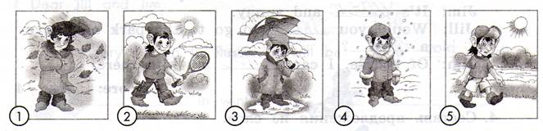

1. It’s cold and windy.
2. _______________.
3. _______________.
4. _______________.
5. _______________.
6. **Посмотри на картинки и прочитай предложения. Выбери и обведи нужное слово.**

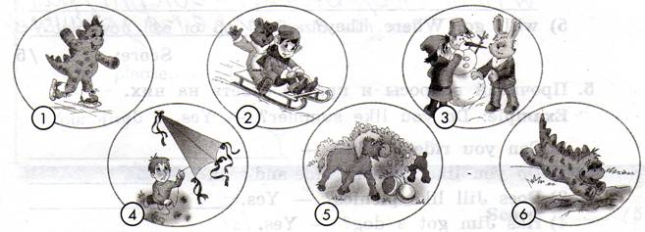

1. Dino can **skate\ski.**
2. Tiny and Billy like to **toboggan\ride a scooter.**
3. Martin and Tiny can **make a snowman\play snowballs.**
4. Jim can **fly a kite\ride a bike.**
5. Jack and Donkey like to **play hide-and-seek\play snowballs.**
6. Dino can **dive\draw.**
7. **Прочитай и вставь пропущенные слова.**

|  |
| --- |
| picnic, weather, fly, warm, like |

Jill: What’s the weather like today?

Jim: It’s ___ and sunny.

Jill: Would you ___ to go to the park and have a ___?

Jim: Of course. I can ___ my kite there.

1. **Составь предложения из слов.**

**Example:** Jim, will, have, picnic, a, Jill, and. – Jim and Jill will have a picnic.

1. will, a, kite, fly, Jim. **- ______________________________________________________________**
2. play, won’t, He, football.____________________________________________________________
3. will, hide-and-seek, dog, play, her, Jill, with.____________________________________________
4. they, Will, badminton, play, park, the, in? ______________________________________________
5. will, go, Where, they? ______________________________________________________________
6. **Прочитай вопросы и кратко ответь на них.**

**Example:** Do you like summer? – Yes, I do.

1. Can you ride a bike? - ______________________
2. Do you like to play hide-and-seek? - ___________
3. Does Jill like picnics? – Yes, _________________
4. Has Jim got a dog? – Yes, ___________________
5. Will they play football in the park? – No, _______
6. Are they students? – Yes, ____________________
7. Is Jill sad today? – No, ______________________
8. **Прочитай письмо, посмотри на рисунки и впиши недостающие слова.**

Dear Jill and Jim,

In January I’ll go to Russia. It will be 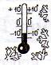 cold and  _______ in winter.

I’ll 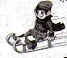 _______ and play snowballs. I’ll make a funny _______.

I’ll 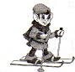 _______ in the park. I won’t 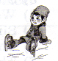 _______ because I can’t.

In the evening I’ll tell my Russian friends New Year fairy tales.

Would you like to go to Russia with me?

Write, please.

Your Tiny