Часть 1. Аудирование

Что делать: послушай 5 диалогов и подчеркни нужное слово.

Как делать: прочитай пять вопросов. Прочитай варианты ответов. Послушай пять мини-диалогов и подчеркни нужный ответ напротив каждого вопроса.
ВНИМАНИЕ! Прослушай пример. Ты услышишь запись каждого диалога два раза.

Пример: 0. What does Kate like to eat? Apples/bananas

1. When did Richard visit his grandparents? Last month/last week

2. How old is Sue’s brother? 8/10

3. What is Tom’s uncle? Pilot/ engineer

4. Where does William live? Flat/house

5. What day did Harry see a football match? Friday/Saturday

Часть2. Чтение. Письмо.

Задание1.

Что делать: подбери подходящий транскрипционный значок к каждой букве или буквосочетанию.
Как делать: впиши нужный транскрипционный значок в пропуск.

Пример: 0.p [p]

- g ________
- ck _______
- qu _______
- wh _______
- th _______

[θ] [kw] [w] [k] [p] [ʤ]

Задание 2.

Что делать: cобери слово из предложенных букв.
Как делать: прочитай слово по-русски. Посмотри на английские буквы. Напиши английское слово с этим же значением, поставив буквы в нужном порядке.

Пример:0. часто ntfoe often

1. строить diulb ____________

2. вчера syteeyard ____________

3.умный rlvece ______________

4.завтра mrotowro _______________

5.погода rewtaeh ________________

Задание 3.

Что делать: найди одну ошибку в каждом предложении.
Как делать: прочитай предложения1-5. Найди одну ошибку в каждом предложении и подчеркни ее. Перепиши предложения без ошибок.

Пример: 0. Are there much animals in the forest?

Are there many animals in the forest?

- In autumn the days grows shorter.
________________________________________________

- He left in London yesterday.
__________________________________________________

- I had very good time last summer.
_________________________________________________

- We were happy to see this fims.
_________________________________________________

- Yesterday it is my friend’s birthday.

__________________________________________________

Задание 4.
Что делать: Выбери нужное слово.
Как делать: Прочитай текст и предложенные слова для каждого пропуска. Впиши подходящее по смыслу слово в пропуск.

Monday.

It is Monday. We have four classes 0. today. We come 1.__________ school early in the morning and go straight to the classrooms. The 2. _______________ class is English. 3._____________ begins at half past eight. The teacher 4.________________ in and we say “Good morning!” 5. _________________ read, write and play during our English lessons. It’s fun.

0. today yesterday tomorrow
1. after from to
2. first last good
3. they it he
4. smiles comes sits
5. I They We

Задание 5.
Как делать: Прочитай письмо с пропусками. Определи, как нужно заполнить каждый пропуск. Впиши нужную информацию в пропуск.

__________________________________,
Thank you for your letter. How are you?
These are some pictures of my flat. We live _______________________________. My flat is very __________________________. My favourite place in the flat is _____________________ because ______________________________________________________________________. What is ___________________________________?
Write soon.
___________________________,
___________________________

Часть3 .ГОВОРЕНИЕ

Задание 1.

Что сделать: Ответь на вопросы о себе.

Пример:
- Teacher: How are you?
You: Fine thanks.

Questions:
- What is your name?
- What is your family name?
- How old are you?
- Where do you come from?
- How many people are there in your family?
- What are your parent’s names?
- What do your parents do?
- What do your parents do at the weekends?
- What languages do you learn at school?
- What languages can you speak?
- What grade are you in?
- What subjects do you study?
- What are your favourite subjects?
- What subjects are you good at?
- How long does it take you to do your homework?
- What time do you usually wake up?
- What time do you get up?
- What do you do after getting up?
- What time do you have breakfast?
- What do you have for breakfast?
- What time do you go to school?
- How long does it take you to get to school?
- How do you get to school?
- What time do you come home after school?
- What time do you have lunch?
- Where do you have lunch?
- What do you have for lunch?
- What do you do after lunch?
- How do you spend your free time?
- How do you help your parents about the house?
- How many rooms are there in your flat?
- What furniture is there in your flat?
- What is your favourite room?
- What piece of furniture would you like to have in your room?
- When do you have dinner?
- What don’t you like to eat?
- How many meals a day do you have?
- How often do you eat fast food?
- What are your hobbies?
- How many friends do you have?
- What is your best friend’s name?
- How old is your friend?
- What is your best friend’s hobby?
- Where do you like to go with your friend?
- How many days a week do you go to school?
- What is your favourite day of the week?
- How did you spend your last weekend?
- What do you do after school?
- When do you have your holidays?
- What are your plans for next summer holidays?

Задание2. Опиши картинку, используя следующие опоры:

In the picture I can see ___________________________________
She is _________________________________________________
She has got ____________________________________________
There _________________________________________________
I think she _____________________________________________

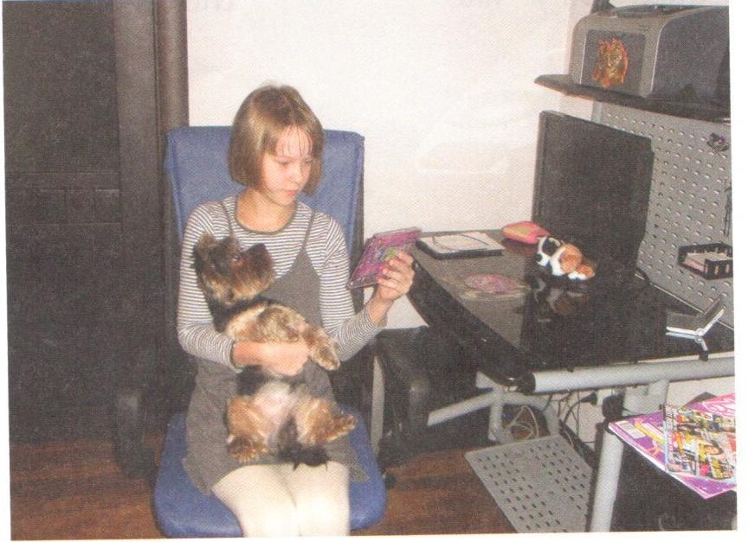

Список учебной литературы:
- Е.Н. Соловова, А.Б. Година, Е.А. Пореченкова "Английский язык.Базовый уровень. Итоговая аттестация.", Москва 2014.
- А.Б.Година"Английский язык. Итоговая аттестация. Тематические задания", Москва 2014.

