Разработка внеклассного мероприятия на тему
Толерантность
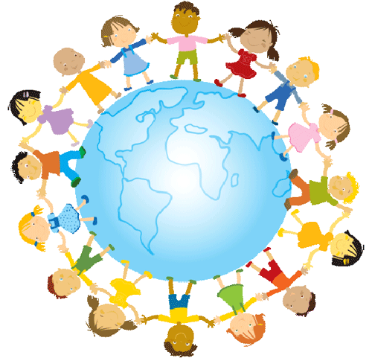
Tolerance

Класс: 8 «а» МБОУ СОШ №4
Разработала: Корниенко В.А

ст.Ольгинская 2012

Тема мероприятия: «Tolerance» («Толерантность»)

Основные цели и задачи:
1. Развивать навыки коммуникативной компетенции по видам речевой деятельности в области:

2. Практиковать учащихся в употреблении нового лексического материала по теме “Tolerance”.

3. Знакомить учащихся с некоторыми страноведческими понятиями, такими как «Организация Объединенных Наций», «Генеральная Ассамблея», расширять их кругозор.

4. Развивать психологические характеристики мыслительной деятельности учащихся, включая внимание, память, логическое мышление, языковую догадку.

5. Содействовать повышению интереса и мотивации к изучению иностранного языка. Побудить учащихся совершенствовать свой уровень владения языком во всех видах речевой деятельности.

6. Содействовать воспитанию толерантности, политической грамотности в их повседневной жизни.

Конспект мероприятия:

1)Good afternoon!
Today we are going to speak about “Tolerance”.
Tell me, what does it means?
Tolerance
In its broadest sense, the word "tolerance" (incidentally, comes from the Latin tolerantia, you have the patience) implies tolerance of others' opinions and actions, the ability to relate to them without irritation. In this sense, tolerance is a rare trait. Tolerant person respects the beliefs of others, not trying to prove its exclusive right. In a narrower sense, the notion of "tolerance" is used in medicine. Here, tolerance - is the body's ability to transfer without loss of the negative influence of the environment.
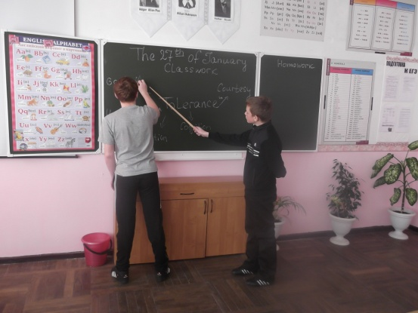
How can we describe this word?
(Pupils talk about tolerance)
This word includes:
Good will
Understanding
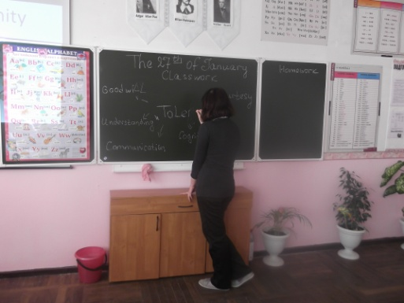
Communication
Cognition
Courtesy
Tolerance,
Internationalism
Humanism
Kindness to others
2) To be tolerant you should know and observe human rights in order not to offend other people and not to be offended by others. Do you agree? So, what do you know about human rights? Not much, as I see. Now, let’s continue our lesson. I hope that by the end of this lesson you’ll know much more on the topic.
Human rights set out in the Declaration
The following reproduces the articles of the Declaration which set out the specific human rights that are recognized in the Declaration.
Article 1
All human beings are born free and equal in dignity and rights. They are endowed with reason and conscience and should act towards one another in a spirit of brotherhood.
Article 2
Everyone is entitled to all the rights and freedoms set forth in this Declaration, without distinction of any kind, such as race, colour, sex, language, religion, political or other opinion, national or social origin, property, birth or other status. Furthermore, no distinction shall be made on the basis of the political, jurisdictional or international status of the country or territory to which a person belongs, whether it be independent, trust, non-self-governing or under any other limitation of sovereignty.
Article 3
Everyone has the right to life, liberty and security of person.
Article 4
No one shall be held in slavery or servitude; slavery and the slave trade shall be prohibited in all their forms.
Article 5
No one shall be subjected to torture or to cruel, inhuman or degrading treatment or punishment.
Article 6
Everyone has the right to recognition everywhere as a person before the law.
Article 7

All are equal before the law and are entitled without any discrimination to equal protection of the law. All are entitled to equal protection against any discrimination in violation of this Declaration and against any incitement to such discrimination.
Article 8
Everyone has the right to an effective remedy by the competent national tribunals for acts violating the fundamental rights granted him by the constitution or by law.
Article 9
No one shall be subjected to arbitrary arrest, detention or exile.
Article 10
Everyone is entitled in full equality to a fair and public hearing by an independent and impartial tribunal, in the determination of his rights and obligations and of any criminal charge against him.
Article 11
Everyone charged with a penal offence has the right to be presumed innocent until proved guilty according to law in a public trial at which he has had all the guarantees necessary for his defence.
No one shall be held guilty of any penal offence on account of any act or omission which did not constitute a penal offence, under national or international law, at the time when it was committed. Nor shall a heavier penalty be imposed than the one that was applicable at the time the penal offence was committed.
Article 12
No one shall be subjected to arbitrary interference with his privacy, family, home or correspondence, nor to attacks upon his honour and reputation. Everyone has the right to the protection of the law against such interference or attacks.
Article 13
Everyone has the right to freedom of movement and residence within the borders of each state.
Everyone has the right to leave any country, including their own, and to return to their country.
Article 14
Everyone has the right to seek and to enjoy in other countries asylum from persecution.
This right may not be invoked in the case of prosecutions genuinely arising from non-political crimes or from acts contrary to the purposes and principles of the United Nations.
Article 15
Everyone has the right to a nationality.
No one shall be arbitrarily deprived of his nationality nor denied the right to change his nationality.
Article 16
Men and women of full age, without any limitation due to race, nationality or religion, have the right to marry and to found a family. They are entitled to equal rights as to marriage, during marriage and at its dissolution.
Marriage shall be entered into only with the free and full consent of the intending spouses.
The family is the natural and fundamental group unit of society and is entitled to protection by society and the State.
Article 17
Everyone has the right to own property alone as well as in association with others.
No one shall be arbitrarily deprived of his property.
3)Now we know some information about the human rights.
Let’s check it.
Imagine, that you are the members of Human Rights Organizations.
We need two teams.
Think of the name of your organization.
Now we must check your knowledge about Declaration of Human Rights.

Complete the sentences:
The Universal Declaration of Human Rights

Was written in _______(1). Millions of people perished in the Second World War Many countries were still deeply divided by racism and military oppression. So the ______(2) countries of United Nations got together and decided that ENOUGH was ENOUGH! So they would sit down and wrote ______(3) articles. That’s the________(4) rights and freedoms which belong to all of us.
Article 1. We are all born__________(5). We have our own thoughts and ideas and we should all be treated the same way.
Article 9 says nobody has the right to put us in prison without good _________(6), to keep us there, to send us away from our country.
Article 15 We all have the____________(7) to belong to the country.
Article 18 says we all have the right to believe in whatever we like, to have a __________(8) and to change it if we wish
Article 19. We all have the right to make up our own minds, to think what we like, to say what we like and to share our thoughts with other people
Article 30. says that nobody can take these rights and freedoms away from us. They belong to everyone.

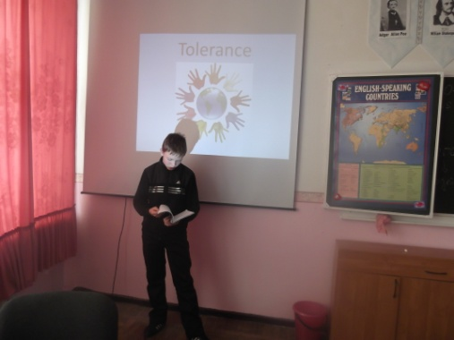
4) Now listen the song “Black Or White”

Who is the singer?
Yes, it’s Michael Jackson.
What about this song?
It is about discrimination.
Discrimination - it is less fair or less good treatment to any person or group, than for others. It is of direct and indirect, based on the same factors as the prosecution.
Let’s think, how to prevent discrimination?
Both Organizations think about prevention measures.
Start with “People should”.
5) Now we watch some video and you should think about it.
Tell me, what they did wrong?
How can we describe actions?
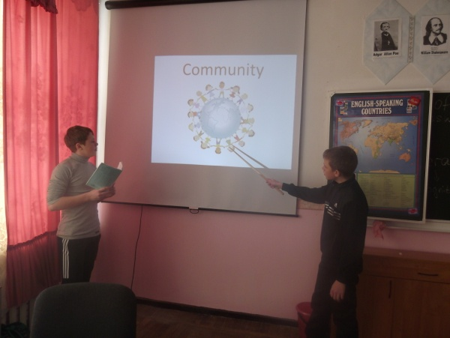
dishonesty
anger
dislike
distrust
lack of understanding
incivility
unresponsive
That’s right!
6)Both Organizations think about tolerance and draw their representations.

Organizations meeting came to the end, we have a lot of information. Now we know how to be tolerant. Thank you for your work. Good bye!

