[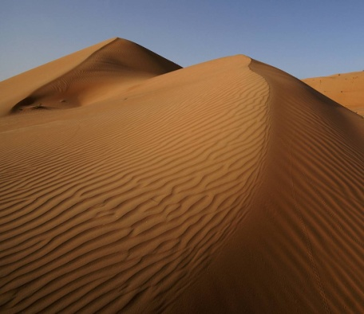](http://eskapada.lodz.pl/OMNAZ/9/country/large/oman.jpg) [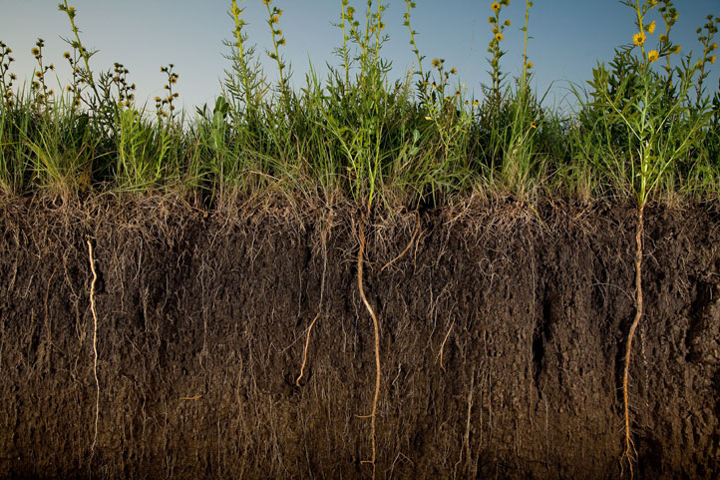](http://ngm.typepad.com/photos/uncategorized/2008/01/02/0103_os.jpg) [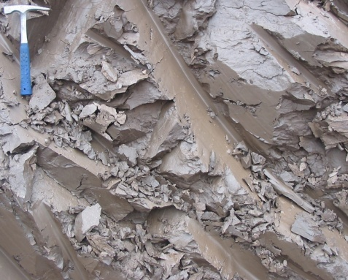](http://weewebwonders.pbworks.com/f/Clay-ss-2005.jpg)

[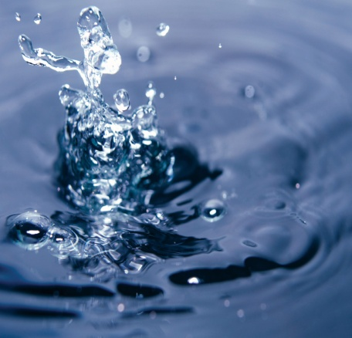](http://megalife.com.ua/uploads/posts/2008-02/1203793820_224231_282_574_artfile_ru.jpg) [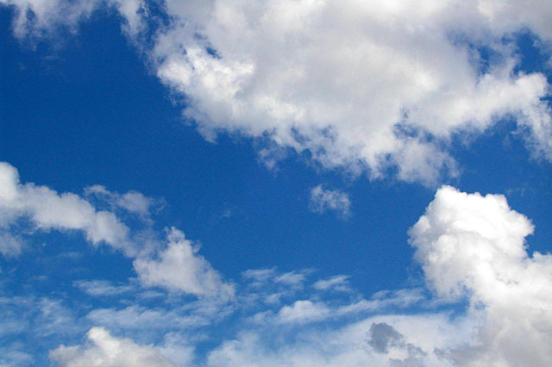](http://good-bye-liozha.narod.ru/liozha.ru/projekty/2003/images/nebo/nebo-moskva-05.jpg) [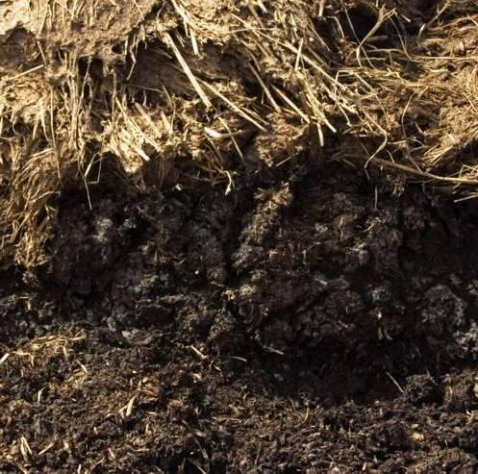](http://images02.olx.ru/ui/15/59/38/1314416313_212465138_1----.jpg)