Белгородская область

п.Томаровка

МОУ «Томаровская СОШ №2»

Учитель английского языка

Шаламова Ирина Викторовна

Внеклассное мероприятие в 5-м классе

"В гостях у Хоббита»"
Цели и задачи:
- развитие и повышение интереса к предмету,
- повторение и закрепление ранее изученной лексики, развитие навыков устной речи,
- развитие познавательных интересов учащихся, творчества, фантазии и воображения,
- воспитание чувства товарищества, коллективизма, дружбы.
Оснащение: декорация-домик Хоббита;
костюмы для сказочных персонажей: Хоббит, Красная Шапочка и Серый Волк,
Мальвина и Буратино, Кот Базилио и Лиса Алиса, Золушка.

На сцене появляется сказочный персонаж Хоббит с шарами и поёт песню «My Own True Friend»:
Hobbit: - Hello, dear Friends! I hope you know my name. I am Hobbit.
I am neither an animal nor a man. I live in a fairy-tale forest.
I like cakes, ice-cream, sweets and jam because I have a sweet tooth.
I like to sit in my armchair and read fairy-tales. But most of all I enjoy
Parties. Today I am going to arrange a Balloon Party. I have invited
A lot of my friends. They are from different fairy-tales. I am looking
forward the meeting with them.
( усаживается в кресло в углу сцены)

На сцене появляются Красная Шапочка и Серый волк. В руках у Красной Шапочки корзинка с цветами. Она идёт напевая.

Little Red Riding Hood: - Flowers here, flowers there,
Flowers growing everywhere!
Grey Wolf: - Hi! How are you, Little Red Riding Hood?

Little Red Riding Hood: - I’m fine, Mr. Wolf.
Are you fine Mr. Wolf?

Grey Wolf: - I’m well, Little Red Riding Hood.
Where are you going, Little Red Riding Hood?

2
Little Red Riding Hood: - I’m going to visit my friend. He lives in a fairy-tale wood.
He is good, very good! He is always in a good mood!

Grey Wolf: - Oh! I know your friend. He is Hobbit! He is my friend, my old good friend!
He is kind and merry. He often plays jokes! Hobbit is polite and hospitable.
Let’s go together!

(Красная Шапочка и Серый волк берутся за руки и поют песню “ The More We Are Together”) 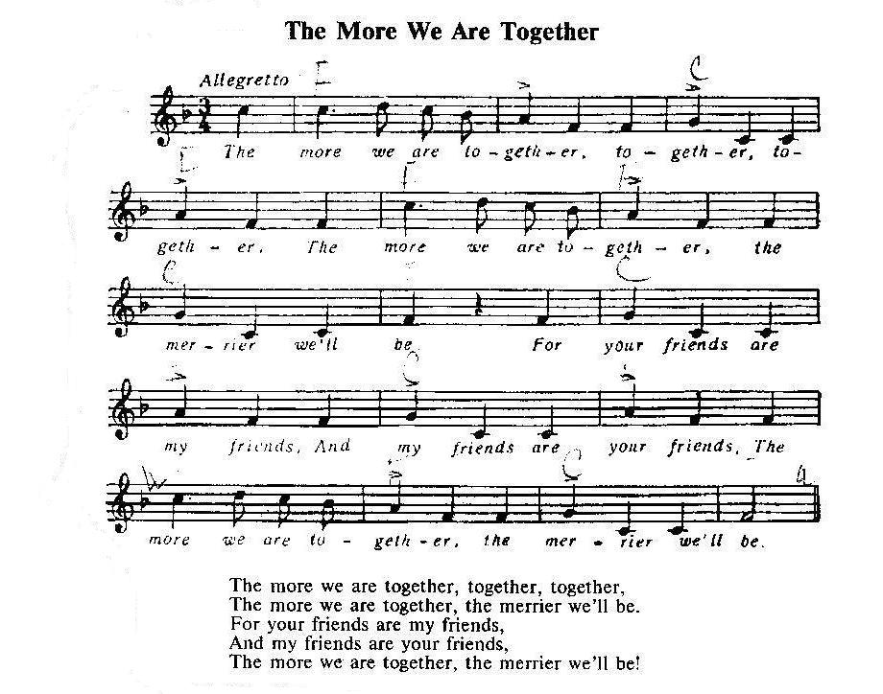

Hobbit: - Hello, dear friends! I’m glad to see you! Welcome to my party.
We’ll dance and sing songs today.

Little Red Riding Hood and Grey Wolf: - It’s great! It’s OK! We’ll have a party today!

На сцену выходит девочка, одетая в английскую одежду.
Janet: Hi! I would like to make friends with you.

Хоббит поёт песню с Дженит «Девочка из Лондона»:

What is your name,
What is your name?
Now tell me , please,
What is your name?
My name is Janet,
My name is Janet,
My name is Janet,
That’s my name!
3

Hobbit: - Janet, may I ask you a few questions?
Janet: - Yes, certainly.
Hobbit: -What are your hobbies?
Janet:- Sport and music.
Hobbit: - Do you play any musical instruments?
Janet: - Yes, I play the guitar.
Hobbit: - Have you got a lot of friends?
Janet: -Yes, lots, but only one close friend.
Hobbit: - How would you describe yourself, I mean what are your main characteristics?
Janet: - Well, I think I am sociable, responsible, curious and have a good sense of humour.
Hobbit: - It’s OK! Let’s make friends.
Friendship is a thing for two,
Three or four, even more,
Like a song that is made to sing.
Friendship is a doing thing.
На сцене новые персонажи: Мальвина и Буратино.

Malvina: - I’m Malvina. I can read, write, count. I think everybody must go to school. I read fast, write neatly, count correctly. My friend Hobbit can read and write too. He likes to get letters.
Every morning at 8 o’clock
You can hear the postman knock.
Up jumps Hobbit to open the door,
One letter, two letters, three letters, four.
Buratino, sit down here and write a letter to Hobbit!
Buratino: - No! No! I don’t like to write. I can’t write at all. It’s so boring.
Malvina: - If you want to go to the Balloon Party you must write a letter. Take a pen and start to write!
Buratino: - I needn’t a pen, I have a long nose. I can write with it.
Malvina: - You are messy. Look! You have made a lot of mistakes. You are a naughty boy! And you won’t go to the Party.
Buratino: - You are a bad, bad girl! I shall go to the Party.
Hobbit: - Don’t quarrel my friends! I invite you to the Party. Take these balloons, please.

На сцену выбегают кот Базилио и лиса Алиса. Они дерутся друг с другом.
Cat: - Give my money back!
Fox: - You are crazy cat! I have no money. I’m poor fox, I have empty box.
Cat: - You have hidden my money, haven’t you? I know you are cunning fox.
Put the money into the box. I can scratch you!

Fox: - Will you scratch me? I will bite you!
Hobbit: - Do you want to be rich? Listen to me! You can become rich if you follow these simple steps:
Be kind to everyone.
Share whatever you have, even if it’s only a little!
Take these balloons and follow us!
Хоббит раздаёт всем шары. Раздаётся стук в двери.

Hobbit:- Listen! Who is knocking? Come in, please! Come, little girl, stay with me, happy you will be.
Cinderella: - I am poor Cinderella. You know my sad story: I have no mother, I have a stepmother. She doesn’t love me; she loves her doughters and makes me to do a lot of things about the house. I am as busy as a bee. But I am fond of dancing. May I dance for you?
4
Hobbit: -Yes, you may.
Золушка исполняет танец. Хоббит вручает ей шарик.

Hobbit:- I’m, I’m a happy man.
You are, you are my old good friends:
He is my friend, she is my friend.
We are good friends, old happy friends!
Все поют песню:
Good-bye, children,
Good-bye, children,
Good-bye, children,
We are all going home.

Merrily we walk along,
Walk along, walk along,
Merrily we walk along,
Singing a fine song!
Список литературы
1. Биболетова М.З., «Английский с удовольствием» учебник для 5-6 классов, Титул 2007;
2. Канчели И.Н., Английский язык для младших классов, «Издат-школа» «Райл» М. 1998г.

