Внеклассное мероприятие для 11 класса.

The 19th of April  
**Тема**: Talk-show “Let’s talk”  
Hobbies “Yes” or “No”  
**Тип урока**:обобщение и систематизация знаний, умений и навыков.

**Цель**-расширение кругозора и повышения общей культуры учащихся.

**Задачи**- активация умений спонтанного говорения;

- развитие интеллектуальной, эмоциональной и мотивационной сферы учащихся,

- развитие логического мышления, умения анализировать, сопоставлять

- развитие креативного мышления и презентационных умений  
**Оборудование** : доска, мультимедийная аппаратура, компьютер, творческие работы учеников, презентации учеников, интернет, скайп,

**Ход урока:**

* Организованный момент.
* Good morning students!
* Good morning teacher!
* Today we have unusual lesson – Talk show “Let’s talk” is devoted to hobbies and interests. There are a lot of different opinions about these theme and we’ll try to consider many aspects of this. Well, let’s begin.

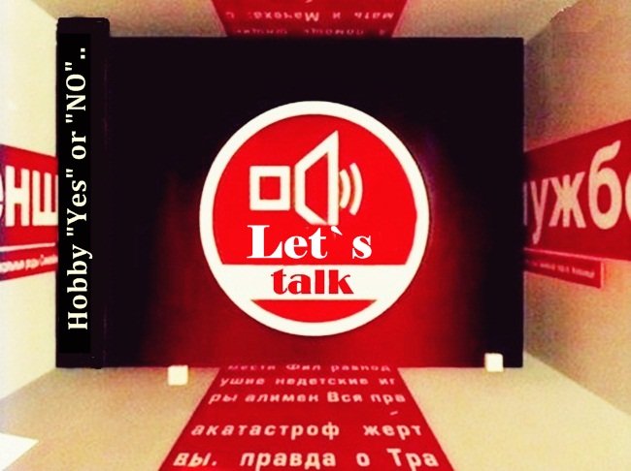**Адель** – Hello, everybody!

Let me introduce myself. My name is Adel Huzin. Today, during the Talk – show we will be discussing the theme: Hobby “Yes” and “No”. We’ll try to consider all aspects of this theme.  
First, let me introduce our quests in the studio.

* The journalist from the famous magazine “Joy” Gulnaz Darzimanova.
* The psychologist – Lilia Ahmadieva.
* The representative of state line – Arevik Sogomonyan.

This theme is very actual nowadays and we’ve decided to talk about it, because there are opposite opinions. Some people think, that our teenagers are so lazy, that they don’t want to do anything except internet and computer games. But some people think differently, they consider that teenagers are very busy nowadays. They are not only study, but they have a lot of interests and hobbies. Moreover their hobbies turn into the future professions. Well, and now, let’s greet our quests from school, their names are: Ura Kuranov and Elvira Muhametdinova. How do you think, do the teenagers have interests and hobbies nowadays?

**Юра** – Yes, of course, I and my friends have hobbies. And, I think, it’s boring to live without it, because it makes our life more interesting, emotional and full. In my opinion, people of all ages should have hobbies. As for me, I like to draw “anime”. I have been doing it for 2 years. Especially I like to draw, when I have a good mood. This way I express myself. There are some my works (on the screen). In my view, this work is the best one, because I have drawn It for a month. I think it’s necessary to find time for hobbies.

**№1**

**Elvira** – But, I don’t agree with its opinion. Because, I think, our life is so busy. At school, we are overloaded, we are given a lot of homework. We go to the tutors, to elective courses, prepare to the exams. At home, we have a lot of responsibilities, too. That’s why I haven’t got any time for hobbies.

**Адель** – Well, I see, I appreciate your revelation.

**Айдар** (from the audience) – May I support this point of view? My name is Aidar Safiulin. I’d like to say, that I have two children and my elder son studies in the 11th form. And I can see how much he is tired at school, after school, he is afraid of the exams very much. That’s why he is nervous and stressful. Sometimes, I worry about him.

**Аревик** – May I say, Adel?

**Адель** – Yes, please.

**Аревик** – Now, we consider the new forms of studying. You’re right that pupils, especially the 11th forms are overloaded preparing for exams very much. We offer to shorten the quantity of hours on optional subjects and give more on compulsory subjects.

**Адель** – And now, I’d like to invite the next guest, her name is Olga Vahterova. She is the young scientist. Her sphere is biology. And now she’ll share with her opinion. Greet her, please. Good morning!

**Ольга** – Good morning!

**Адель** – Could you share with your point of view about should people have any hobbies?

**Ольга** – I consider, that each person should have hobby or hobbies. As for me, when I was a little girl, I liked watching butterflies, insects, collected dry leaves. When I was 6 years old I asked my parents to buy microscope. I’ve begun to interest of building alive organism. At school we organized the biological coterie where we shared our watching, changing and news in the science world. And I’ve chosen the biology as the main sphere of my activity.

**Адель** – Thank you, Olga, it was very interesting. And may hobby be useful for the society? Let’s greet the next guest Phatihova Adeliya. And she’ll share her opinion about this question.

**Аделя** – Good morning everyone! My name is Adeliya. I’m the owner of veterinary clinics “Doctor Vet”! My chain is limited to three hospitals in Kazan, Samara and Ufa, but I’m going to open a clinic in Almetyevsk. I’m sure hobby may be very useful, for example in my case. I love animals very much, caring for them became my hobby. When I was a child I always fed the street animals, tried to help them. I promised myself, when I will be adult I will have business. I will help homeless animals and pets. With the help of charity I opened my first clinic in Kazan. I would like to see all animals have its own home and people care about their pets. So I’d like to show you a little advertisement of my clinic. If you have the wish to help, you may contact me on phone 55-05-07. I’m sure, that somebody wants to help them, thank you!

**№2**

**Адель** – Well, we’ve invited the famous football player Artur Frolov, but unfortunately he is in the Great Britain now. But we have such possibility to talk to him on Skype.

-Hi, Artur. How are you? What’s the weather like today there?

**Артур** – Hi, I’m fine, it’s rainy and foggy as usual.

**Адель** – Artur, we have different opinions. Could you tell us your opinion? Should people have hobbies?

**Артур** – Well, with pleasure. I’ve been playing football for 10 years. I’ve begun playing football since 11 years old. First, it was just interesting to play with my friends on the playground. Then I joined to the football team. Of course, I had some problems. It was hard, I trained 5 times a week on 2-3 hours a day. And I was very tired after trainings, but in spite of this, I continued playing. I had exact timetable which I followed. It helped me to become more patient, confident, organized. That is why, I think, I succeeded and now my hobby is my profession.

**Адель** – Thank you so much, bye, Artur.

**Артур** – Thank you, bye.

**Адель** – Let’s greet our next guest – the famous figure-skating – Oksana Shalaeva.

- Oksana, what do you think about this theme: Hobby “Yes” or “No”?

**Оксана** – I have begun to do figure-skating since 7 years old. My mother took me there just to improve my health, but I loved figure-skating. Well, it was so hard – a lot of trainings, studying, of course, I wanted to do for a walk with my friends, as all usual children. But I had to sacrifice much for sports. I ate badly, I had not get enough sleep, I met with my friends very seldom, that’s why I’ve lost them, because they didn’t like that I spent a lot of time training. I had an exact timetable, that’s why sport and studying I combined easily. Teachers understood me and I thanked them for it.

**Адель** – How long have you done figure-skating?

**Оксана** – 12 years, during that period I had either up and down, a lot of bruises, injuries, tears, but for my lovely figure-skating I’m ready on everything. (on the screen)

**№3**

**Адель** – Audience can see only 2,3-minutes performance, where all are happy and joyful, but in reality, these are: years of trainings, hard work, that the performance would be wonderful and great.

**Оксана** – Yes, you’re right. I always thank my mother. Thanks to her persistence, tolerance and love I could succeed. I haven’t done anything without her. Now, my hobby is my profession.

**Адель** – Thank you very much, Oksana!

Greet the next quests the popular group “Dance paradise”. What do you think about Hobbies “yes” or “No”

**Group: Карина** – Our group “Dance Paradise” has formed 5 years ago. Each of us has danced from the childhood.

**Регина** – Once, we came to a big dance casting and there we’ve met each other. We were combined in one group and were called “Dance Paradise”. We began training together, imagined dances and performed before audience.

**Айгуль**- We were invited to big concerts to dance with popular star singers . That’s why we became successful, popular and the hobby turned into lovely work.

**Адель** – Let’s remember the first your performance on the stage. (on the screen – dance).

**№4**

**To sum up the quests express their opinions:**

**Лилия** – I think, that each person of any ages should have hobby. Moreover, it influences on formation teenager’s sanity. If they have hobbies it means, that there aren’t problems in person’s sanity.

**Гульназ** – May, I add? To sum up, we can say that hobby “Yes”, because nowadays children keen on TV and internet too much. But if we and our future generation will have hobby, it will improve our health and develop child’s personality.

**Адель** – Thank you so much, thank all of you. See you next time. Good luck, everybody!