[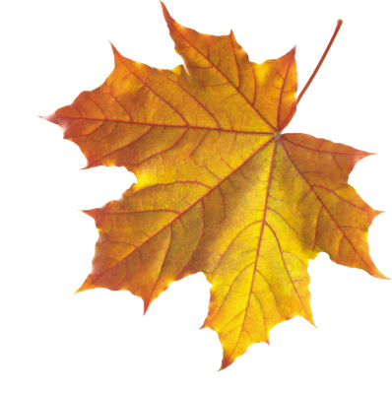](http://2.bp.blogspot.com/_sLP0xJjTMAY/SNK53eYYHvI/AAAAAAAAB3E/cys4KYJ7ru4/s400/klen.png)

[](http://2.bp.blogspot.com/_sLP0xJjTMAY/SNK53eYYHvI/AAAAAAAAB3E/cys4KYJ7ru4/s400/klen.png)

[](http://2.bp.blogspot.com/_sLP0xJjTMAY/SNK53eYYHvI/AAAAAAAAB3E/cys4KYJ7ru4/s400/klen.png)

[](http://2.bp.blogspot.com/_sLP0xJjTMAY/SNK53eYYHvI/AAAAAAAAB3E/cys4KYJ7ru4/s400/klen.png)

[](http://2.bp.blogspot.com/_sLP0xJjTMAY/SNK53eYYHvI/AAAAAAAAB3E/cys4KYJ7ru4/s400/klen.png)

[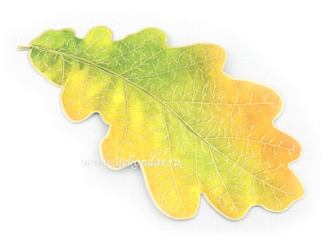](http://www.gekondar.ru/products_pictures/68158-MP.jpg)

[](http://www.gekondar.ru/products_pictures/68158-MP.jpg)

[](http://www.gekondar.ru/products_pictures/68158-MP.jpg)

[](http://www.gekondar.ru/products_pictures/68158-MP.jpg)

[](http://www.gekondar.ru/products_pictures/68158-MP.jpg)

[](http://www.gekondar.ru/products_pictures/68158-MP.jpg)