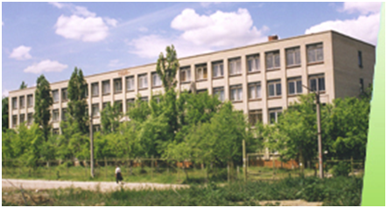
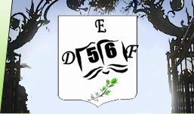

Municipal Educational Institution
“Secondary School № 56 “
Leninsky District
Saratov

Our school was founded in 1968. It has a long history.
Nowadays more than 900 students study in it. 60 highly- qualified teachers work in it.
Our students have deep knowledge of English, German and French. They begin to study foreign languages in the 1-st form.
The teachers and students of our school take part in many language contests and conferences and become the winners.
Every year many students of our school pass exams of exams of international sample of different levels.( Cambridge exams, DELF, DSD). The total number of them is 31. Since January 2011 school 56 is the Preparation Centre Cambridge ESOL.
The teachers and students of school 56 are active participants of many exchange programs. 8 students of our school were the winner of “Flex”-program and visited the USA
School №56 has partnership relations with many institutions of higher education ( Saratov State Pedagogical Institute, Saratov State University, Stolypin Volga Region Institute, Russian State University of Trade and Economics), and with different public organizations (German and American Corners, French Embassy in Russia, the educational centre “Tritec” and others ) .
Two language clubs were organized in our school “Francomania-56” in December 2010 and “BrAm– club” - in November 2011.
In November 2011 there was a great project in our school—the group of professional actors and musicians from Lewis School of English and students from our school staged two brilliant plays ; “A Midsummer Night Dream” by W. Shakespeare and “Peter Pan”.

Programs at school:
Junior and secondary education;
Intensive learning of foreign languages
Preparation for German and English exams
Preparation for state exams
Intensive learning of other subjects
Cooperation with commercial and social
organizations

Teaching methods at the school:
Information and computer technologies;
Game technologies;
Research work;
Developing technologies;
Technologies of intercultural dialogue;
Differentiating learning.

