**Приложение 1**

|  |  |  |  |
| --- | --- | --- | --- |
|  | **[s]** | **[z]** | **[iz]** |
| spider**s** |  |  |  |
| rabbit**s** |  |  |  |
| seahorse**s** |  |  |  |
| tortoise**s** |  |  |  |
| parrot**s** |  |  |  |
| crocodile**s** |  |  |  |
| elephant**s** |  |  |  |
| whale**s** |  |  |  |
| horse**s** |  |  |  |
| snake**s** |  |  |  |

**Keys**

|  |  |  |  |
| --- | --- | --- | --- |
|  | **[s]** | **[z]** | **[iz]** |
| spider**s** |  |  |  |
| rabbit**s** |  |  |  |
| seahorse**s** |  |  |  |
| tortoise**s** |  |  |  |
| parrot**s** |  |  |  |
| crocodile**s** |  |  |  |
| elephant**s** |  |  |  |
| whale**s** |  |  |  |
| horse**s** |  |  |  |
| snake**s** |  |  |  |

**Приложение 2**

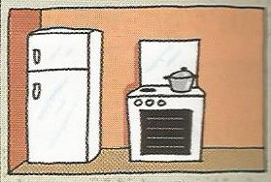



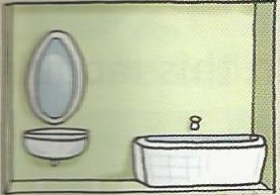

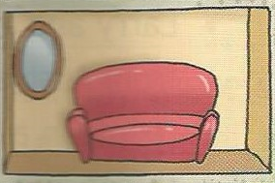

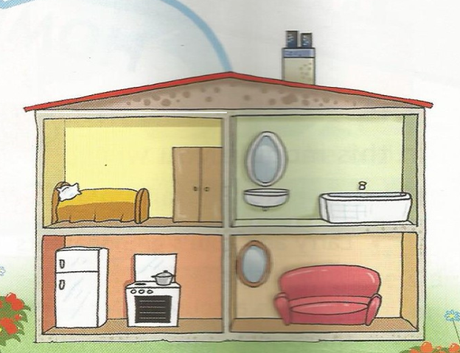

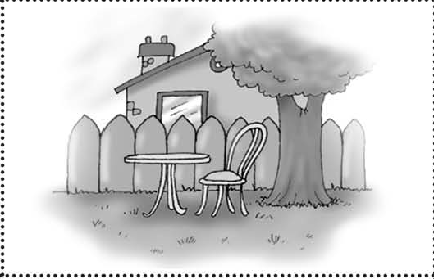

**Приложение 3**

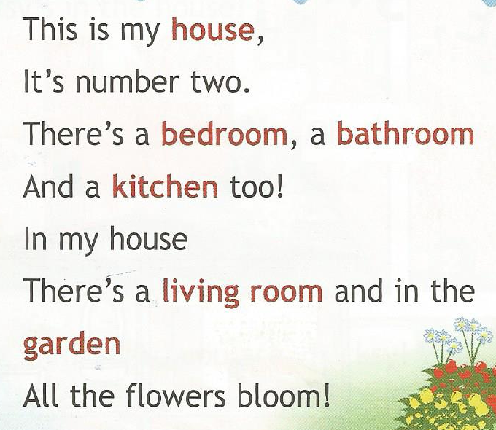

**garden**

**house**

**bathroom**

**bedroom**

**living room**

**kitchen**

**Приложение 4**

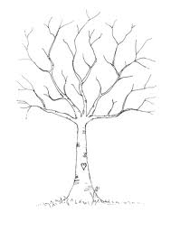

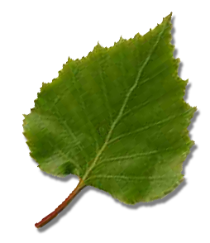****



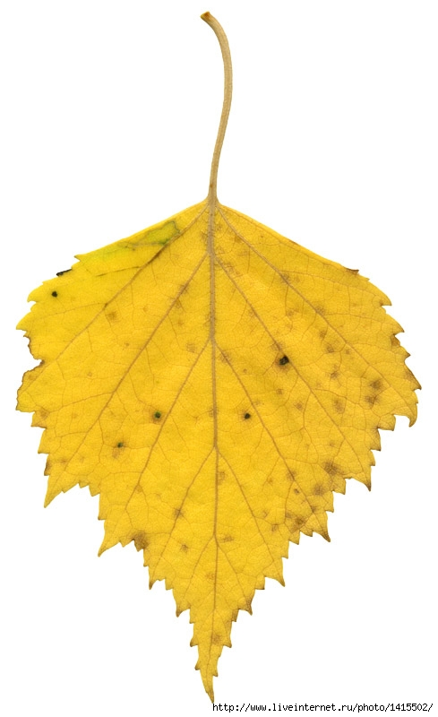 

**   **







**Приложение 5**

** **

** **

**Приложение 6**

