The lesson in the 6 -7th forms.

**The Baltic Sea in our life”.**

**The aim of the lesson:**

- to help the children see their influence on the Baltic sea and their life.

**The tasks of the lesson:**

-to remind students of the Baltic Sea countries;

-to show responsibility of the countries for the Baltic Sea’s environment;

-to raise pupils’ interest to the Baltic Sea;

-to help children develop a sense of belonging to the Baltic Sea;

-to discuss the decision levels at which environmental problems can be solved.

**The equipment for the lesson:** the computer, the smart board, the presentation” The 24th of November”, the handout pictures, the cut map.

**The plan of the lesson.**

1. **The opening address of the teacher about the DAY of WATER.**

“Good morning , children! How are you? What date is it today?”

“Today is the 24th of November(Slide1).

“Yes? You are right. Today is a special day in all over the world. It is the DAY of WATER. Why is it so important to speak about water nowadays?”

“Water is our life .We can’t live without it! There are a lot of water problems. Some countries don’t have water and they buy it We have to save water by doing little steps for example, take shorter showers.

1. **A slide show quiz about the Baltic sea( Slide2).**

The pupils work in pairs and show their answers “YES” or “No”.

-What is the depth of the Baltic sea?

-Do we know much about the sea?

-Is the Baltic sea the freshest sea in the world?

-There are more than 20 mln. people living on the banks of the sea, aren’t there?

-Are there morsels among the sea animals?

-Is the Baltic Sea a great place for navigation?

“Now you’ll be shown the photos of three seas-the Baltic sea, the Black sea and the Mediterranean sea. Your task is to determine which sea is shown in each photo (Slide3).

1. **The group work.” Who is the best one?”**

The pupils are split into 3 groups and given a pre –cut outline map.

-“Combine the pieces into the outline map of the Baltic region.

-Mark the countries which have access to the Baltic Sea.

-Put the flags on the Baltic sea countries and name their capitals.

The brightest pupils are given prizes

1. **The discussion in groups.**

The pupils discuss the influence of the Baltic sea on the life of our city.” The weather changes. The sea is the home for animals. It is a trade way”(Slide4).

“The influence is much greater than we think. Working on this activity, we will try to find as many influences as possible. You ‘ll be given the cards. They will help you to recall how the Baltic sea influences our life in our city. Your task is to guess what each card represents.( the cards are: ships, fish, the sun, tourists, the dirty water in the sea).

The teacher:” What can you say about this man in a hammock chair.”

The pupils:”People can take holidays n the sea coast. There are a lot of hotels on the bank of the sea.

The Baltic sea is the most important artery. We deliver our goods, oil, coal to other countries through the Baltic Sea.

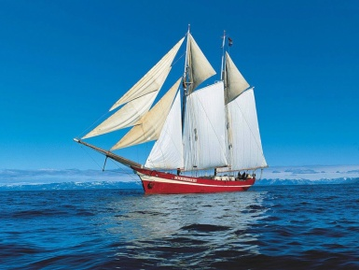

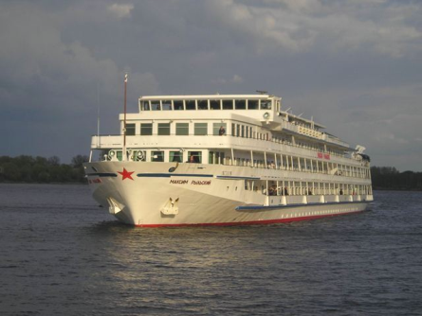

Cruise ships come to our port . There are a lot of tourists. They spend a lot of money visiting our city. This means income for our city

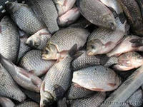

Whose father likes fishing? Anchovy, sprats, are native to the Baltic Sea.

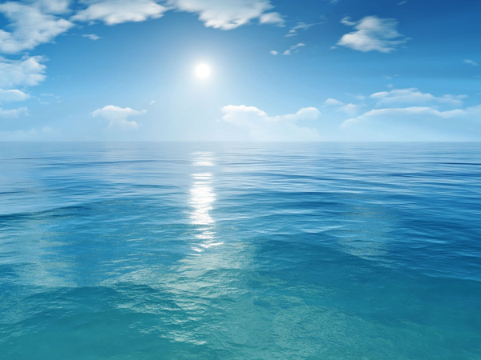

The Baltic Sea has a strong impact on our climate. It is milder , more humid, less sunny than in the Siberian cities.

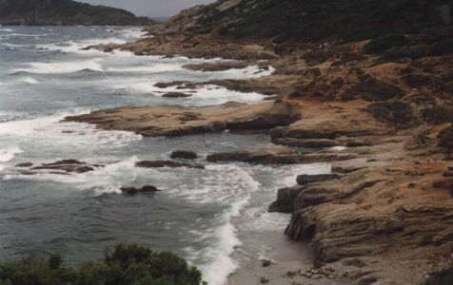

The Baltic Sea has been a sewage drain for city wastewater and discharges. There are thousands of barrels with toxic chemical weapons.

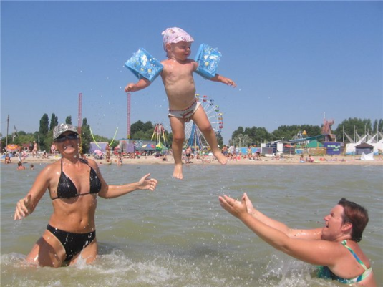

The Baltic sea coast is a nice place for recreation. We go there for outings and to swim. There are a lot of resorts, hotels, and spas along the coast line.

1. **Brainstorm(Slide5).**

The pupils write the words that are connected with the theme of the lesson ”We and the Baltic Sea” in a diagram on the board.

Then pupils read the words and translate them.

1. **The conversation of the teacher about**

**the sea impact on our life** .

The working procedure is similar

to that in the previous phase.

1. **The dialogue of the teacher and the pupils.**

-Did you expect the diagram to be so big?

-Have you ever thought that the Baltic Sea influences our lives so strongly?

-Which impacts do we usually think least of? Why?

**8. Filling the table.**

The pupils work in groups.

|  |  |  |  |
| --- | --- | --- | --- |
|  | The problem | The result | The way out |
|  | Toxic washing power | It he Baltic Sea into | To buy washing powder in which the concentration of phosphates is low |
| The enterprises | Wastes of enterprises |  |  |
| the cities | The cleaning constructions |  |  |
| the nations | The high concentration of heavy metals |  |  |
| The world | The high concentration of carbonic acid gas |  |  |
|  |  |  |  |

1. **The rules to save The Baltic clean.**

“ To reduce of greenhouses gas emissions”.

Ban production and use of the most toxic chemicals.

“Build the water treatment plants capable to clean all wastewater”.

“Use detergents and washing powders that would do less harm to the Baltic sea”.

**9.The results of the lesson(Slides 6, 7).**

“Even if we don’t visit the sea for many months the Baltic still impacts our lives every day in one way or another. Give some ideas how the problem of the pollution Of the Baltic can be solved at the different levels( in groups)

**10.Homework(Slide8).**

To write the project “How to solve the Baltic Sea problems”(choose any level: Personal level, Companies and business, Municipal and regional, State , International)..